VEGETATION MANAGEMENT AT OUTDOOR ADVERTISING SIGNS

1) PURPOSE:
To maintain highway beautification in conjunction with sustainable roadside maintenance programs; protect public
investments in roadside vegetation; and to acknowledge the advertising industry's desire to maintain advertising displays located adjacent to interstates and primary federal-aid highways for the benefit of the general traveling public.

To establish a means for owners or operators of legal conforming/non-conforming advertising signs to make a request for vegetation management for maintaining visibility of such signs and the criteria and process considered by GDOT
in the evaluation of the request.

2) AUTHORITY:
Sections 32-6-75.1, 32-6-75.2, 32-6-75.3 (Control of Signs & Signals), Official Code of Georgia, Annotated

3) SCOPE:
All sign owners with GDOT permitted outdoor advertising signs adjacent to Georgia interstates and primary federal aid
highways who wish to maintain vegetation within the GDOT right of way or wish to ensure visibility will be required to
comply with this policy for vegetation management. To ensure consistent maintenance of GDOT right of way, this process and criteria will be used by all of the permit review personnel in GDOT.

4) REFERENCES:
4.01 Georgia D.O.T. Standard Specifications, Construction of Roads and Bridges, most recent edition.
4.02 ANSI A300 (Part 1) – 2001, American National Standard for Tree Care Operations – Tree, Shrub, and Other Woody Plant Maintenance – Standard Practices (Pruning)
4.03 National Pollutant Discharge Elimination System (NPDES Phase 2) standards.
4.04 Federal Highway Administration (FHWA) Manual on Uniform Traffic Control Devices, current edition.

5) BACKGROUND:
This Policy is necessary to implement statutory changes made in 1998, and to establish Department procedure for processing Permit’s for Vegetation Management at Outdoor Advertising Sign(s) for the duration of the rule making and procedure development process.

6) DEFINITIONS:

6.01 Acceptable condition -- The area is clear of debris and obstructions to conventional mowing and maintenance practices; stabilized by approved vegetative treatments; in conformance with Vegetation Management Permit conditions; and Georgia DOT Standard Specifications.

6.02 Cleaning – Selective pruning to remove only dead or broken branches.

6.03 Crown -- The leaves and branches of a tree measured from the lowest branch on the trunk to the top of the tree.

6.04 Crown Elevation or Raising -- The removal of lower tree limbs to allow clearance or visibility beneath the tree crown while maintaining the natural symmetry of the tree. A maximum of 25 percent of the leaf bearing crown may be removed.

6.05 Crown Reduction -- Selective pruning to decrease height and/or spread of the crown. Crown reduction shall be utilized in hazardous or safety applications only. A hazardous tree is one that has partially fallen, or that the Engineer determines is about to fall, threatening persons or property.

6.06 Drip line -- The peripheral limits of the horizontal crown of a tree spread vertically to the ground, provided, however, that the same shall not be less than a circle with a five-foot radius measured from the center of the tree.

6.07 Effectively destroy -- To cause, allow, or permit any act which will cause a tree to die, exhibit an unnatural shape or go into a period of unnatural decline within a period of two years from the date of the act. Acts which may effectively destroy a tree include, but are not limited to: damage inflicted to the root system by heavy machinery or soil compaction; excessive pruning; severing the leader or leaders; stubbing mature wood; tree abuse; grade changes; damage intentionally inflicted on the tree permitting infection or pest infestation; application of herbicides or intentional fire damage to the trees intended to remain; infliction of a trunk wound that is thirty (30) percent or greater of the circumference of the trunk, or the removal of sufficient canopy to cause the unnatural decline of the tree.

6.08 Exotic pest plants -- Non-native invasive plants also called noxious weeds, which are a problem in natural communities and ecosystems on public & private land. Example: Kudzu (Pueraria lobata), Princess tree (Paulownia tomentosa), Privet (Ligustrum sinense and vulgare), Mimosa (Albizia julibrissin), and Japanese honeysuckle (Lonicera japonica), Johnson Grass (Sorghum halepense).

6.09 Hardwood -- Trees usually with deciduous leaves, including examples such as maple, oak, cherry, plum, hickory, ash, beech, willow, poplar, and sweetgum, with notable evergreen exceptions such as magnolia and live oak.

6.10 Heading -- The cutting of an older branch or stem back to a lateral branch not large enough to assume apical dominance in order to meet a defined structural objective. Heading is not an acceptable pruning practice.

6.11 Mitigation – Reduction of the impact of vegetation management activities with additional or supplemental work. Forms of mitigation include: (1) Choosing an area of least impact; (2) restoration/revegetation by grassing all disturbed areas; (3) Erosion and sedimentation control.

6.12 Native plant -- A grass, herb, shrub or tree, which grows naturally within particular regions in Georgia, also called indigenous.

6.13 Nonhardwood – A tree usually evergreen, including pine, spruce, fir, cypress, juniper, cedar and other conifers.

6.14 Pruning – The selective removal of plant parts without damaging the natural symmetry of the tree or having a negative effect on the tree’s long term health. Pruning types are restricted to cleaning, crown elevation, thinning, and vista pruning only, as defined by the GDOT. Never remove more than 25 percent of the trees leaf bearing crown. Crown reduction shall be utilized in hazardous or safety applications only.

6.15 Removal or removed -- The elimination of trees or other vegetation.

6.16 Screened view -- The obstruction of view of the sign shall be determined as viewed from the centerline of the nearest lanes of traffic from an eye level of no less than 36 inches above the highway surface. A sign will be considered to have a screened view when the advertising message is not discernible when viewed in the defined sign-viewing zone in the direction the sign is facing.

6.17 Shrub -- A woody plant smaller than a tree usually having multiple permanent stems, branching from or near the ground.

6.18 Sign viewing zone (See APPENDIX A-1, A-2, A-3 and A-4) -- An area measured 500' maximum, as applicable, along the adjacent edge of the nearest travel lane on the same side of the highway to which the sign is permitted, which has:
A. As terminus A, the point on the adjacent edge of travel lane immediately opposite the edge of the outdoor advertising sign face closest to the highway at a 90 degree angle to the roadway;
B. As terminus B, the point measured along the edge of pavement 500 feet (maximum) in the direction from which the sign is viewed; provided that the second terminus point shall not include quadrant and ramp areas at interchanges; and
C. As terminus C, the point on the edge of the sign that is furthest from the road.

6.19 Target Viewing Zone -- A combined area of up to a 250 foot horizontal distance parallel to a state right of way and within the sign viewing zone in which all nonhardwood trees may be removed when all other considerations have been met. For signs erected on or before April 20, 1998, which are less than 35 feet in height or which are lowered to such a height, the target viewing zone may be increased to a maximum 350 feet where all other requirements can be met. Hardwood trees greater than 8 inches in diameter, measured 6 inches from the ground, may not be removed.

6.20 Thinning – Shall consist of selective pruning to reduce density of live branches. Thinning shall result in an even distribution of branches on individual limbs and throughout the crown. The maximum size range of the parts to be removed shall be one and a half inches (1-1/2”) in diameter. Not more than 25 percent of the leaf bearing crown may be removed.

6.21 Topping – The reduction of a tree’s size using heading cuts that shorten limbs or branches back to a predetermined crown limit. To sever the leader or leaders or to prune a tree by the stubbing of mature wood. Topping is prohibited.

6.22 Tree -- Any living, self-supporting, dicotyledonous or monocotyledonous woody perennial plant which normally grows to an overall height of no less than ten (10) feet in Georgia.

6.23 Tree abuse
A. Topping a tree or cutting that destroys a tree's natural habit of growth; or
B. Pruning that leaves stubs or results in a flush cut or splitting of limb ends including chemical or mechanical (shearing) mowing of trees; or
C. Peeling or stripping of bark, or the removal of bark to the extent that if a line is drawn at any height around the circumference of the tree, over one-third of the length of the line falls on portions of the tree where bark no longer remains; or
D. The use of climbing spikes, nails or hooks, except for the purpose of total tree removal; or
E. Pruning that is not in accordance with the policies and provisions hereof.
F. Damaging a tree(s) while felling another tree.

6.24 Trim or Trimming – See Pruning.

6.25 Unique vegetation -- All forms of vegetation including, but not limited to; historical specimen trees or plant communities, plants on the limits of their natural range, and canopy trees or shrubs that protect rare or endangered plants growing under them.

6.26 Vegetation -- All woody and herbaceous plants either naturally occurring or planted.

6.27 Vegetation Management -- All planned work activities relating to landscape and roadside development on public right of way. These activities may include the removal, pruning of trees or other vegetation, grassing, erosion control, and any maintenance management of their related features.

6.28 Vista Pruning – Selective removal of lateral branches (major structural branches of the tree) to the branch bark collar on the trunk or a central leader. Never remove more than 25 percent of the trees leaf bearing crown. Vista pruning shall result in balanced symmetry of the tree.

- APPLICATION FOR A VEGETATION MANAGEMENT PERMIT

  - A Permit for Vegetation Management at Outdoor Advertising Sign(s) may be requested by submitting a completed Application for Vegetation Management at Outdoor Advertising Sign (GDOT Form # FH-0402) to the District Engineer or designee with (Maintenance) responsibility for the segment of state road to which the subject site is to be permitted. (NOTE: This procedure does not apply to requests to trim or remove selected vegetation that screens on-premise signs or places of business.)
- The Application form shall be available at GDOT’s State Outdoor Advertising Office and any District Office of the Department.
- No person or entity may trim, prune, cut, or remove trees, shrubs, or herbaceous plants on public right of way to make visible or to ensure future visibility of off-premise outdoor advertising signs (billboards) without obtaining a Permit for Vegetation Management at Outdoor Advertising Sign(s).
- For purposes of this Policy, the application of chemical control and tree abuse constitutes removal of the affected tree, shrub, or herbaceous plant.
- The approved application, including any conditions stated therein and all of the approved Vegetation Management Plan shall become part of the Permit for Vegetation Management at Outdoor Advertising Sign(s).

  - Applications for Vegetation Management at Outdoor Advertising Sign(s) must be submitted by the Outdoor Advertising sign permit holder or the sign owner.

Grassing activities shall conform to this policy and any requirements as directed by the Area Permit Inspector.

7.03 The application shall contain:

A. The name, address, telephone number, facsimile number, and e-mail address if available, of the applicant, the name of the property owner, the GDOT sign permit number, the sign company's billboard face number, and the notarized signature of the applicant's authorized representative.

B. An affidavit stating the subject sign has had advertising messages thereon for some period during the preceding six months. (ATTACHMENT #1)

C. Time/Date stamped, color photographs of the sign (minimum of 2 photos) providing evidence that the sign has been maintained and the entire vegetation management zone (minimum of 4 photos) taken within six weeks of the application date. The photographs shall depict a clear representative overview of all the vegetation within the view zone. (ATTACHMENT # 2)

D. Vegetation Management Plan submittals:

1. The Sign Viewing Zone Inventory Sheet (ATTACHMENT #3) that shows the applicant’s target view zone and the tree sizes and quantities in the viewing zone. Trees located in the target view zone shall be quantified and sized in a separate chart, as provided on the inventory sheet, from those trees outside of the target view zone. The Certified Arborist or Forester is responsible for using and guaranteeing the information provided on the inventory sheet. The Sign Viewing Zone Inventory Sheet includes:
a. A typical 500 foot Sign Viewing Zone: The length of the sign viewing zone is at a scale of 1” = 60’. The depth of the sign viewing zone is not to scale. The applicant shall delineate and dimension the target view zone, and any related site features (i.e. bridges, bodies of water, kudzu, etc.).
i. The arborist/forester shall be responsible for averaging the number of trees, 4 inches in diameter and greater, in five random 10-foot by 10-foot square plots within the sign viewing zone to determine an average density. This average density will be used in Appendix B-2 to determine Location/Condition of the trees.
b. A Target View Zone Chart: The applicant shall quantify and size all of the trees 4 inches and greater in the target view zone and place the totals in this chart.
i. Two-inch classes are used for tree size, whereas, a four inch tree measures 4.0 to 4.99, a six inch tree measures 5.0 to 6.99, an eight inch tree measures 7.0 to 8.99, a ten inch tree measures 9.0 to 10.99, etc.
c. A Non-Target View Zone Chart: The applicant shall quantify and size all of the trees 4 inches and greater that are outside of the Target View Zone (Non-Target View Zone) and place the totals in this chart. The applicant will not be required to fill in this chart if no vegetation is to be disturbed inside the Non-Target View Zone areas.
2. Name and copy of certification of Arborist or Forester responsible for all on-site work, all required tables and worksheets, and direct supervision of all tree-related operations. (ATTACHMENT # 4)
3. Name and copy of license of personnel responsible for pesticide use and on-site observation, if applicable. (ATTACHMENT #5)
4. A Summary of Tree Values Worksheet (ATTACHMENT #6) that calculates the Total Contributory Value of all proposed vegetative pruning and/or removal valuation.
5. A Stocking Points Chart (ATTACHMENT #7) completed by the certified Arborist or Forester shall be submitted if the applicant proposes to remove pine trees, having a diameter outside bark of 12 inches or more at a height of 6 inches above ground level, in the Non-target View Zone.
6. A Work Schedule for Vegetation Management for a minimum of one year. (ATTACHMENT #8) The Work Schedule shall be used for the initial proposed vegetation management work (pruning and/or removal activities; condition/treatment of site at completion of work; and the grassing and maintenance activities). The Schedule shall include the equipment to be used and the work method for the prosecution of removal, pruning, and site cleanup work to be completed within a 5-day maximum duration. The Work Schedule shall also be used for proposed annual vegetation maintenance of the sign viewing zone.

E. The payment of all fees: (See Appendix C)
1. Application review and permit fee of $400.00 (non-refundable – to be submitted with the initial application and attachments); and
2. A Total Contribution check (non-refundable) equal to or greater than the value of the affected vegetation to be removed and/or pruned. The applicant shall submit the Contribution check only after receiving their notification of Approval of Permit and in conformance with the approved management plan. (Established in the notification of Approval of Permit) The payment of contribution fee(s) is due at the issuance of such permit.
- A minimum flat $500 fee is established for any and all vegetation management work. This minimum fee will include any and all work (pruning and/or removal) that affects vegetation under 4 inches in diameter.
b. Determination of Value of affected vegetation, 4 inches and greater, is established in Appendices B-1 and B-2. This is in addition to the minimum flat $500 fee. Provide the Summary of Tree Values Worksheet of all affected vegetation (all trees and understory vegetation pruned, and/or removed).

F. A performance bond in an amount equal to the contributory value of the affected vegetation and proposed mitigation, if applicable (minimum $3,500) with sureties in the amount acceptable to the Department to run concurrently with the permit. The performance bond shall be subject to forfeiture to the Department in the event of violation of these regulations or upon failure of the permittee to leave the work site in a condition acceptable to the Department. Blanket bonds may be considered for owners submitting multiple applications.

G. The Permittee and their arborist/forester must attend a scheduled field review or pre-construction site meeting for the determination of all work limits, points of access, sedimentation and erosion control requirements, traffic control requirements (rush hour traffic limitations, etc.), and finalized work schedule. GDOT reserves the right to determine the final location of each zone. As a part of a field review, condition of approval, and after approval notification, the permittee shall provide:
1. On-site field stakes depicting the limits of the vegetation management zone (sign viewing zone);
2. Field stakes depicting the limits of the target view zone. Stakes shall be a minimum 36” (900mm) wooden stake topped with lime green flagging tape and installed at a maximum of 20 feet on center. If the stakes are damaged at any time, re-establish the stake line immediately before clearing operations resume.
3. Fluorescent lime green flagging tape depicting vegetative removal/save identification;
- Protective barriers around the drip line of trees to be retained prior to the field review.
- For a larger (350 foot) target viewing zone, verification of the sign structure height, ensuring conformance to all applicable regulations and policies.

7.04 All vegetation management proposed in the plan shall be in accordance with this Policy, GDOT Standard Specifications, and the following guidelines;

- No trees or vegetation shall be trimmed, cut or removed other than within an approved sign-viewing zone.
B. All vegetation to remain within the sign-viewing zone, shall be maintained in a healthy acceptable condition.
C. All grassing shall be guaranteed for one growing season at installation and establishment (maintenance) period. All disturbed areas shall be in conformance with the grassing and establishment maintenance specifications of this policy and GDOT Standard Specifications.
D. The Schedule for Vegetation Management must provide for the eradication of exotic pest plants or any other noxious weed growth and shall be maintained free of exotic pest plants.
E. The vegetation management zone shall be maintained by the yearly permit renewal from the Department.
F. Hardwood trees having a diameter outside bark of more than 8 inches, at a height of 6 inches above the ground level, shall not be removed.
G. Work shall be accomplished during normal daylight working hours. No work shall be performed on Saturdays, Sundays, or designated State holidays.
- The Permittee shall give the local District Engineer, or designee, a minimum of 48-hour notification prior to any and all permitted and scheduled vegetation management activity on the right of way.
I. The permittee must provide a minimum of five (5) working days notification of any changes to the approved work schedule.
J. All tree-related work shall be performed under the direct supervision of an ISA certified Arborist or Georgia registered Forester. All work shall be performed in accordance with ANSI for Tree Care Operations and this Policy. Work shall meet all rules and regulations set forth by local agency/County/State/Federal. Aesthetic considerations are secondary to structural integrity and tree health.
K. Chemical control of vegetation is limited to selective control of invasive exotic pest plants and stump treatments. Herbicide storage, application, and disposal shall be in accordance with all of the manufacturer’s recommendations and with State and Federal rules and regulations.
1. Herbicides shall be certified for right of way use and approved by the Department.
2. Perform all herbicide applications under the direct supervision of a person licensed by the Georgia Department of Agriculture to apply herbicides (Certified Pesticide Applicator) in the category of Right of Way use. Provide this information, as applicable. (ATTACHMENT #5).
3. Herbicides shall have an approved dye for inspection purposes.
4. Spray no herbicides in or directly adjacent to streams, rivers, or bodies of water.
5. Invasive exotic pest plants identified as trees or shrubs shall be removed and stump treated.
6. Invasive exotic pest plants identified as vines or grasses shall be sprayed with a selective herbicide. Foliage within 4 feet of the ground shall be sprayed. No foliar spray shall be used above 4 foot high. Invasive vines and grasses shall be sprayed during the growing season. Vines, such as kudzu may require several herbicide treatments before they are totally eradicated. Broadcast spraying is limited to areas approved by the annual permit.
7. All applicators shall wear proper safety attire as recommended by the chemical instructions.
8. All chemical control operations shall be supervised by the District Maintenance Engineer or designee, with 48-hour notification.
- Wound dressing or paints will not be used.
M. Equipment that will damage the bark and cambium layer shall not be used. The use of climbing spurs is not permitted. All cut limbs shall be removed from the tree crown upon completion of the pruning.
N. Vegetation management shall not proceed during specified times of the year if the University of Georgia Extension Service or other appropriate government agency identifies a specific disease or insect pest that poses a significant threat of spreading due to those activities during that time of the year.
- Pruning should not leave large open spaces in the general outline of the tree. Only Crown Raising and Vista Pruning are allowed on pine trees’ lateral limbs. Cutting the leader of mature wood constitutes topping and is prohibited.
P. Sabal palms shall not be pruned. Sabal Palms may be considered for relocation only and with bond requirements held until final acceptance after two growing seasons.
- Erosion control shall be as directed by GDOT or per National Pollutant Discharge Elimination System (NPDES Phase 2) standards and Best Management Practices (BMPs) consistent with the State Soil and Water Conservation Commission’s Manual for Erosion and Sediment Control in Georgia. An erosion and sedimentation plan is not required unless the view zone is in or adjacent to an environmentally sensitive area such as a stream or wetland or as directed by the Area Permit Inspector. Vegetation Management (VM) activity is considered construction activity and not silviculture for the purposes of work on the GDOT R/W.
R. All work shall be done without damage to native trees and shrubs that are being pruned, are to remain in the sign viewing zone or are adjacent to the sign viewing zone. During any pruning or removal work, the permittee/contractor shall adhere to the following:
- Place and maintain protective barriers around the drip line of all trees to be retained on the site to prevent their destruction or damage. The protective barriers shall be high enough to be seen easily by operators of trucks and other equipment. Protective barriers shall be bright orange and constructed of sturdy material (not flagging or ribbons).
- Clearing of vegetation within the drip line of trees designated for preservation shall only be done by hand or light rubber-wheeled equipment that will not damage tree roots or compact soils.
3. Any trees designated to be preserved (within and adjacent to the sign viewing zone) which are damaged during pruning and removal activities shall be treated as failure to comply with guidelines:
a. For damage that does not effectively destroy a tree, as determined by the Department, the permittee shall be required to convey to the state the amount equal to the Removal Value of the affected vegetation as calculated in Attachment #6. The Department may require all work be to be stopped until the damaged tree is properly pruned, if applicable, and the contributory value of the damaged tree is received.
b. For damage that does effectively destroy a tree, as determined by the Department, the permittee shall be required to convey to the state the amount equal to the Basic Value of the affected vegetation as provided in Appendix B-1. The Department may require all work be to be stopped until the damaged tree is properly pruned or removed, if applicable, and the Basic Value of the damaged tree is received. If more than 25 percent of the leaf bearing crown of a tree is damaged the tree is effectively destroyed.
c. If a hardwood tree with a diameter of more than 8" is damaged, the action will be treated as an unauthorized removal of the tree.
d. Repeated and/or excessive damage to a tree(s) may result in immediate revocation of the vegetation management permit on file, forfeiture of bonds, and/or permanent denial of any future vegetation management permits.
S. The work shall include proper disposal of all waste and debris on a daily basis. When completed, the work site must be clear of all litter, debris, exotic pest plants, including natural debris such as fallen and dead tree limbs, branches and palm fronds, and be in acceptable condition for mowing by conventional mowing equipment.
T. Remove tree stumps and roots projecting through the surface of the ground by means of stump grinding equipment designed for this purpose, or by hand. Blasting or pushing the stumps out with bulldozers will not be permitted. Holes or voids created by the removal (grinding) of stumps shall be filled, graded and compacted with acceptable fill material.
1. Mowable Areas: All tree stumps, brush stumps, and roots projecting through or appearing on the surface of the ground, shall be removed by cutting or grinding flush with the surrounding ground surface.
2. Non-mowable Areas (slopes greater than 3:1): All stumps and roots located on non-mowable slopes shall be removed to a height of 3 inches or less above the surrounding ground. Stump height shall be measured from the top of stump to base of stump on the lowest side of the slope.
3. The permittee is to request an interim inspection, with 48-hour notification to the Department, prior to any stump grinding work.
4. Shrub and tree stumps that are invasive, exotic pest plants shall be stump treated. All other stumps may be treated with a selective herbicide, if approved by the Department. Herbicides used on the stumps shall have an approved dye for inspection purposes and shall be applied immediately (within 15 minutes) after cutting.
- All work shall include the proper protection of right of way slopes, drainage features, fencing, signage, guard rail and delineator posts. Any damage to right of way facilities shall be replaced and restored to the satisfaction of the Engineer. This cost shall not be included in provided mitigation values.

7.05 An approved Permit for Vegetation Management at Outdoor Advertising Sign authorizes the permittee to prune (cut or trim), or remove trees, shrubs, or herbaceous plants only within an approved sign viewing zone (vegetation management zone), which will be determined as follows:
- The approved sign viewing zone (vegetation management zone) shall be based on a continuous 500 maximum linear foot distance parallel to the adjacent edge of the travel lane, all within the Department right of way (See APPENDIX A-1, A-2, A-3 and A-4).
1. Hardwood trees measuring 8 inches in diameter or less, measured 6” from the ground, may be removed from within a sign viewing zone.
2. Non-hardwood trees measuring less than 12 inches in diameter, measured 6” from the ground, may be removed from within a sign viewing zone.
3. All Non-hardwood trees may be removed from within a sign viewing zone for a combined total of 250 feet. This area is the target viewing zone.
4. Pine trees having a diameter outside bark of 12 inches or more, at a height of 6 inches above ground level, shall not be removed from a sign viewing zone in such numbers as to reduce stocking to less than the minimum standard for full stocking for such trees, as determined by the Georgia Forestry Commission, over an area having a combined total of not less than 250 feet horizontal distance parallel to the right of way. Stocking may apply to the non-target viewing zone (the remaining 250 feet of the sign viewing zone/vegetation management zone).
5. For signs erected on or before April 20, 1998, which are less than 35 feet in height or which are lowered to such a height, the target viewing zone may be increased to a maximum 350 feet where all other requirements can be met. Sign height shall be measured from the top of the sign to the ground directly beneath or to the road level, whichever distance results in the best view or the greatest elevation.
6. Any or all understory vegetation under 4” in diameter, which screens a sign, except exotic nuisance plants, shall be described by square feet and be included in the $500 minimum value-flat fee.

B. A sign shall be permitted a "sign viewing zone" only within the right of way of the highway to which the sign is permitted. There shall be a permit required for each sign viewing zone/vegetation management zone requested. In cases where a sign has two sides, as in V-back signs, each side is considered a separate sign-viewing zone. A permit for each side (or face direction) of the sign, including all submittal requirements and review process shall be required for each view zone.
  - The sign viewing zone for a right-view sign direction (see APPENDIX A-1) is an area measured along the right edge of the nearest travel lane on the same side of the highway to which the sign is permitted, which has:
a. As terminus A, the point on the adjacent edge of travel lane immediately opposite the edge of the outdoor advertising sign face closest to the highway at a 90 degree angle from the roadway;
b. As terminus B, the point measured along the edge of pavement 500 feet in the direction from which the sign is viewed; provided that the second terminus point shall not include quadrants at interchanges; and
c. As terminus C, the point on the edge of the sign that is furthest from the road.
2. The viewing zone for a left-view sign (See APPENDIX A- 2) shall be measured as above, except that terminus A and terminus B should be measured along the left edge of the nearest travel lane on the other side of the highway centerline.
3. The target-viewing zone is an area of up to 250-foot horizontal distance parallel to a state right of way and within the sign viewing zone/vegetation management zone in which all non-hardwood trees may be removed.
a. This 250 foot horizontal distance is not required to be contiguous if:
i. The combined area does not exceed 250 feet horizontal distance; and,
ii. GDOT determines that the vegetation to remain between a split target viewing zone can be left undamaged above and below ground.
b. For signs erected on or before April 20, 1998, which are less than 35 feet in height or which are lowered to such a height, the target viewing zone may be increased to a maximum 350 feet where all other requirements can be met. Sign height shall be measured from the top of the sign to the ground directly beneath or to the road level, whichever distance results in the best view or the greatest elevation.
c. The location will vary by site and will be established ONE time at the initial permit process. No revisions or subsequent permit requests for a different area will be permitted.

7.06 No Permit for Vegetation Management at Outdoor Advertising Sign shall be issued:
A. For applications that are incomplete.
- For vegetation management to enhance the view of an outdoor advertising sign which does not have a currently valid sign permit which meets the requirements of state law with no pending violations.
- For mowing or non-selective chemical or mechanical control of grass or other vegetation.
- For signs that do not have a screened view.
- For vegetation management in medians, interchange quadrants, or any other areas integral to a ramp or interchange.
- To remove any hardwood tree having a diameter outside bark of more than 8 inches at a height of 6 inches above ground level.
- To prune, trim, or remove vegetation that has historic significance, is listed as an endangered species, is protected by state law, or has been planted as part of any local, state, or federal planting project.
- To remove Pine trees having a diameter outside bark of 12 inches or more at a height of 6 inches above ground level in such numbers as to reduce stocking to less than the minimum standard for full stocking for such trees, as determined by the Georgia Forestry Commission, over an area having a combined total of not less than 250 feet horizontal distance parallel to the right of way. Exceptions may be made for signs that qualify for a larger target view zone. (see 7.06.B.3)
- To prune, trim, or remove vegetation at signs originally permitted by GDOT after January 1, 1999, for a period of five (5) years.
- To prune, trim, or remove vegetation where such vegetation are part of a beautification project implemented prior to the vegetation management permit and/or where the beautification project is specifically identified in the Department's construction or landscape plans, permitted landscape projects, or agreements.
- To prune, trim, or remove vegetation when the District Engineer, or designee have determined that creation of the new view zone will significantly disrupt natural systems, roadside aesthetics, or have other negative impacts on the operation of the highway.
- To create a new sign view zone by pruning, trimming, or removing existing vegetation in the preparation of a new sign site or pending a permit or permit action.
- To an applicant whose record of conduct regarding the disturbance of trees or other vegetation on state rights of way by actions of theirs or others that has afforded a view zone without conferring to the state the value of the vegetation disturbed.
- For a sign that has been unused for advertising for the preceding six consecutive month period.

7.07 Applications will be reviewed, approved or denied in accordance with the Georgia Outdoor Advertising Control Act, O.C.G.A. Section 32-6-70, et. Seq.

7.08 In the event two adjacent signs with overlapping viewing zones, but different Outdoor Advertising sign permit holders or sign owners, are involved in the permitting process, the GDOT reserves the right to amend the usual process for permitting vegetative management in order to avoid conflicting or potentially conflicting vegetative management activities.

A. Each sign viewing zone is permitted separately. Any new Vegetative Management Permits for sign viewing zones that overlap existing, permitted viewing zones will be held until the performance bond for the earlier, permitted vegetative management activities is released.
B. Schedules for management/maintenance of the overlapping target viewing zone once the initial pruning/removing/grassing are completed will be coordinated by the GDOT based on the individual vegetative management plans submitted by both earlier and subsequent sign permittees.
C. When there are two adjacent signs with the same Outdoor Advertising sign permit holder or sign owner, the GDOT may, at their discretion, allow requests for vegetative management activities to take place simultaneously for both sign viewing areas.

7.09 A Permit for Vegetation Management at Outdoor Advertising Sign is valid for the term of one year in accordance with all parts of the approved Vegetation Management plan. An updated permit application, a $50 renewal fee, and an updated Schedule for Vegetation Management (Attachment #8) shall continue to be due each year while maintenance activities continue.
A. The $50 annual permit renewal is for a period of one year. It allows the applicant to maintain only the area of the sign viewing zone initially modified.
B. Trees and Vegetation 4 inches in diameter and larger shall not be pruned or removed.
C. Mowing and trimming in the areas initially modified may be included in the schedule.
D. Any proposed chemical control shall comply with section 7.04.K guidelines.

7.10 Color photographs (minimum of 6 different photos) providing evidence that all applicable standards for pruning and requirements of the permit having been satisfied shall be submitted by the permittee at the completion of the work. The photographs should depict a clear representative view of the vegetation pruned and preserved.

7.11 A permit placard (GDOT Form#FH-0404) must be displayed within the vegetation management zone in clear view from the main traveled way when any vegetation management is in process. The placard will be collected at the completion of work and re-distributed as necessary to facilitate permitted maintenance activities.

7.12 Release of Bond: The performance bond will be released upon final inspection, review and approval of as-built photos, and final acceptance by the Department, less any deficiencies of the Permit conditions or special provisions. The Permittee shall submit certification from licensed professional responsible for the plan or work that all permit conditions and provisions have been met. The bond will remain in effect until such time as the Department accepts the Permittee's certification of completion, indicating that the site is in conformance with the Department Standard Specifications and this Policy.

- GROUND RESTORATION/MITIGATION

8.01 Erosion control shall be as directed by GDOT or per National Pollutant Discharge Elimination System (NPDES Phase 2) standards and Best Management Practices (BMPs) consistent with the State Soil and Water Conservation Commission’s Manual for Erosion and Sediment Control in Georgia. An erosion and sedimentation plan is not required unless the view zone is in or adjacent to an environmentally sensitive area such as a stream or wetland or as directed by the Area Permit Inspector. Vegetation Management (VM) activity is considered construction activity and not silviculture for the purposes of work on the GDOT R/W.

8.02 Distribution of chipping debris on non-mowable slopes, if they exist within the sign view zone, is allowed as long as the chips are evenly distributed and as long as the depth of chips is kept no more than 3 inches deep. Non-mowable slopes are slopes steeper than 3:1.
8.03 For all clear-cut, mowable slopes, re-grassing is required. The area must be left in mowable condition. The ground surface must be left without mounds and depressions in the final grade, with leaf litter and debris removed so grass seed is able to come into contact with the soil and germinate.
8.04 Restore original grades for any area that is disturbed by vegetation management activity. Grass and place wood fiber blanket, Type II on all areas disturbed by the work. For all disturbed areas, ensure that final stabilization occurs prior to completion of a workday or prior to a rain event, whichever comes first.
8.05 Use wood fiber blanket that meets the requirements of GDOT Standard Specifications – Section 713. Apply the blanket at the application rate of 3,000 lbs./ acre (3.4 Mg/ha) for 4:1 or flatter slopes, 3,600 lbs./acre (4.1 Mg/ha) for slopes between 4:1 and 2:1, and 4,000 lbs./ acre (4.5 Mg/ha) for slopes steeper than 2:1.
8.06 Apply the grass seed with the wood fiber mulch. Fertilizer, lime and mulching will not be required. Ground preparation will not be required unless specified by the Engineer. Plant permanent grass as specified.
8.07 Apply grass seed as follows:

Area | Type Grass Seed Mix | Application Rate
Mowable  Areas  Permanent Grass | Common Bermuda  Common Bermuda  Elymus virginicus (Virginia Wildrye) | 24 lbs/acre (25 kg/ha) total  (8 lbs (9 kg) hulled --  8 lbs (9 kg) un-hulled)  8 lbs/acre (9 kg/ha) total
Non-mowable  Areas | Native Grass Mix  Andropogon virginicus (broomsedge)  -- Schizachyrium scoparium (Little Bluestem)  Elymus virginicus (Virginia Wildrye) | 24 lbs/acre (25 kg/ha) total  8 lbs (9 kg)  8 lbs (9 kg)  8 lbs (9 kg)

9) FAILURE TO COMPLY WITH GUIDELINES-UNAUTHORIZED CUTTING, TRIMMING OR REMOVAL OF VEGETATION:
In the event the PERMITTEE through any cause fails to perform any of the terms, conditions or provisions of the Vegetation Management Permit on their part to be performed, or if they for any cause fail to maintain the designated working area in a reasonable manner, or if the PERMITTEE violates any terms, conditions or provisions of the Permit, the GDOT shall have the right to terminate the Permit by giving thirty (30) days notice in writing of the termination and date of such termination to PERMITTEE. Violation of the Vegetation Management Permit will be grounds for the cancellation of the Permit, and the sanctions provided for in Rule 672-14 and the Georgia Outdoor Advertising Control Act, OCGA Section 32-6-70 et.seq. shall apply. The procedures provided under Section 32-6-95 shall apply the same as in cases wherein the Department believes that a sign is being maintained in violation of this part. Any person engaged in unauthorized pruning, trimming, or removal of vegetation in violation of Section 32-6-75 OCOGA is subject to a penalty of $10,000 to $20,000 per incident and restitution in a amount equal to the appraised value of the trees or vegetation, or both, which were unlawfully trimmed or removed, as outlined in this Policy.

10) SAFETY
At all times, the permitee shall install and maintain traffic control in accordance with the diagram in Appendix D – VM activity traffic control or the Manual on Uniform Traffic Control Devices (MUTCD), current edition. For applications not covered in these references and for work requiring lane(s) closures(s), a detailed traffic control plan shall be submitted to the department for review.

Access to the site shall only be from the mainline.

11) HIGHWAY BEAUTIFICATION:
No vegetation that will interfere with the visibility of an outdoor advertising sign face shall be planted within an active permitted vegetation management zone.
12) TRAINING:
The General Maintenance Office-Landscape Architecture Section will provide training as necessary.
13) FORMS:
The following forms will be incorporated by reference into Rule Chapter 672-14 OCOGA and are available in the Forms Library:
Form FH-0402, Application for Vegetation Management at Outdoor Advertising Sign (s)
Form DOT-0403, Vegetation Management Permit Record of Sale of Goods or Services / Cash Receipt Transmittal
Form FH-0404, Permit for Vegetation Management at Outdoor Advertising Sign

PART II VEGETATION MANAGEMENT APPLICATION/PERMIT PROCESSING

14) APPLICATION/PERMIT PROCESSING

14.01 The District Maintenance Engineer or designee shall accept Applications for Vegetation Management At Outdoor Advertising Signs (Form #FH-0402) and collect application fees. The District Maintenance Engineer or designee shall complete a Vegetation Management Permit Record of Sale of Goods or Services Form (GDOT Form DOT-0403). The applicant's copy shall be returned by certified mail or hand delivered to the applicant and a copy retained for the District file.

A. The Fees will be submitted to the District Administrator’s Office for holding until the District Outdoor Advertising Agent performs an initial review regarding overlapping Vegetation Management permits on the site. If there is a conflict, the fee(s) are refunded. If there is no conflict, then the Outdoor Advertising Agent requests that the fee(s) be deposited into a fund designated for highway beautification. All fees and contributions to the designated fund should be entered in such a manner that monitoring (confirmation of funds) by Department personnel (and Roadside Enhancement and Beautification Council) is readily accessible.

B. Review by the District Outdoor Advertising Agent of all Applications for Vegetation Management at Outdoor Advertising Signs and accompanying vegetation management plans shall consider all criteria listed in this policy and all other related Department policies, rules, procedures, standard indexes, and manuals. Where deemed appropriate by the District Outdoor Advertising Agent, the applicant may be required to provide an access plan for the vegetation management zone. The District Outdoor Advertising Agent’s review shall include the following:

1. The Outdoor Advertising Agent confirms the accuracy of all applicant and sign information provided by the applicant on the application. They confirm the legal status of the sign and sign permit. The Outdoor Advertising Agent completes the Verification Section on the application by corresponding with the Access Manager, Legal Officer, Roadside Enhancement Coordinator, the Environmentalist, and by reviewing all required application attachments. The following District Staff confirm the following within 4 working days of request:
a. District Legal Officer confirms that the applicant’s record of conduct regarding disturbance of trees or other vegetation on state right of way is in good standing.
b. District Access Manager confirms that the sign viewing zone is not in an area having a landscape encroachment and/or mowing and maintenance agreement.
c. District Roadside Enhancement Coordinator confirms that the sign viewing zone is not in an area having planted vegetation.
d. District Environmentalist reviews the legal status of work with respect to NEPA permit requirement and Section 404 jurisdictional requirements. If eligible for programmatic categorical exclusion, a project sheet shall be filled out and included in the project file. When the District Environmentalist determines that a site cannot be permitted, the Application and fee should be returned to the applicant.

2. The Outdoor Advertising Agent confirms the accuracy of all attachments to the application, including review for value of affected vegetation; additional contributions value due, and bond requirement. When the Outdoor Advertising Agent determines that a sign site cannot be permitted, the Application should be returned to the applicant.

3. The District Outdoor Advertising Agent completes the Recommendations Section of the Application. This includes verifying the Contribution amount totaled in the attachments and determining the bond amount, stipulating any additional conditions of the permit, and recommending approval or denial of the permit.

C. Final approval or denial of all Permit (s) For Vegetation Management at Outdoor Advertising Signs is made by signature of the District Maintenance Engineer or designee. Applications that cannot be approved should be returned to the applicant by certified mail, with appropriate comments that will indicate revisions necessary to gain approval, if applicable.
D. When an Application for Vegetation Management at Outdoor Advertising Signs is approved and signed by the District Maintenance Engineer, the Outdoor Advertising Agent returns it to the applicant for signature of agreement to abide by permit requirements. A request for the bond, insurance verification, and contribution check, is included. The signed original plus two additional copies are returned to the Outdoor Advertising Agent. A disclaimer is added to notify the applicant that there will be no refunds once the application is signed.
E. Once the signed application and requested information are submitted to the District Outdoor Advertising Agent, they complete a Vegetation Management Permit Record of Sale of Goods or Services Form (GDOT Form DOT-0403) for the contribution check. The applicant's cash receipt and a Document Receipt for the performance bond shall be returned by certified mail or hand delivered to the applicant and a copy retained for the District file.
F. The Document receipt notifies the applicant of approval and includes instructions to contact the Area Permit Inspector to receive the approved permit and schedule a field review.
G. The District Administrative Office sends checks/fees to the General Accounting Office to be deposited into a fund designated for highway beautification.
H. The District Outdoor Advertising Agent sends two permit packages to the appropriate Area Permit Inspector. One package is for the applicant.
I. The applicant schedules a field review with the Area Permit Inspector. The Area Permit Engineer shall coordinate a pre-construction site meeting with the permittee/contractor and their certified Arborist/Forester, for the determination of all work limits, points of access, traffic control requirements, erosion control requirements, tree preservation requirements, and work schedule. If significant discrepancies are found, the Inspector will notify the District Outdoor Adverting Agent with a recommendation to revoke the permit.
J. Individual permit placards (Form FH-0404) will be issued for each approved vegetation management zone listed on a single application. The permit placards will share the same vegetation management permit number found on the application.
K. The Area Permit Inspector shall periodically visit all permitted vegetation management zones to verify compliance with conditions of this directive and vegetation management permits. If a violation is detected, designee shall notify the District Outdoor Advertising Agent and District Maintenance Engineer or the State Maintenance Engineer. No other Permit (s) for Outdoor Advertising Sign (s) shall be issued to the same applicant until the appropriate fine or contribution funds are collected or vegetation management permit requirements are satisfied.
L. For final acceptance, the Area Permit Inspector shall perform a final site inspection for review and approval of work. The applicant shall submit as built photos and written certification that all work is complete.
M. The Area Permit Inspector shall attach photos to application and forward package to the District Outdoor Advertising Agent for district files. The Area Permit Inspector must also be sure to collect surrendered vegetation management permit tags.
N. The Outdoor Advertising Agent shall maintain all files relating to applications and permits for Vegetation Management at Outdoor Advertising Signs. All Application (s) / Permit (s) for Vegetation Management at Outdoor Advertising Sign (s) shall be entered and monitored by Department personnel in the (newly created) Vegetation Management Permits Information Tracking System. The Office of Maintenance shall establish a yearly application renewal & fee collection process, and collect fines for unauthorized vegetation management.

14.02 The Outdoor Advertising Agent is responsible for maintaining a file system where a consistency review (field inspection) for vegetation management is conducted prior to the issuance of a sign renewal permit, monitoring advertising usage (6 month rule), sign structural requirements, the legal process of deeming a sign as illegal, non-conforming or in violation of vegetation management permit requirements, and the enforcement of the sign removal rules.
STATE OF GEORGIA DEPARTMENT OF TRANSPORTATION
APPLICATION FOR VEGETATION MANAGEMENT
AT OUTDOOR ADVERTISING SIGN(S)
FORM FH-0402

VM PERMIT NUMBER:______________________ VM PERMIT EFFECTIVE DATE:______________
INIITIAL PERMIT FEE AMT ($400):__________ RECEIVED BY____________________ DATE:__________
RENEWAL FEE AMT ($50):________________ RECEIVED BY____________________ DATE:__________
TOTAL CONTRIBUTORY VALUE:_____________RECEIVED BY____________________ DATE:__________
ADDITIONAL MITIGATION AMOUNT:____________ RECEIVED BY__________________ DATE:__________
BOND AMOUNT:________________________ RECEIVED BY__________________ DATE:__________
SURETY AMOUNT_______________________RECEIVED BY:___________________ DATE___________
DATE OF LAST CHANGE IN SIGN STATUS (Conforming/Non-Conforming):________________
VM FIELD MTG SCHEDULED DATE:________________FINAL INSPECTION SCHEDULED__________________
CONTINGENT APPROVAL DATE______________DATE LETTER OR ACCEPTANCE SENT:_________________
FINAL APPROVAL DATE_____________DATE PHOTOS ACCEPTED/BOND RELEASED:____________________
Parts 1-4 to be completed by applicant

PART 1 – APPLICANT INFORMATION

Sign Company Identification Number:___________Outdoor Advertising Structure Permit Number: ____________
Name of Applicant ___________________________________________________________________________
Sign Company Name: ________________________________________________________________________
Mailing Address: ____________________________________________________________________________
City, State, ZIP Code: ________________________________________________________________________
Telephone Number: ____________________ Fax Number: ___________ E-mail _________________________
Contact Person: _______________________________Contact Telephone Number:_______________________
Property owner: ____________________________Property Owner Telephone Number: ____________________

PART 2 – SIGN/LOCATION INFORMATION
Sign Displayed: (Check One) __ 1. Single Face __ 2. Back-to-back __ 3. Side-by-Side __ 4. V-Type
__ 5. Combination of ____________________________________________________________
Location of Sign is on the __N __E __S __W side of ______________(Highway Name & S.R. Number)
In ___________County; situated ______(nearest tenth miles) __N __E __S __W of __________________
Nearest Secondary Road, Street, Route, County line, City Limits or other nearest location.
Direction Sign Faces: __N __E __S __W __Left viewing (across road) __Right viewing
Nearest Mile Post # _____
Distance(s) to nearest billboard:____(Minimum 500’) Distance to nearest interchange:____ (Minimum 1000’)
Sign height: ______Feet Sign Width:______Feet Sign Length_______Feet Sign area_______Sq.Feet
Date sign erected: __________________ Was sign newly permitted after January 1, 1999? ____

PART 3 – VEGETATION MANAGEMENT PLAN (Submitted with non-refundable $400 Review and Permit Fee)
- Submit Affidavit of 6-month sign history (See ATTACHMENT #1)
- Submit time/date stamped color photographs of the entire sign view zone (minimum of 6) and adjacent sign (minimum of 2 showing advertising message) taken within six weeks of application submittal as (ATTACHMENT #2).
- Submit Sign Viewing Zone Inventory Sheet (existing trees) in conformance with Vegetation Management at Outdoor Advertising Sign(s) Rules and Manual of Guidance (ATTACHMENT #3) (to be completed by a certified arborist/forester).
- Submit the name and copy of certification of the certified arborist/forester responsible for all on-site work, all required tables and worksheets, and direct supervision of all tree-related operations (ATTACHMENT #4).
- If chemical use is proposed, submit name and copy of certification number of person responsible for its use (ATTACHMENT #5).
- Submit Application Fee of $400 per sign view zone and submit completed Summary of Tree Values Worksheet (ATTACHMENT #6). Also, $500 minimum flat fee is required for performing any work on the Right Of Way. This minimum includes any and all work which affects trees or shrubs under 4” in diameter. Reference Appendix B-1 & B-2 for basic value and condition/location/density factors.
- Submit Stocking Points Chart prepared by the certified Arborist or Forester (ATTACHMENT #7) (if applicable).
- Submit Vegetation Management Plan Annual Work Schedule (ATTACHMENT #8).

PART 4 – APPLICANT CERTIFICATION AND NOTARIZATION

I, _________________________hereby certify that I am familiar with the information contained in this application and that to the best of my knowledge this information is complete and accurate and that the sign meets all requirements of Chapter 32-6 of the Georgia Code. I further certify that subject sign currently bears or has born advertising in the past six months. I have read and agreed to the Conditions of Permit on page 2 of this application. Further, I understand that I am responsible for acquiring any local or other jurisdictional documentation and/or permits that may be legally required before performing the activities described herein.

______________________________ ______________________________
Applicant Signature Date

Sworn and subscribed before me this ___day of _________, _____by_____________________________(name of affiant). He/She is personally known to me or has produced ______________________________________ as identification.
(Type of identification)

_____________________________________________ ____________________________________________
Signature of Notary Notary’s Printed Name

_______________________________
My commission expires
(SEAL)

CONDITIONS OF PERMIT FOR VEGETATION MANAGEMENT
The following conditions shall be applicable to all vegetation management permits, or parts thereof, issued by the Department.
    - All permits must be posted on the site in clear view from the roadway when the work is being performed. Work shall be accomplished during normal daylight hours. No work shall be performed at night, on Saturdays, Sundays, or State designated holidays. Work shall be performed in accordance with the PERMIT conditions and all special provisions listed on the permit.
    - Applicants must contact the District GDOT Outdoor Advertising Agent before initial staking of the Viewing Zone.
    - Upon completion of the initial work and subsequent maintenance activities, the permittee shall notify the Area Permit Inspector for a compliance inspection.
    - Any work performed shall be done in accordance with the FHWA Manual on Uniform Traffic Control Devices (MUTCD) or the diagram in Appendix D – VM Activity Traffic Control. Any signs used must be of rigid, one-piece construction covered with suitable sheeting and legend (engineering grade). Roll-up type signs may be used if they meet MUTCD Standards. Equip all signs with flags. A Traffic Control Plan will be required when any work requires lane(s) closure(s). No stored equipment shall be located within 30 feet of the edge of the traveled way.
    - The Permittee will be required to furnish a performance bond in the amount determined by the Department to run concurrently with the Permit and released upon satisfactory completion of all work.
    - The permittee shall indemnify , defend, and hold harmless the GDOT and all of its officers, agent, and employees or subcontractors during the performance of vegetation management or mitigation work as approved by the permit, whether direct or indirect, and whether to any person or property to which the GDOT or said parties may be subject, except that neither the permittee nor any of its subcontractors will be liable under this Article for damages arising out of the injury or damage to persons or property directly caused or resulting from the negligence of the GDOT or any of its offices, agents, or employees.
    - The permittee will be held responsible for any damage on the right of way and repair to access areas, such as restabilization of slopes and replanting grass.
    - Erosion control shall be as directed by GDOT or per National Pollutant Discharge Elimination System (NPDES Phase 2) standards and Best Management Practices (BMPs) consistent with the State Soil and Water Conservation Commission’s Manual for Erosion and Sediment Control in Georgia. An erosion and sedimentation plan is not required unless the view zone is in or adjacent to an environmentally sensitive area such as a stream or wetland or as directed by the Area Permit Inspector. Vegetation Management (VM) activity is considered construction activity and not silviculture for the purposes of work on the GDOT R/W.
    - Any damage to vegetation which is to remain, to highway fences, signs, paved area, or other facilities shall be repaired or replaced by the Permittee to the satisfaction of the Department.. All trimmings and debris shall be removed from the right of way and disposed of in areas provided by the permittee on a daily basis. No burning or burying shall be permitted on the right of way. Trimmings may be chipped and evenly distributed (maximum 3 inch depth) within the sign viewing zone on non-mowable slopes (if they exist) and if acceptable to the Area Permit Inspector.
    - Nothing in these rules shall be construed to give permission to anyone to construct or maintain sign structures from the right of way.
    - The permittee shall comply with GDOT policies on Utility Notification Requirement.
    - The permittee shall be responsible for determining and notifying all other uses of the right of way.
    - Issuance of a Vegetation Management Permit by the Department does not relieve the permittee from any other legally required local or other jurisdictional requirements.
    - Failure to comply with all the requirements specified in the permit, unless otherwise mutually resolved, will result in immediate revocation of the permit and forfeiture of any or all of the performance bond as determined by the State Maintenance Engineer.
    - The permittee shall notify the Department Maintenance Office indicated on the permit at least five (5) working days in advance of CHANGES to starting the proposed work. 48-hour notification shall be given to begin work as scheduled.
PART 5 – VERIFICATION (To be completed by GDOT Outdoor Advertising Agent)
I have reviewed the information submitted by the Applicant along with all GDOT records applicable to the above described sign and find that the sign conforms to all of the provision of Georgia Law and that it is not scheduled to be removed within the next 12 months.
OA Sign Structure Permit Number: ________________; ___Conforming ___Nonconforming

_______ There are no existing or pending violations at this site.
_______ All renewal fees are current – Expiration date for Outdoor Advertising Sign Structure: __________
_______ GDOT Outdoor Advertising permit and sign face is in good standing
_______ Review Attachment #1: Affidavit
_______ Review Attachment #2: Photos
_______ Review Attachment #3: Sign Viewing Zone Inventory
_______ Review Attachment #4: Arborist/Forester Certification
_______ Review Attachment #5: Pesticide Applicator Certification
_______ Review Attachment #6: Summary of Tree Values - Total Contributory Value: $____________
_______ Review Attachment #7: Stocking Points Worksheet
_______ Review Attachment #8: Vegetation Management Plan Annual Schedule

Signature Print Name Date

PART 6 – VERIFICATION & RECOMMENDATION (To be completed by District Environmentalist)
Eligible for Programmatic Categorical Exclusion: ___Yes ___No: Requires CE documentation-FHWA approval and/or 404 jurisdictional review. Comments: _______________________________________

Signature Print Name Date

PART 7 – RECOMMENDATION (To be completed by GDOT Outdoor Advertising Agent)

Additional Mitigating Contributory Value Due: $_____________________

Comments / Conditions of permit:
_________________________________________________________________________________________________
_________________________________________________________________________________________________
_________________________________________________________________________________________________
_________________________________________________________________________________________________
_________________________________________________________________________________________________

Performance Bond/Sureties Requirement: _____________Anticipated Release date: ___________________

Recommendation for ____ Approval ____Denial / Date_______ (District Outdoor Advertising Agent)

___________________________________________ (District Maintenance Engineer or designee / DATE)

To be completed by PERMITTEE at permit issuance after Parts 5, 6, and 7 have been completed by GDOT and returned to applicant:
I agree with all provision/conditions
of the permit approval documents: ________________________________________________________
Print Name / Signature / Date
ATTACHMENTS TO APPLICATION FOR VEGETATION MANAGEMENT

The following must be included with your application:

Attachment 1: An affidavit stating the subject sign has had advertising messages thereon for some period during the preceding six months, provided however the display of a phone number only shall not constitute an advertising message for purposes of satisfying this message requirement.

Attachment 2: Time/Date stamped color photographs of the entire sign view zone (minimum of 6) and adjacent sign (minimum of 2) taken within six weeks prior to the application being made to the Department that depicts a representative overview of the vegetation to be pruned, removed, or remain.

Attachment 3: The Sign Viewing Zone Inventory sheet that shows the applicant’s target view zone and the tree sizes and quantities in the viewing zone. Trees located in the target view zone shall be quantified and sized in a separate chart, as provided on the inventory sheet, from those trees outside of the target view zone. The Certified Arborist or Forester is responsible for using and guaranteeing the information provided on the inventory sheet.

Attachment 4: Name and copy of certification of Certified Arborist or Forester responsible for all on-site work, all required tables and worksheets, and direct supervision of all tree-related operations.

Attachment 5: If chemical use is proposed, submit NAME and CERTIFICATION NUMBER of person responsible for its use and direct on-site supervision.

Attachment 6: Summary of Tree Values
A. Application Review Fee of $400 per sign view zone;
- Contribution Requirement Fee per sign view zone.
  - There is a minimum flat fee of $500 for vegetation management work on the Right of Way. This minimum fee includes any and all work, which affects vegetation under 4 inches in diameter.
  - Fee for removal and pruning of vegetation 4 inches in diameter and above: Additive values are established in Appendix B-1 and B-2. This requirement can be calculated using the Attachment #6- Summary of Tree Values Worksheet. The Contribution Value requirement is equal or greater than the value of the vegetation being pruned or removed using Appendix B-1 and B-2. The summary includes a calculation of the value of the proposed treatment of the R/W over and above leaving the R/W in acceptable condition.

Attachment 7: A Stocking Points Chart shall be prepared by the certified Arborist or Forester and submitted if the applicant proposes to remove pine trees, having a diameter outside bark of 12 inches or more at a height of 6 inches above ground level, in the Non-target view zone.

Attachment 8: A Schedule for Vegetation Management for a minimum of one year. The Schedule for Vegetation Management shall be a document that describes the vegetation management work (pruning and/or removal activities; condition/treatment of site at completion of work; and the grassing and maintenance activities) setting out in detail the incremental plan for completing all vegetation management work. This document shall also be submitted annually.
ATTACHMENT #1
Affidavit of 6-month Sign History

(Attachment #1 - form will vary according to individual attorney)

Insert Affidavit Here.
ATTACHMENT #2
Color Photographs of Entire Viewing Zone

(Minimum of 2 time/date stamped photos of the Sign and 6 photos of the View Zone)

Insert Photos of Site Here
(See Instruction Sheet)
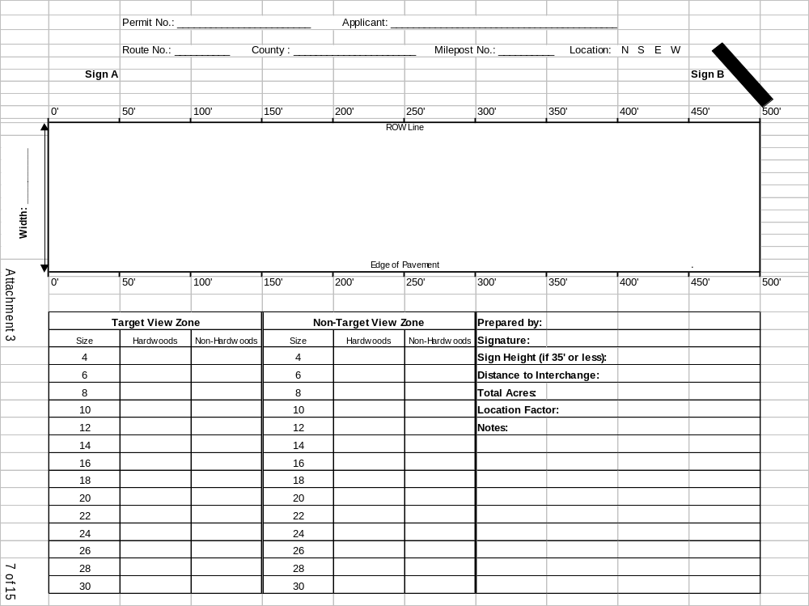.
SIGN DIRECTION A

SIGN DIRECTION B

Instructions for Completing Attachment # 3

- Prior to Completing Attachment #3:
a. Notify the Department a minimum of 48 hours prior to any site visit or fieldwork. (Contact the District Outdoor Advertising Agent to find out who you should notify at the Area Office level)
b. Stake the Sign Viewing Zone and the Target View Zone on site. (See Appendices A-1, A-2, A-3, and A-4 for illustrations.)
- Complete information at top of sheet, being sure to indicate sign location relative to the road. For roads that run generally south to north the sign location would be either east or west. For roads that run generally west to east the sign location would be north or south.
- Circle the sign face direction that applies - A or B.
- The rectangular diagram on Attachment 3 represents a typical 500 foot long Sign Viewing Zone. The 500 foot length of the Sign View Zone is scaled at 1” = 60’. The width is not to scale.
a. Enter width of the distance from the edge of pavement to the ROW line in the space provided on the left side of the rectangular diagram.
b. In the rectangular area, delineate and dimension the Target View Zone that has been staked out onsite. The length of the Target View Zone shall not exceed a 250 foot horizontal parallel distance to a state ROW. (For signs erected on or before April 20, 1998, which are less than 35 feet in height, the Target View Zone may be increased to a maximum 350 feet where all other requirements can be met.)
c. In the rectangular area, delineate and dimension any site features such as bridges, bodies of water, guardrail, walls, kudzu, etc. If another outdoor advertising sign is located closer than 500 feet of your sign face direction, write the word, “SIGN”, above the R.O.W. line at the approximate distance from your sign face.
- For vegetation 4 inches in diameter and greater enter numbers of hardwoods and non-hardwoods in the charts for the Target View Zone and the Non-Target View Zone next to the applicable size. If no vegetation is to be disturbed inside the Non-Target View Zone do not fill in the Non-Target View Zone chart.
a. Trees shall be measured at a height of 6 inches above ground level.
b. Two inch classes are used for tree size, where a four inch tree measures 4.0 to 4.99, a six inch tree measures 5.0 to 6.99, an eight inch tree measures 7.0 to 8.99, etc.
- To determine Density, the Arborist/Forester shall average the number of trees, 4 inches in diameter and greater, in five random 10-foot by 10-foot square plots within the sign viewing zone. This density average will be used in Appendix B-2 to determine Location/Condition of the trees (the Location Factor).
- The preparing arborist’s/forester’s name and signature are required.
- Indicate sign height if the sign is 35 feet in height or less.
- Indicate distance to interchange (if within 1,000 feet of an interchange).
- Indicate total number of acres for entire sign viewing zone (500 feet times the width of the sign viewing zone divided by 43,560 square feet).
- Indicate location factor (as determined in Step 6).
- Include any pertinent notes.

ATTACHMENT #4
Copy of Arborist/Forester Certification

(Attachment #4 to be provided by permitee)

Insert Proof of Certification Here.
ATTACHMENT #5
Copy of Pesticide Applicator License

(Attachment #5 to be provided by permitee)

Insert Proof of Pesticide Certification Here.
ATTACHMENT #6 SUMMARY OF TREE VALUES WORKSHEET
(One worksheet per sign view zone)

HARDWOODS |  |  | (See Attachment # 3 for Existing Tree Counts) |  |  |  |  |  | Totals
Tree Dia. | Basic Value | Location  Factor | Number of trees to be removed |  |  | REMOVAL Value = Basic value x location x number of trees | Number of trees to be pruned | PRUNING Value = Basic value x location x number of trees x 0.25*
4 | $ 95.00 |  |  |  |  | $ - |  | $ -
6 | $ 435.00 |  |  |  |  | $ - |  | $ -
8 | $ 945.00 |  |  |  |  | $ - |  | $ -
10 | $ 1,625.00 |  | N/A |  |  | N/A |  | $ -
12 | $ 2,030.00 |  | N/A |  |  | N/A |  | $ -
14 | $ 2,965.00 |  | N/A |  |  | N/A |  | $ -
16 | $ 4,070.00 |  | N/A |  |  | N/A |  | $ -
18 | $ 5,345.00 |  | N/A |  |  | N/A |  | $ -
20 | $ 6,790.00 |  | N/A |  |  | N/A |  | $ -
22 | $ 8,405.00 |  | N/A |  |  | N/A |  | $ -
24 | $ 10,190.00 |  | N/A |  |  | N/A |  | $ -
26 | $ 12,145.00 |  | N/A |  |  | N/A |  | $ -
28 | $ 14,270.00 |  | N/A |  |  | N/A |  | $ -
30 | $ 16,565.00 |  | N/A |  |  | N/A |  | $ - | Hardwood Total
 |  |  | Total |  |  | $ - | + | $ - | $ -
PINES/NON-HARDWOODS |  |  | (See Attachment # 3 for Existing Tree Counts)
Tree Dia. | Basic Value | Location¹  Factor | Number of trees to be removed |  |  | REMOVAL Value= Basic value x location x number of trees | Number of trees to be pruned | PRUNING Value = Basic value x location x number of trees x 0.25*
4 | $ 65.00 |  |  |  |  | $ - |  | $ -
6 | $ 335.00 |  |  |  |  | $ - |  | $ -
8 | $ 845.00 |  |  |  |  | $ - |  | $ -
10 | $ 1,525.00 |  |  |  |  | $ - |  | $ -
12 | $ 1,930.00 |  |  |  |  | $ - |  | $ -
14 | $ 2,865.00 |  |  |  |  | $ - |  | $ -
16 | $ 3,970.00 |  |  |  |  | $ - |  | $ -
18 | $ 5,245.00 |  |  |  |  | $ - |  | $ -
20 | $ 6,690.00 |  |  |  |  | $ - |  | $ -
22 | $ 8,305.00 |  |  |  |  | $ - |  | $ -
24 | $ 10,090.00 |  |  |  |  | $ - |  | $ -
26 | $ 12,045.00 |  |  |  |  | $ - |  | $ -
28 | $ 14,170.00 |  |  |  |  | $ - |  | $ - | Pine/non-
30 | $ 16,465.00 |  |  |  |  | $ - |  | $ - | Hardwood Total
 |  |  | Total |  |  | $ - | + | $ | $ -
Palm Relocation - |  | $400 x |  |  |  | (quantity relocated) | ----------------------------------- |  | $ -
Vegetation Management Work on the R/W ---------------- Minimum initial flat fee of $500  (Minimum fee includes all removal/pruning of vegetation less than 4” in diameter.) |  |  |  |  |  |  |  |  | $ 500.00
 |  |  |  |  |  |  | Total Contributory Value |  | $ -

ATTACHMENT #7
1

Stocking Points Chart
(Use only for proposals to remove Pine trees  12” caliper within the Non-Target View Zone)
EXISTING |  |  |  |  |  |  | PROPOSED
Diameter  Outside Bark  (in) | × | Units  (converts to ft²) | × | No. of Existing  Trees | = | Existing  Tree Points  (ft²) | Diameter  Outside Bark  (in) | × | Units  (converts to ft²) | × | No. of  Trees to be Removed | = | Proposed Tree Points  (ft²)
12 |  | 0.6 |  |  |  |  | 12 |  | 0.6
14 |  | 0.8 |  |  |  |  | 14 |  | 0.8
16 |  | 1.1 |  |  |  |  | 16 |  | 1.1
18 |  | 1.4 |  |  |  |  | 18 |  | 1.4
20 |  | 1.8 |  |  |  |  | 20 |  | 1.8
22 |  | 2.2 |  |  |  |  | 22 |  | 2.2
24 |  | 3.1 |  |  |  |  | 24 |  | 3.1
26 |  | 3.7 |  |  |  |  | 26 |  | 3.7
28 |  | 4.3 |  |  |  |  | 28 |  | 4.3
30 |  | 4.9 |  |  |  |  | 30 |  | 4.9
32 |  | 5.6 |  |  |  |  | 32 |  | 5.6
34 |  | 6.3 |  |  |  |  | 34 |  | 6.3
Total Existing Tree Stocking Points |  |  |  |  | 2 |  | Total Proposed Removal Stocking Points
5

3
_________________ × 50 ft²/acre* = __________________
No. Acres of the Site *Minimum stocking points/acre required Minimum Points
(the entire viewing zone) for ≥ 12” Pine tree removal in the For Adequate Stocking (ft²)
Non-Target View Zone

4
_________ - ___________ = _____________
Total Existing (minus) Minimum Points Removal Stocking
Stocking Points (ft²) For Adequate Stocking (ft²) Points Available (ft²)

6
__________ - ______________ = ____________
Total Proposed (minus) Removal Stocking MUST BE ≥ 0
Removal Stocking Points (ft²) Points Available (ft²)

STEP 1: List, by size in the chart above, the number of existing Pine trees ≥ 12” in diameter in the Non-Target View Zone.

STEP 2: Multiply the number of existing Pine trees in the Non-Target View Zone ≥ 12” in diameter times the unit conversion factors in the chart to determine the Existing Tree Stocking Points (basal area in ft²) for each size. Add the Existing Tree Points for all sizes to determine the Total Existing Tree Stocking Points.

STEP 3: Multiply the number of acres on the entire site times the 50 ft2/acre standard to determine the Minimum Tree Points for Adequate Stocking for the site. The number of acres for the entire site should be listed in Attachment #3.

STEP 4: Subtract the ‘Minimum Points for Adequate Stocking’ (Step 3 Total) from the ‘Total Existing Tree Stocking Points’ (Step 2 Total) to determine the Stocking Points Available for Pine Tree Removal in the Non-Target View Zone. (If this number is ≤ 0, then no Pine trees ≥ 12” in diameter may be removed. Omit Steps 5 and 6.)

STEP 5: If the Stocking Points Available for Tree Removal are > 0 (Step 4 Total), multiply the number of Pine trees ≥ 12” in diameter proposed for removal times the unit conversion factors in the chart to determine the Proposed Tree Removal Stocking Points for each tree size. Add the Proposed Tree Points for all the sizes to determine the total Proposed Removal Stocking Points.

STEP 6: Subtract the Removal Stocking Points Available (Step 4 total) from the total Proposed Removal Stocking Points (Step 5 total). The result MUST BE ≥ 0 for removal of Pine trees ≥ 12” in diameter in the Non-Target View Zone.
GEORGIA DEPARTMENT OF TRANSPORTATION
ANNUAL WORK SCHEDULE FOR
VEGETATION MANAGEMENT AT OUTDOOR ADVERTISING SIGNS

ATTACHMENT #8
_________________________________________________________________________________________________________

SECTION A:

SCHEDULE IS HEREBY MADE TO THE GEORGIA DEPARTMENT OF TRANSPORTATION BY:

APPLICANT NAME & ADDRESS: _________________________________________________________________________

PHONE #: ____________________ FACSIMILE #: ____________________ EMAIL: ________________________________

SIGN PERMIT #:_______________________ DISTRICT: ______ COUNTY: _____________________ STATE ROUTE NUMBER___________

DESCRIPTION OF OUTDOOR SIGN _______________________________________________________________________________________

NEAREST MILE MARKER:________ PROPOSED START DATE: ______/______/____________

SECTION B – INITIAL VEGETATION MANAGEMENT SCHEDULE:

CHECK THE APPROPRIATE BOX OR BOXES FOR EACH MAINTENANCE ACTIVITY THAT THIS SCHEDULE APPLIES TO:

GRASSING CHEMICAL CONTROL PRUNING & TREE REMOVAL

1. GRASSING:
LIST THE TYPE OF GRASS, INSTALLATION AND MAINTENANCE METHODS PROPOSED, AND CONDITION/TREATMENT OF SITE AT COMPLETION (SECTION D).

2. CHEMICAL CONTROL:
IF CHEMICALS WILL BE USED ON THE RIGHT OF WAY, LIST THE CHEMICAL NAME(S), RATE(S) OF APPLICATION, METHOD(S) OF APPLICATION, AND REASON(S) FOR THE PROPOSAL OF CHEMICAL CONTROL (SECTION D).

3. PRUNING AND TREE REMOVAL:
LIST THE EXTENT OF PRUNING/TREE REMOVAL OF VEGETATION LESS THAN 4” IN DIAMETER, METHOD OF DISPOSAL OF DEBRIS, EQUIPMENT TO BE USED, METHOD OF TREE PROTECTION FOR TREES TO REMAIN, METHOD OF ACCESS FOR WORK WITHIN THE VIEWING ZONE. DESIGNATE WHERE PRUNING/TREE REMOVAL WILL OCCUR WITHIN THE SIGN VIEWING AREA. INDICATE THE METHOD OF IDENTIFYING TREES TO BE REMOVED/TREES TO REMAIN. (SECTION D).

SECTION C – ANNUAL VEGETATION MAINTENANCE SCHEDULE (For renewals only):

VEGETATION MANAGEMENT PERMIT #___________________

CHECK THE APPROPRIATE BOX OR BOXES FOR EACH MAINTENANCE ACTIVITY THAT THIS SCHEDULE APPLIES TO:

CHEMICAL CONTROL MOWING & TRIMMING

1. CHEMICAL CONTROL:
IF CHEMICALS WILL BE USED ON THE RIGHT OF WAY, LIST THE CHEMICAL NAME(S), RATE(S) OF APPLICATION, METHOD(S) OF APPLICATION, AND REASON(S) FOR THE PROPOSAL OF CHEMICAL CONTROL (SECTION D).

2. MOWING AND TRIMMING:
LIST THE PROPOSED MOWING/TRIMMING ACTIVITIES FOR VEGETATION LESS THAN 4’ IN DIAMETER, METHOD OF DISPOSAL OF DEBRIS, AND EQUIPMENT TO BE USED (SECTION D).
GEORGIA DEPARTMENT OF TRANSPORTATION
ANNUAL WORK SCHEDULE FOR
VEGETATION MANAGEMENT AT OUTDOOR ADVERTISING SIGNS
GENERAL PROVISIONS

FOR ALL SITES, THE OUTDOOR SIGN VEGETATIVE MANAGEMENT REQUIREMENTS IN THE CURRENT EDITION OF THE VEGETATION MANAGEMENT AT OUTDOOR ADVERTISING SIGNS MANUAL OF GUIDANCE ON FILE IN THE GENERAL OFFICE OF THE DEPARTMENT OF TRANSPORTATION, IS MADE A PART HEREOF BY REFERENCE, AND ALL PROVISIONS SHOWN IN THE APPENDICES, OR ATTACHED HERETO, DURING THE MAINTENANCE OF THE PERMITEE’S VIEWING ZONE WITHIN THE RIGHT OF WAY.

AT ALL TIMES, THE PERMITEE SHALL INSTALL AND MAINTAIN TRAFFIC CONTROL IN ACCORDANCE WITH THE DIAGRAM IN APPENDIX D – VM ACTIVITY TRAFFIC CONTROL OR THE MANUAL ON UNIFORM TRAFFIC CONTROL DEVICES (MUTCD), CURRENT EDITION. FOR APPLICATIONS NOT COVERED IN THESE REFERENCES, A DETAILED TRAFFIC CONTROL PLAN SHALL BE SUBMITTED TO THE DEPARTMENT FOR REVIEW. A TRAFFIC CONTROL PLAN IS REQUIRED FOR WORK INVOLVING LANE CLOSURE(S).

ACCESS TO THE SITE SHALL BE FROM THE MAINLINE.

THE OUTDOOR SIGN VEGETATIVE MANAGEMENT PERMITEE MAY ONLY USE THOSE PESTICIDES ON THE RIGHT OF WAY WHICH THE DEPARTMENT HAS APPROVED ON THE OUTDOOR SIGN VEGETATIVE MANAGEMENT PERMITEE’S VEGETATIVE MAINTENANCE SCHEDULE.

IT IS THE OUTDOOR SIGN VEGETATIVE MANAGEMENT PERMITEE’S RESPONSIBILITY TO VERIFY THE LIMITS OF RIGHT OF WAY FOR MAINTENANCE OF VIEWING ZONE OF THE PERMITEE’S SIGN AUTHORIZED HEREBY.

NO INHERENT OR RETAINED RIGHT OR PRIVILEGE OF ANY ABUTTING PROPERTY OWNER IS AFFECTED BY THIS SCHEDULE, NOR IS THE
DEPARTMENT RESPONSIBLE FOR ANY CLAIM WHICH MAY DEVELOP BETWEEN THE OUTDOOR SIGN VEGETATIVE MANAGEMENT PERMITEE AND ANY PROPERTY OWNER CONCERNING USE OF THE RIGHT OF WAY.

THE OUTDOOR SIGN VEGETATIVE MANAGEMENT PERMITEE SHALL GIVE THE DEPARTMENT A MINIMUM OF 48 HOURS NOTICE PRIOR TO BEGINNING ANY WORK UNDER THIS SCHEDULE.

THE PROVISIONS OF THIS SCHEDULE ARE REGULATORY AND NOT CONTRACTUAL. NO INTEREST OR RIGHT OF AN OUTDOOR SIGN VEGETATIVE MANAGEMENT PERMITEE GRANTED BY THIS SCHEDULE MAY BE TRANSFERRED TO ANOTHER EXCEPT BY WRITTEN CONSENT OF THE DEPARTMENT. THIS VEGETATIVE MAINTENANCE SCHEDULE MAY BE REVOKED AT THE PLEASURE OF THE DEPARTMENT UPON WRITTEN NOTICE TO THE OUTDOOR SIGN VEGETATIVE MANAGEMENT PERMITEE.

EROSION CONTROL SHALL BE AS DIRECTED BY GDOT OR PER NATIONAL POLLUTANT DISCHARGE ELIMINATION SYSTEM (NPDES PHASE 2) STANDARDS AND BEST MANAGEMENT PRACTICES (BMPS) CONSISTENT WITH THE STATE SOIL AND WATER CONSERVATION COMMISSION’S MANUAL FOR EROSION AND SEDIMENT CONTROL IN GEORGIA. AN EROSION AND SEDIMENTATION PLAN IS NOT REQUIRED UNLESS THE VIEW ZONE IS IN OR ADJACENT TO AN ENVIRONMENTALLY SENSITIVE AREA SUCH AS A STREAM OR WETLAND OR AS DIRECTED BY THE AREA PERMIT INSPECTOR. VEGETATION MANAGEMENT (VM) ACTIVITY IS CONSIDERED CONSTRUCTION ACTIVITY AND NOT SILVICULTURE FOR THE PURPOSES OF WORK ON THE GDOT R/W.

A VEGETATION MANAGEMENT PERMIT MUST BE DISPLAYED IN A LOCATION CLEARLY VISIBLE FROM THE NEAREST TRAVEL LANE DURING ANY VEGETATION MANAGEMENT ACTIVITIES.
SECTION D: (FOR RENEWALS, COMPLETE STATEMENTS 8 THROUGH 11 ONLY.)
- TYPE OF GRASS _____________________________________________________________________________________
INSTALLATION AND MAINTENANCE METHODS_______________________________________________
- CONDITION/TREATMENT OF SITE AT COMPLETION __________________________________________________
- EXTENT OF PRUNING/TREE REMOVAL _______________________________________________________________
- METHOD OF TREE PROTECTION _____________________________________________________________________
- METHOD OF ACCESS WITHIN THE VIEWING ZONE ____________________________________________________
- WHERE PRUNING/TREE REMOVAL WILL OCCUR Inside Target View Zone Outside Target View Zone
- METHOD TO ID TREES TO BE REMOVED/TREES TO REMAIN ___________________________________________
- CHEMICALS to BE USED ______________________________________________________________________________
RATE(S) OF APPLICATION _____________________________________________________________________
METHOD(S) OF APPLICATION _________________________________________________________________
REASON(S) FOR THE PROPOSAL OF CHEMICAL CONTROL _____________________________________
- METHOD OF DISPOSAL OF DEBRIS ____________________________________________________________________
- EQUIPMENT TO BE USED _____________________________________________________________________________
- PROPOSED MOWING/TRIMMING ACTIVITIES__________________________________________________________
GEORGIA DEPARTMENT OF TRANSPORTATION
ANNUAL WORK SCHEDULE FOR
VEGETATION MANAGEMENT AT OUTDOOR ADVERTISING SIGNS

SECTION E:

I HAVE READ AND COMPREHEND THE VEGETATION MANAGEMENT SECTION OF THE DEPARTMENT’S VEGETATION MANAGEMENT AT OUTDOOR ADVERTISING SIGNS MANUAL OF GUIDANCE, CURRENT EDITION.

Permit requested this ______day of _____________ 20___

by: ___________________________________________________\_____________________________________________
(Applicant Signature) (Applicant’s Printed or Typed Name)

___________________________________________________________________
(Applicant’s Title)

WITNESS TO SIGNATURE:

_______________________________________________________\_________________________________________
(Signature) (Print or Type Name)

COMMENTS
______________________________________________________________________________
______________________________________________________________________________
______________________________________________________________________________
______________________________________________________________________________
______________________________________________________________________________
______________________________________________________________________________
______________________________________________________________________________
______________________________________________________________________________
______________________________________________________________________________
______________________________________________________________________________
______________________________________________________________________________
______________________________________________________________________________
______________________________________________________________________________
______________________________________________________________________________

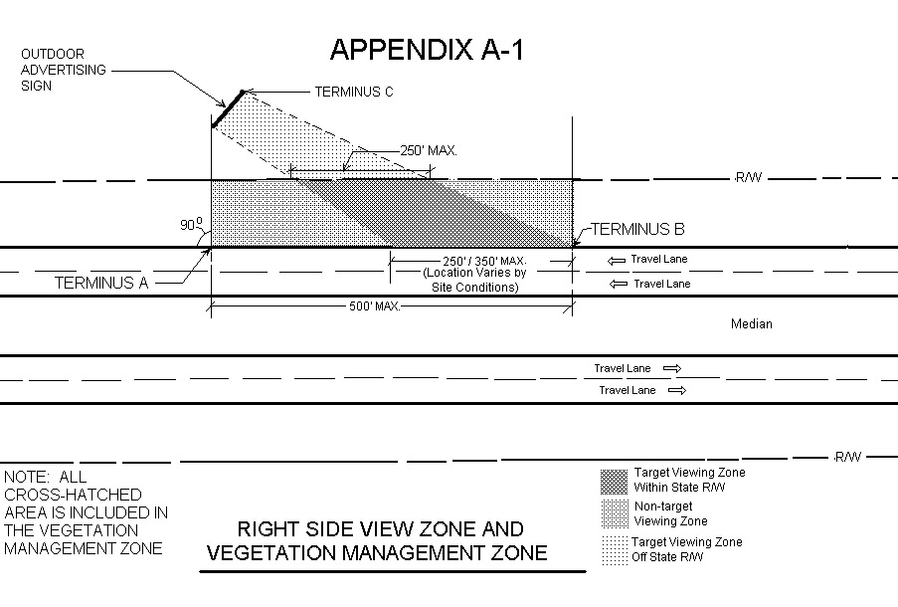
A - 1
Appendix A - 1

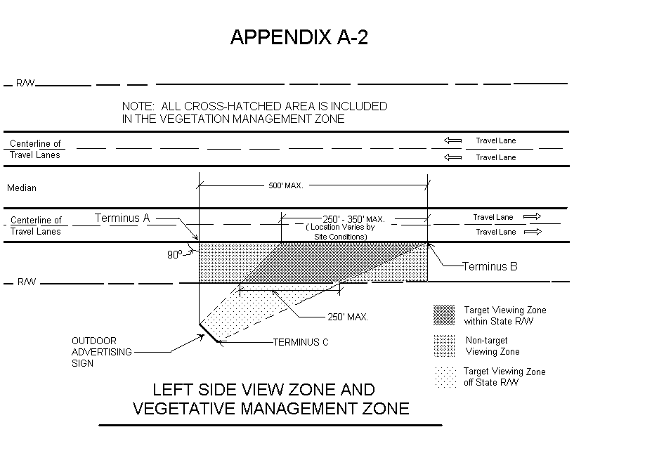
A - 2
Appendix A - 2
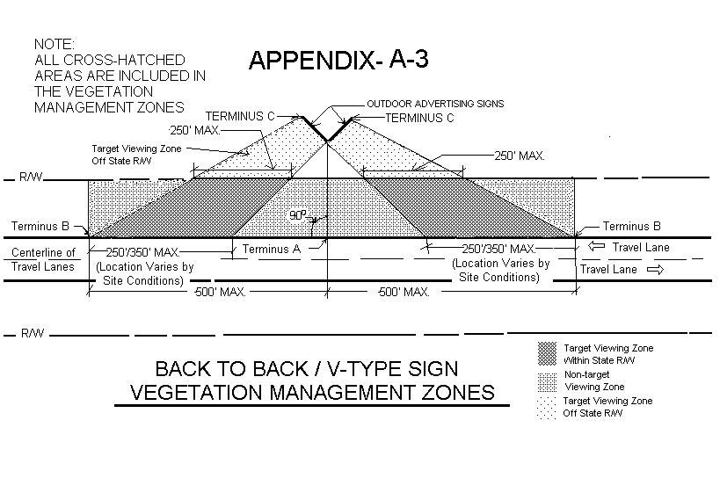
A - 3
Appendix A - 3

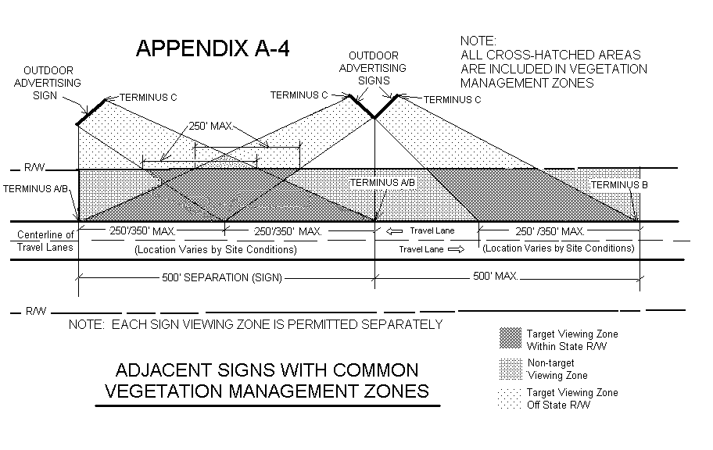
A - 4
Appendix A - 4
Appendix B-1
Basic Value

Tree Diameter versus Species
 |  | Species
 |  | Hardwood | Pine
 | 4 | $ 95.00 | $ 65.00
 | 6 | $ 435.00 | $ 335.00
 | 8 | $ 945.00 | $ 845.00
Tree | 10 | $ 1,625.00 | $ 1,525.00
Diameter | 12 | $ 2,030.00 | $ 1,930.00
(inches) | 14 | $ 2,965.00 | $ 2,865.00
 | 16 | $ 4,070.00 | $ 3,970.00
 | 18 | $ 5,345.00 | $ 5,245.00
 | 20 | $ 6,790.00 | $ 6,690.00
 | 22 | $ 8,405.00 | $ 8,305.00
 | 24 | $10,190.00 | $ 10,090.00
 | 26 | $12,145.00 | $ 12,045.00
 | 28 | $14,270.00 | $ 14,170.00
 | 30 | $16,565.00 | $ 16,465.00

1. The Trunk Formula Method is used to determine the appraised value for removal and pruning of hardwood and non-hardwood trees on the right of way. The Trunk Formula Method is established in the International Society of Arboriculture publication, Guide for Plant Appraisal, latest edition. The Formula is:
APPRAISED VALUE = Basic Value x Condition x Location

2. Appendix B-1: Establishes the Basic Value for the above formula. The formula to determine the Basic Value using a standard 4” caliper replacement tree is:

BASIC VALUE = {Replacement Cost + [Basic Price x (Trunk Area of the Appraised Tree - Trunk Area of the Replacement Tree)]} x Species Rating

A. Replacement Cost for a 4” caliper tree = Tree Cost ($85 per caliper inch of the replacement tree or $340) + Freight (15% of the $340 tree cost or $51) + planting cost ($25 per caliper inch of the replacement tree or $100) for a total replacement cost of $491.00.
B. Basic Price = Replacement Tree Cost ($85 per caliper inch or $340) / Trunk Area of the Replacement tree (12.56 square inches) = $27.07 per square inch.
C. Trunk Area of the Appraised Tree = 0.785 (π/4) x diameter² (caliper size, measured 6 inches above ground, of the existing tree)
D. Trunk Area of the Replacement Tree = 0.785 x 4² = 12.56 sq. in.
E. Species Rating = 50% for hardwoods and 30% for non-hardwoods. The Southeastern United States Tree Species Rating Guide, published by the International Society of Arboriculture, was used to determine the species ratings. The percent ratings were derived by averaging the species values rating of hardwoods and non-hardwoods found on GDOT rights of way.

3. See Appendix B-2 for Condition and Location tables.
Appendix B-2
Condition and Location

Condition/Location Factor

Condition/Density | Low Density  Less than 1 | Medium  Density  1 to 3 | High Density  Over 3
Location  Outside MPO | 0.20 | 0.10 | 0.04
Location  Inside MPO | 0.33 | 0.18 | 0.07

1. The Trunk Formula Method is used to determine the appraised value for removal and pruning of hardwood and non-hardwood trees on the right of way. The Trunk Formula Method is established in the International Society of Arboriculture publication, Guide for Plant Appraisal, latest edition. The Formula is:
APPRAISED VALUE = Basic Value x Condition x Location

2. Appendix B-2: Combines the Condition rating and Location rating, for the above formula, into one chart. The Condition Ratings were multiplied by the Location Ratings for the six different scenarios shown in the chart. The different scenarios consider:
A. The average low, medium, and high density of trees (4 inches in caliper and greater) per 100 square feet, in a sign viewing zone. The applicant is required to average the number of trees in five random 10-foot by 10-foot square plots within the sign viewing zone.
B. The Urban or Rural location of the sign viewing zone. Urban locations are defined as being in Georgia’s Metropolitan Planning Organizations (Inside MPO) and Rural locations are defined as areas outside of Georgia’s Metropolitan Organizations (Outside MPO).
C. Condition Rating = A percentage based on tree health and structure. It varies by the average number of trees taken from 5 random 100 square foot plots in the sign viewing zone. As more trees grow in the same area, each tree is less healthy and less structurally sound. The condition ratings were broken into three densities:
1. Low Density (less than 1 tree per 100 square feet) = 65%
2. Medium Density (1 to 3 trees per 100 square feet) = 50%
3. High Density (Over 3 trees per 100 square feet) = 35%
D. Location Rating = A percentage based on the quality of the setting, the trees’ contribution to the value of the setting, and the average number of trees in the 5 random 100 square foot plots. This variation is due to the fact that as more trees are in the same location, each individual tree has less impact on the total landscape value for the area. The Location Rating also has a direct relationship with the value and location of the land. The location ratings are:
1. Low Density (less than 1 tree per 100 s.f.) = 50% for Inside MPO and 30% for Outside MPO.
2. Medium Density (1 to 3 trees per 100 s.f.) = 35% for Inside MPO and 20% for Outside MPO.
3. High Density (Over 3 trees per 100 s.f.) = 20% for Inside MPO and 10% for Outside MPO.
E. The Percentages in 2.C – Condition Rating are multiplied with the percentages in 2.D – Location Rating and totaled in the Appendix B-2 Chart above.

Use the average of the five random (10’ by 10’) plots to determine whether to use the
Low, Medium, or High number in the chart. Determine if the sign viewing zone is located inside/outside of an MPO. Use the factor that corresponds to the appropriate Location and Density found in the chart above as the multiplier in the LOCATION FACTOR column found in ATTACHMENT #6 – SUMMARY OF TREE VALUES WORKSHEET.
APPENDIX C

SUMMARY OF FEES

Vegetation Management Review and Permit Fee $400.00
Check #1 for the Permit Fee is to be paid to The Georgia Department Of Transportation and remitted with initial application submittal. Permit fees are non-refundable.

Total Contribution (See Attachment #6) $______ (varies)
Check #2 for the Contributory Value is to be paid to The Georgia Department Of Transportation. Check #2 is not remitted with the initial application submittal. It is remitted with final signature and final permit application package submittal. This contribution check is the amount equal to or greater than the value of all affected vegetation. There is a minimum flat fee of $500.00 for any and all work on the Right of Way. Included in this flat fee is any and all work (pruning/removal) which affects vegetation (trees/shrubs) under 4” in diameter. The permittee’s contribution will be designated to a fund for the beautification of the State Right of Way. The Contribution check is non-refundable.

Annual Permit Renewal Fee $ 50.00
Check #3 for the Renewal Fee is to be paid to The Georgia Department Of Transportation and remitted with renewal application submittal.

ADDITIONAL REQUIREMENTS:

- A Performance Bond in the amount equal to the Work and affected vegetation value or $3,500.00 whichever is greater.

- Sureties Bond equal to the Performance Bond amount

- Insurance Liabilities in the amount of $1,000,000 per Person, $3,000,000 per Occurrence and workers compensation insurance in the amount of $ 500,000 each accident, $ 500,000 each employee, and $500,000 policy limit.

- Any damages incurred during the prosecution of the work and maintenance period. Additive fees are established in Appendix B.

A - 4

APPENDIX D - VM ACTIVITY TRAFFIC CONTROL DIAGRAM

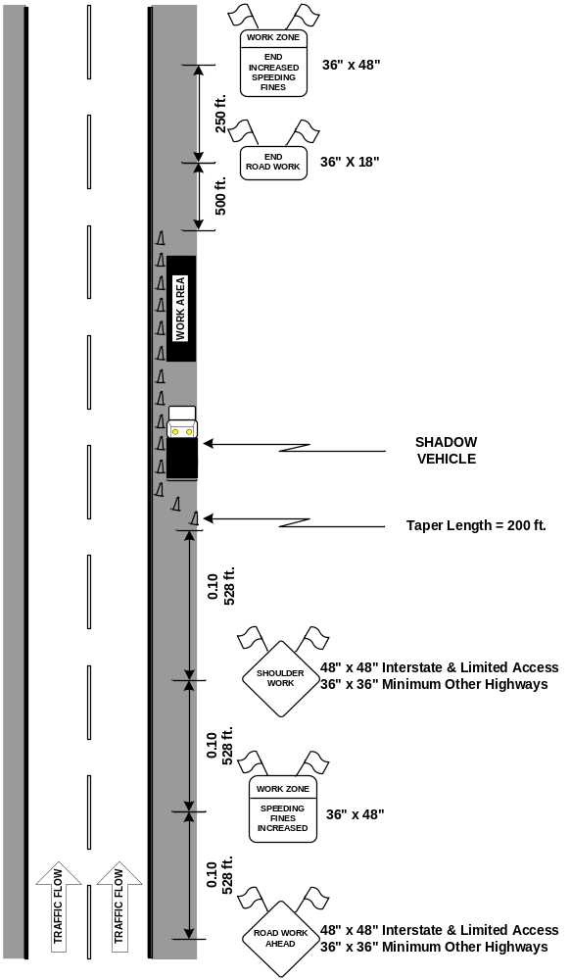
Guidance:

- All lanes should be a minimum of 3 m (10 ft) in width as measured to the near face of the channelizing devices.

Option:

- For the work, use on low-volume, low-speed roadways with vehicular traffic that does not include longer and wider heavy commercial vehicles, a minimum lane width of (9 ft) may be used.
- Where the opposite shoulder is suitable for carrying vehicular traffic and of adequate width, lanes may be shifted by use of closely spaced channelizing devices, provided that the minimum lane width of (10 ft) is maintained.
- Additional advance warning may be appropriate, such as a ROAD NARROWS sign.
- Temporary traffic barriers may be used along the work space.
- The shadow vehicle may be omitted if a taper and channelizing devices are used.
- A truck-mounted attenuator may be used on the shadow vehicle.
- For the work, the taper and channelizing devices may be omitted if a shadow vehicle with activated high-intensity rotating, flashing, oscillating, or strobe lights is used.
- Vehicle hazard warning signals may be used to supplement high-intensity rotating, flashing, oscillating, or strobe lights.

Standard:
- Vehicle hazard warning signals shall not be used instead of the vehicle’s high-intensity rotating, flashing, oscillating, or strobe lights.
- A Traffic Control Plan will be required when any work requires lane(s) closure(s).

- Stakes shall be a minimum 36 inches (900 mm) wooden stake topped with lime green flagging tape. Install stakes for the Target View Zone at a maximum of 20 feet on center. If the stakes are damaged at any time, re-establish the stake line immediately before clearing operations resume. - Use flagging tape to depict vegetative removal identification. - Place protective barriers around the drip line of trees to be retained prior to the field review.
See Appendix B-2 for Location Factor * 0.25 is the factor used for removing a maximum of 25% of a tree’s leaf-bearing crown.

