TOPPS 5240-1

Work Zone Safety and Mobility Policy
Georgia Department of Transportation

List of Acronyms

AASHTO – American Association of State Highway and Transportation Officials
ADT – Average Daily Traffic
ATMS – Advanced Traffic Management System
ATSSA – American Traffic Safety Services Association
CBD – Commercial Business District
CFR – Code of Federal Regulations
CMAQ – Congestion Mitigation and Air Quality
FFPR-Final Field Plan Review
FHWA – Federal Highway Administration
FOS-Full Oversight
GDOT – Georgia Department of Transportation
HERO – Highway Emergency Response Operators
IM – Interstate Maintenance
ITS – Intelligent Transportation Systems
LOS – Level of Service
MUTCD – Manual on Uniform Traffic Control Devices
NEPA-National Environmental Policy Act of 1969
NHS – National Highway System
PDP- Plan Development Process
PFPR-Preliminary Field Plan Review
PI – Public Information
PM- Project Manager
PS&Es – Plans, Specifications, and Estimates
STP – Surface Transportation
TCP – Traffic Control Plan
TMA – Transportation Management Area
TMC – Transportation Management Center
TMP – Transportation Management Plan
TO – Transportation Operations
TTC – Temporary Traffic Control
TOPPS – Transportation Online Policy & Procedure System
WTCS – Worksite Traffic Control Supervisor
Table of Contents
I. Introduction 5
II. Georgia Work Zone Safety and Mobility Policy 5
A. Goals and Objectives 6
B. Specific Policy Provisions for Application During Project Delivery 7
1. Parameters that May Affect Classification of Projects 7
2. Work Zone Performance Standards/Requirements 8
3. Policy Guidance and Agency Processes and Procedures 8
4. Definitions 10
5. Stakeholder and Team and Information 13
6. Roles and Responsibilities 13
7. Contact Persons 13
8. Policy and Exemption Criteria and Process 13
III. State Level Process and Procedures 14
A. Work Zone Assessment and Management – Procedures and/or Criteria… 14
1. For Identifying And Categorizing Significant Projects 14
2. Vary In The Level Of Intensity Based On The Complexity Of Project 14
3. That Trigger Consideration of Various Project Options And Management Strategies 14
4. For Developing TMPs Based Upon Certain Categories Or Intensity Of Impacts 14
5. For Monitoring TMP And Work Zone Performance During Construction 14
6. For Post-Construction Performance Assessment For Process And Procedural Improvement 14
B. Use of Work Zone Data 15
1. Project Level 15
2. Traffic Operations 15
3. Maintaining Data and Information Resources 15
C. Work Zone Related Training 15
1. Identification of Target Audience 15
2. Identification of Existing Training that Meets the Needs of the Target Audience 15
3. Development and Implementation of Training Programs for Training GDOT Employees 15
4. Identification Of Typical Refresher Course Requirements For The Target Audience 15
5. Record-Keeping And Facilitation Of Training Updates 15
6. Contractor, Consultant, And Other Private Sector Involvement 15
D. Process Reviews 15
1. Assemble Multi-Disciplinary Team 15
2. Develop Review Objectives 16
3. Determine Review Methods 16
4. Conduct Review 16
5. Analyze And Interpret Results 16
6. Develop Inferences, Recommendations, And Lessons Learned 16
7. Prioritize Recommendations And Lessons Learned 16
8. Apply Recommendations And Lessons Learned 16
IV. Project Level Procedures 16
A. Significant Projects 16
B. Exception Process 16
1. Qualifications for Exception as a Significant Project 16
2. Process for Requesting an Exception as a Significant Project 17
3. Blanket Exceptions for Significant Projects 17
4. Blanket Exception Candidates (list is not all inclusive) 17
C. Transportation Management Plans (TMPs) 18
1. TMP Components 18
2. TMP Development 20
3. Potential TMP Components 24
Appendix A – TMP Potential Components Checklist 25
Appendix B – Example Work Zone Management Strategies Matrix 27
Appendix C – Significant Project Flowchart 49
Appendix D – Roles & Responsibilities Chart 50
Appendix E – Links to Documents Available Online 55
Appendix F - Final Rule on Temporary Traffic Control Devices 56

Work Zone Safety and Mobility Policy
Georgia Department of Transportation

- Introduction

In an effort to develop an agency culture committed to providing reasonably safe work zones for all workers and road users while considering mobility and access, the Georgia Department of Transportation (GDOT) has developed this Work Zone Safety and Mobility Policy. The 2004 Federal Highway Administration’s Work Zone Safety and Mobility Rule Title 23 CFR 630 Subpart J initiated the development of this policy. Requirements of this updated final rule promote the development of a state work zone safety and mobility policy to support systematic consideration and management of work zone impacts related to safety, mobility, operations, and training.

- Georgia Work Zone Safety and Mobility Policy

The Georgia Department of Transportation’s mission is to provide a safe, efficient and sustainable transportation system through dedicated teamwork and responsible leadership supporting economic development, environmental sensitivity and improved quality of life and to consider and manage work zone impacts.
The intent of this policy is to standardize a Department-wide process for project evaluation and implementation. This standard process will create more uniform procedures to advocate innovative thinking in work zone planning, design, and management, to consider alternative/innovative design, construction, contracting, and transportation management strategies on Georgia’s Transportation network for Federal-aid highway projects. These procedures will:

- Expand planning beyond the project itself to include the surrounding road network
- Consider work zone strategies when choosing feasible alternatives in the planning process
- Expand work zone management beyond traffic safety and traffic control to address mobility and operations issues
- Promote innovative thinking in work zone planning, design and management
- Provide a way to continuously assess and improve work zone strategies, practices and procedures
Specific components of this policy include a Policy Statement, Goals and Objectives, and Policy Provisions for application during planning, design and construction. The policies provisions are used in evaluate and categorize projects as a systematic process to accomplish the Goals and Objectives for each project. Appropriate work zone strategies may be applied to projects to create more efficient and effective work zones based on the impacts each project will have on the road users, businesses and local communities during construction.

This policy applies to all Federal-aid highway projects. Local agencies implementing Federal-aid highway projects must follow these policies and procedures. This policy does not apply to projects that are authorized and constructed through the Department’s State Aid Office. Any state funded project which may be eligible for Federal funding at a future date should be considered applicable under the provisions of this policy.
Information to support this policy, such as state level and project level procedures to achieve the Goals and Objectives, criteria for evaluating a project, procedures for identifying significant projects, exceptions, procedures for selecting Transportation Management Plan (TMP) components, procedures for evaluation, and roles and responsibilities for GDOT staff are included. Committee member and stakeholder information is included in Section II (B) (5). Links to related documents are included throughout this document and are summarized in Appendix E.

  - Goals and Objectives

The goals and objectives of the GDOT Work Zone Safety and Mobility Policy are as follows.

- Goal – Implement requirements of the Work Zone Safety and Mobility Policy (Title 23 CFR 630 Subpart J)

Objective – Develop work zone policies and procedures in collaboration with other GDOT offices.

- Goal – Develop an agency culture committed to the Work Zone Safety and Mobility Policy.

Objective-Provide training and informational sessions to all offices involved.

- Goal – Provide reasonably safe work zones for all workers and road users.

Objective – Consider ITS on appropriate projects, monitor and maintain work zone devices, consider use of law enforcement and maintain a public information program. (See Appendix F for additional guidance)

- Goal – Consider mobility and access in work zones.

Objective – Advocate innovative thinking in work zone planning, design and management. Provide road users with adequate access to businesses and residences (where applicable) without compromising efficiency and safety of the work zone.

- Goal – Assess and improve work zone strategies, practices and procedures.

Objective – Conduct a bi-annual process review to assess wide scale performance of work zones with the goal of improving work zone processes and procedures, regularly conduct inspections of active construction project work zones, conduct safety inspections/audits as needed to address specific problems that occur and address non-compliance. Participate in the FHWA Work Zone Self Assessment Program.

- Goal – Provide appropriate training pursuant to job related applications.

Objective – GDOT shall provide or make available appropriate training for those persons involved in the development, design, implementation, operation, inspection, enforcement, and effectiveness of the work zone traffic control and the transportation management plan. The requirement for appropriate training may also include GDOT staff responsible for decisions and policies, information officers, law enforcement, incident responders, and designated representatives acting on behalf of the GDOT. Upon passage of a preset amount of time as determined by the GDOT, these persons will participate in periodic training updates to address changes in the highway construction industry. All training will be relevant to the responsibilities of the individuals in relation to implementation of The Policy.

  - Specific Policy Provisions for Application During Project Delivery
    - Parameters that May Affect Classification of Projects
      - Roadway functional classification – e.g., Interstate, expressway, principal arterial, major arterial, minor arterial, collector.
      - Area type – e.g., urban, suburban, rural.
      - Traffic demand and travel characteristics – e.g., lanes affected, average daily traffic (ADT), expected capacity reduction, level of service (LOS).
      - Type of work – e.g., new construction, reconstruction, rehabilitation, maintenance, bridge work, equipment installation/repair.
      - Complexity of work – e.g., duration, length, intensity.
      - Level of traffic interference with construction activity.
      - Roadway classifications (reference Plan Development Process [TOPPS 4050-1] )
        - “Minor Project.” A project that does not require a significant amount of right-of-way and whose environmental analysis can be accomplished with a “Categorical Exclusion.” Examples of projects that are generally considered minor are Bike/Pedestrian projects, Transportation Enhancement (TE) projects and Ride Sharing projects, Transit enhancements, Transportation studies using capital funds, Turn lane, Intersection improvements, Signal projects, Bridge rehabilitation, Bridge replacements, Signage, Lighting, Landscaping, Traffic barriers, Guardrail projects, Recreational trail projects, ITS/ATMS projects less than $1 million, and Maintenance resurfacing projects less than $1 million. These projects will generally not be significant but in certain circumstances may, see significant project flowchart (Appendix C)
        - “Major Project.” A project that significantly changes the function of the facility being improved, or requires the acquisition of significant amounts of right-of-way, or has a significant impact on abutting property, or has significant changes in travel patterns, or has significant social, economic, or environmental effects. A Major Project will not follow “Time Saving Procedures.” A Major Project will require a public hearing or the opportunity for a public hearing and Location and Design Approval. These projects will generally be significant but in certain instances may not, see significant project flowchart.
    - Work Zone Performance Standards/Requirements
      - Sustained work zone impacts refer to work zone-induced deviations from the normal range of transportation system safety and mobility. A significant traffic impact is thirty minutes above normal recurring traffic delay on the existing facility or the delay threshold set by the Department head, whichever is less. The extent of the work zone impacts may vary based on factors such as: road classification, area type (urban, suburban and rural), traffic and travel characteristics, type of work being performed, time of day/night, and complexity of the project. These impacts may extend beyond the physical location of the work zone itself, and may occur on the roadway on which the work is being performed, as well as other highway corridors or other modes of transportation. Project design and construction sequencing should be developed to reduce traffic impacts to the traveling public and apply innovative techniques as applicable to minimize construction time. (Reference Plan Development Process [TOPPS 4050-1]).
    - Policy Guidance and Agency Processes and Procedures
      - Overall policy issues (list is not all inclusive)
The following policies and guidance’s that are already in place should be considered as resources to aid in the implementation of this policy:
- Plan Development Process (TOPPS 4050-1)
- Public Involvement Guidelines (TOPPS 4055-1)
- Construction Manual
- Utility Accommodation, Policy and Standard Manual
- MUTCD
- GDOT Design Manuals
- GDOT Standards and Construction Details
- AASHTO Roadside Design Guide
- AASHTO Green Book
- See Appendix F for additional guidance

      - Work Zone Options
GDOT will consider night work, full-closure, detours, temporary pavements, temporary structures, use of existing shoulders, on-site detours, etc. (See Appendix F for additional guidance)
      - System Planning Strategies
GDOT will consider grouping and sequencing of projects in a corridor; including the costs for work zone management strategies in plans.
      - Design Strategies
GDOT will consider traffic control, choice of materials, use of positive separation, close and detour, temporary structures, temporary pavements [runaround], ramp closures, etc. (See Appendix F for additional guidance)
      - Contracting Strategies
GDOT will consider low bid, design-build, incentive/disincentive contracting, etc.
      - Work Zone Management Strategies
GDOT will consider use of intelligent transportation systems, traveler information & real-time work zone monitoring [Navigator], traffic incident management (HERO Units), GDOT will consider use of enforcement but will consider implementation on a project by project basis. (See Appendix F for additional guidance)
      - Agency Use of Work Zone Reviews, Process Reviews, or Safety Inspections/Audits
The project engineer conducts work zone reviews as outlined in the Departments Construction Manual and specification 150. The contractor’s Worksite Traffic Control Supervisor [WTCS] conducts inspections according to the provisions of Specification 150. Process reviews are conducted on at least every two years in accordance with Title 23 CFR 630 Subpart J
      - Strategy for Use and Collection of Work Zone Data
The policy for the use and collection of data are documented in the Construction Manual General Provisions 150 and Section 17 and as outlined in Appendix D-Responsibilities
      - Criteria for Identifying Significant Projects
Significant Project Flowchart – Appendix C, Plan Development Process [TOPPS 4050-1]
      - Exception Criteria and Procedures for Significant Projects
See IV.A.

      - Procedures for Determining TMP needs for Projects
See IV.B.
    - Definitions
      - Highway Workers. Highway workers include, but are not limited to, personnel of the contractor, subcontractor, DOT, utilities, and law enforcement, performing work within the right-of-way of a transportation facility.
      - Mobility. For work zones, mobility pertains to moving road users efficiently through or around a work zone area with a minimum delay compared to baseline travel when no work zone is present, while not compromising the safety of highway workers or road users. The commonly used performance measures for the assessment of mobility include delay, speed, travel time and queue lengths.
      - Roadside Safety Hardware. What is considered pre-existing roadside safety hardware?

Barriers: guardrail, guiderail, cable barriers, median barriers, Jersey barriers (plus “F” shape, constant slope, vertical, and low profile barriers), barrier terminals, crash cushions, bridge rails, permanent water-filled barriers,* etc.
Breakaway devices: sign supports**, luminaire supports, motorist aid callboxes, (traffic signal poles and utility poles when designed to be breakaway.)
* Water-filled barriers must redirect vehicles per NCHRP Report 350 barrier criteria. Longitudinal channelizing devices are tested like barriers and must meet the same test and evaluation criteria except vehicles may penetrate the line of channelizers. Some water-filled barriers are identical in appearance to longitudinal channelizing devices.
** Ground-mounted sign supports shall be crashworthy if within the clear zone whether they are permanent installations or only there for the duration of a construction project (or phase of a project.)
What would it mean to maintain it "at an equivalent or better level than existed prior to project implementation"?
1) Where existing barriers (guardrail, guiderail, cables, concrete barriers, bridge railings, crash cushions) meet the crashworthiness requirements of NCHRP Report 350 they should be maintained in a crashworthy condition as long as they are in place.
2) If existing barriers do not meet current crashworthiness standards they should be maintained in their existing condition or upgraded during the project.
3) Ideally, where existing barriers must be removed for construction, construction should be staged so that the final barriers are in place prior to removal of the existing. Where this is not possible, there are two key principles when roadside safety hardware is removed for construction: 1) that the now exposed hazard be protected at the NCHRP Report 350 Test Level 2 standard and 2) this be done at the quickest practicable speed or exposure be minimized through construction phasing. A temporary barrier that meets NCHRP Report 350 Test Level 2 (70 kmh) or better should be used where a barrier is warranted. If the project requires removal of the existing barrier construction should be phased so that the roadside/median is left unshielded for the minimum time necessary before temporary or permanent barrier is installed. Barrier removal can be handled in a number of ways depending on duration. For example, if approach guardrail at a bridge abutment/pier is removed it should immediately (within hours) be mitigated by the use of an impact attenuator or other methods. However, in the case of replacement of linear guardrail removed due to paving, the resetting operation could be longer (days), but the work should be done in a staged manner to minimize exposure and mitigated (e.g., through warning signs, channelizers, temporary attenuators or crash cushions). A truck-with-TMA may be used where there are many linear feet of barrier to be removed/installed and the raw end of the barrier is in a different location every day. If the situation is to be in any one place for longer than 48 hours then a work zone crash cushion should be installed.
Keep in mind that new barriers generally should be installed beginning with the leading end terminal and proceeding in the direction of traffic. This ensures that there are not any exposed/blunt ends facing oncoming traffic. Installation sequencing may be adjusted based on project conditions.
      - Significant project. A significant project is one that, alone or in combination with other concurrent projects nearby is anticipated to cause sustained work zone impacts that are greater than what is considered tolerable based on agency policy and engineering judgment. All Interstate system projects within the boundaries of a designated Transportation Management Area (TMA) that occupy a location for more than three days with either intermittent or continuous lane closures shall be considered as significant projects.
      - TMA. A Transportation Management Area is an urbanized area with a population of more than 200,000 people. There are 5 TMAs in Georgia.
      - TMP. A Transportation Management Plan is comprised of a set of coordinated strategies to manage project work zone impacts and a description of how these strategies will be used to manage the work zone impacts of a project. The scope, content, and level of detail of a TMP may vary based on the anticipated work zone impacts of the project. The possible components of a TMP are TTC, TO, and PI. A TTC plan describes temporary traffic control measures and devices to be used for facilitating road users through a work zone or an incident area. The TTC plan shall either be a reference to specific TTC elements in the MUTCD, approved standard TTC plans, State transportation department TTC manual or be designed specifically for the project (specification 150, etc.). The TO component of the TMP includes the identification of strategies that will be used to mitigate impacts of the work zone on the operation and management of the transportation system within the work zone impact area. The PI component of the TMP includes communication strategies that seek to inform affected road users, the general public, area residences and businesses, and appropriate public entities about the project and the expected work zone impacts.
      - Work zone. The area of a roadway with construction, maintenance, or utility work activities. A work zone is typically marked by signs, channelizing devices, barriers, pavement markings, and/or work vehicles. It extends from the first warning sign or high-intensity rotating, flashing, oscillating, or strobe lights on a vehicle to the END ROAD WORK sign or the last TTC device.
      - Work zone impacts. A work zone impact is a deviation from the normal range of transportation system mobility and safety as a result of the presence of a work zone. The extent of the impacts may vary based on factors such as road classification, area type, travel characteristics, type of work, temporal factors, and project complexity.
      - Work Zone Mobility. Work Zone is the ability to move road users efficiently through and around a work zone area with minimum delay compared to a baseline travel when no work zone is present.
      - Work Zone Safety. Safety is a representation of the level of exposure to potential hazards for users of transportation facilities and highway workers. For work zones, safety refers to minimizing potential hazards to travelers and highway workers in the vicinity of a work zone.
    - Stakeholder and Team and Information
      - GDOT Management
      - FHWA Management
      - Committee Members
- Randy Hart-Construction (General Office)
- Richard Marshall-Construction (General Office)
- Bill Rountree-Preconstruction (District 3)
- Emmanuella Myrthil-Communications
- Chuck Hasty-Urban Design
- Jim Simpson-Road Design
- Dana Robbins-FHWA
- Stanley Hill-Consultant Design
- Cindy Vandyke-Planning
- Ken Crabtree-Construction (District 3)
- Mickey McGee-Construction (District 7)
- Kathy Bailey-Traffic Safety & Design
- Cedric Randolph-Maintenance
- James Gordon-Traffic Operations
- Mike Bolden-Utilities
- Brian Summers-Engineering Services
- Rick Smith-Training
    - Roles and Responsibilities
The roles and responsibilities for each GDOT office are contained in Appendix D.
    - Contact Persons
      - Randy Hart, GDOT State Construction Engineer
    - Policy and Exemption Criteria and Process
See IV.A.

- State Level Process and Procedures

  - Work Zone Assessment and Management – Procedures and/or Criteria…

    - For Identifying And Categorizing Significant Projects

Projects are classified based on the traffic impact policy statement included in the significant project flowchart in Appendix C. Other criteria include type of work, expected project duration, project length, location – urban or rural, congestion and crash experience at project location, and whether project is expected to be regionally significant

    - Vary In The Level Of Intensity Based On The Complexity Of Project

A large complex project may warrant several levels of work zone impacts assessment using qualitative tools, whereas for a less complex project it may be sufficient to qualitatively assess the potential work zone impacts. For significant projects consider traffic delay, alternate routes, etc.

    - That Trigger Consideration of Various Project Options And Management Strategies

All interstate projects with lane closures within the limits of a TMA will utilize night/weekend work as feasible.

    - For Developing TMPs Based Upon Certain Categories Or Intensity Of Impacts

Traffic Impact Policy – Significant traffic impact is thirty (30) minutes above normal recurring traffic delay on an existing facility or the delay threshold set by the Office head, whichever is less and will trigger TO and PI components. Non-significant projects may benefit from TO and/or PI strategies. The preparation of a TMP should be considered for these type projects (based on the engineering judgment of the Office Head)

    - For Monitoring TMP And Work Zone Performance During Construction

Specification 150 contains guidelines for the project engineer and WTCS; guidelines for the project engineer are included in the Construction Manual.

    - For Post-Construction Performance Assessment For Process And Procedural Improvement

Conduct an Operational Review on a minimum of one significant project per year.

  - Use of Work Zone Data
    - Project Level
      - Work Zone Data Analysis Procedures are outlined in the Construction Manual for data collection at the project level.
    - Traffic Operations
      - Traffic Operations will generate an annual report using combined data from the Accident Information System database and the Traffic Interruption Report database. The report will be used to identify potential trends in crash types, frequency and/or severity of crashes within lane closures.
    - Maintaining Data and Information Resources
      - GDOT owns the crash data, and the project engineer is to maintain project files as outlined in the Construction Manual

  - Work Zone Related Training
    - Identification of Target Audience
      - Planning, design, operation, construction inspection, and enforcement of work zone related transportation management and traffic control; training is appropriate to the job decision each individual is required to make
    - Identification of Existing Training that Meets the Needs of the Target Audience
      - Project engineers academy, yearly traffic control training, WTCS certification by ATSSA or National Safety Council, Roadside Design Guide training, PDP training, MUTCD training and all GDOT sponsored courses
    - Development and Implementation of Training Programs for Training GDOT Employees
      - Construction Office will work with the Training Office to identify appropriate programs.
    - Identification Of Typical Refresher Course Requirements For The Target Audience
      - GDOT shall require periodic training updates that reflect changing industry practices and State processes and procedures
    - Record-Keeping And Facilitation Of Training Updates
      - District Training Officer and each Office Training Coordinator
    - Contractor, Consultant, And Other Private Sector Involvement
      - Included in all aspects of item 1.

  - Process Reviews
    - Assemble Multi-Disciplinary Team
      - Includes FHWA and GDOT Planning, Preconstruction, Construction and Maintenance Offices
    - Develop Review Objectives
      - Team to determine at the time of the review
    - Determine Review Methods
      - Team to determine at the time of the review
    - Conduct Review
      - At least every two years
    - Analyze And Interpret Results
      - Team to determine at the time of the review
    - Develop Inferences, Recommendations, And Lessons Learned
      - Team to determine at the time of the review
    - Prioritize Recommendations And Lessons Learned
      - Team to determine at the time of the review
    - Apply Recommendations And Lessons Learned
      - Team will report recommendations to management

- Project Level Procedures

  - Significant Projects
    - What is a significant project?
Significant projects will be identified based on the significant project flowchart – Appendix C
    - When should significant projects be identified?
Significant projects should be preliminarily identified in the planning process with a final determination made in the design phase.
    - Identifying significant projects
To determine whether the project will cause sustained work zone impacts, analyze the project using the flowchart in Appendix C and in criteria in II.B.2.

  - Exception Process

    - Qualifications for Exception as a Significant Project

A project or work operation, generally classified as a significant project, may qualify for an exception from the significant project classification provided the GDOT can demonstrate to the FHWA that the project or work operation in question will not generate a high level of sustained work zone impacts. Also, the GDOT may seek a blanket exception for certain categories of projects or work operations that the GDOT considers not to have sustained impacts.

A project or work operation should be conducted during off-peak hours and in compliance with all hourly prohibition restrictions to qualify for consideration as an exception from classification as a significant project.

    - Process for Requesting an Exception as a Significant Project

The GDOT must submit to the FHWA a request to approve a project be granted an exception from classification as a Significant project. The exception request will include an assessment of the anticipated work zone impacts and a description of the project and the local conditions.

The process for requesting an exception is as follows:

- Evaluate and compare the anticipated work zone impacts with the requirements of The Policy.
- Prepare the exception request and submit to the FHWA
- Take appropriate actions upon acceptance or denial of the request

    - Blanket Exceptions for Significant Projects
A blanket exception provides an exception from classification as a Significant project for all projects within a specific category of projects or work operations. All requirements for a single project exception also apply to a blanket exception. A specific project category or work operation should be conducted during off-peak hours and in compliance with all hourly prohibition restrictions as required for a single project exception. The work operations listed below generally have minimal impacts and are considered candidates for a blanket exception from classification as significant projects. However, if a specific project or work operation should include any aspects that will generate sustained work zone impacts; an appropriate transportation management plan must be developed and implemented

    - Blanket Exception Candidates (list is not all inclusive)

- Median or shoulder work that does not require lane closures, including cable barrier installation and maintenance, guardrail installation and maintenance, sign installation and maintenance. Shoulder closures for these items are acceptable.
- Projects that will be completed outside the roadway, including landscaping, airport projects, wetland mitigation projects, park & ride lots, enhancement projects
- Interstate projects with low anticipated traffic impacts such as welcome center construction, weigh station construction or maintenance, and interchange lighting
- Routine maintenance such as pothole patching or any work that can be completed as a mobile operation (pavement markings, rumble strip placement or RPM replacement, etc.)
- Traffic Signal Upgrade Projects
- Non-let projects (including Force Accounts)
- Permit Work (Utilities, access, special encroachment, etc.)

  - Transportation Management Plans (TMPs)

A Transportation Management Plan (TMP) lays out a set of coordinated strategies and describes how these strategies will be used to manage the work zone impacts of a project. The scope, content, and level of detail of a TMP may vary based on the anticipated work zone impacts of the project. The type of TMP needed for a project is based on whether the project is determined to be a “significant project.”

    - TMP Components
      - For significant projects, the TMP shall consist of a Temporary Traffic Control (TTC) plan as well as Transportation Operations (TO) and Public Information (PI) components.
        - A TTC plan describes TTC measures to be used for facilitating road users through a work zone or incident area. (See Appendix F for additional guidance)
        - The TO component addresses sustained operations and management of the work zone impact area. The TO component shall include the identification of strategies that will be used to mitigate impacts of the work zone on the operation and management of the transportation system within the work zone impact areas. Typical TO strategies may include, but are not limited to, demand management, corridor/network management, safety management and enforcement, and work zone traffic management. The scope of the TO components should be determined by the project characteristics, and the transportation operation and safety strategies identified.
        - The PI component addresses communication with the public and concerned stakeholders. The PI component shall include communication strategies that seek to inform affected road users, the general public, area residences and businesses, and appropriate public entities about the projects, the expected work zone impacts, and the changing conditions on the project. This may include traveler information strategies. The scope of the PI components should be determined by the project characteristics and the public information and outreach strategies identified. Public information should be provided through methods best suited for the project, and may include, but not be limited to, information on the project characteristics, expected impacts, closure details, and commuter alternatives.
      - Appendix B contains a matrix of example work zone management strategies. The matrix provides guidance on which strategies are anticipated to lead to an improvement in mobility or safety and what project characteristics may trigger the strategy for consideration. The Appendix is taken from the FHWA guidance document “Developing and Implementing Transportation Management Plans for Work Zones” which can be found online at http://ops.fhwa.dot.gov/wz/resources/final_rule.htm
(See Appendix F for additional guidance)
      - For projects that are not classified as significant projects, the TMP may consist only of a TTC plan (see definitions section under TMP). However, GDOT will consider TO and PI issues for these projects as well. Reference significant project flowchart (Appendix C).
      - A TTC plan shall be consistent with the provisions under Part 6 of the Manual on Uniform Traffic Control Devices (MUTCD) and with the work zone hardware recommendations in Chapter 9 of American Association of State Highway and Transportation Officials (AASHTO) Roadside Design Guide. The TTC plan may be incorporated in the TMP by reference, such as reference to elements in the MUTCD, approved standard TTC plans, State transportation department TTC manual, or be designed specifically for the project (specification 150).
        - In developing and implementing the TTC plan, pre-existing roadside safety hardware shall be maintained at an equivalent or better level than existed prior to project implementation.
      - GDOT should coordinate with appropriate stakeholders in developing a TMP as per Public Involvement Guidelines (TOPPS 4055-1)
      - The provisions for a TMP shall be included in the project’s Plans, Specifications, and Estimates (PS&Es). The PS&Es shall either contain all the applicable elements of an agency-developed TMP, or include provisions for a contractor to develop a TMP. In the case of contractor-developed TMPs, the contractor will incorporate the minimum TMP requirements already developed by the GDOT during the planning process. The PS&Es for a design-build project may include the skeleton for a TMP, as developed by the GDOT in its planning process, and the provisions for completing TMP development under the contract. The GDOT must approve contractor developed TMPs and they shall not be implemented until approved. The contractor may submit an alternate sequence of operations as provided in specification 150.
      - Pay item provisions for implementing the TMP shall be included in PS&Es, either through method-based specifications (pay items, lump sum, or combination) or performance-based criteria at the Department’s discretion. Examples of potential performance criteria include number of crashes in the work zone, incident response or clearance time, travel time through the work zone, delay, queue length, and/or traffic volume.
      - The GDOT and the contractor shall each designate a trained person at the project-level who has the primary responsibility and sufficient authority for implementing the TMP.

    - TMP Development

      - Compile Project Level Material
        - Assemble the initial project data:
  - Project scope and roadway and traffic characteristics.
  - Information from adjacent projects within the corridor or close proximity for evaluation of the combined or cumulative impact of the projects.
  - Preliminary work zone management strategies
  - Preliminary cost estimates for implementation of the proposed work zone management strategies

        - During the initial stages of developing the TMP, evaluate each basic element of the project, travel and traffic, and work zone characteristics listed below;
          - Project Characteristics
            - Roadway classification (interstate, primary, or secondary).
            - Area type (urban or rural).
            - Project size, length, duration, cost, and complexity.
            - Type of work (maintenance, rehabilitation, reconstruction, widening, bridge replacement, bridge repair, etc.).
            - Type of work zone (long term - more than 3 days, intermediate term - 12 hours to 3 days, short term - 1 hour to 12 hours, short duration - up to 1 hour, mobile - moves continuously {NO stops}).
            - Level of conflict between traffic and work area (full lane closure, temporary road closure, lane closures, shoulder closures, lane width reduction, detours, night work, etc.)
            - Project schedule.

          - Travel and Traffic Characteristics
            - Traffic volumes.
            - Variations in traffic volumes (hourly, daily, weekly, or seasonal).
            - Percentages of different vehicular types (cars, trucks, or buses).
            - Type of travel (commuter or tourist).
            - Public and private facility traffic generators (schools, manufacturing plants with shift changes, etc.).
            - Special events (sporting events, concerts, etc.).
            - Potential weather impacts (hurricanes, hurricane evacuation routes).
          - Work Zone Characteristics
            - Impacts of the project at both the corridor and network levels to include parallel corridors, alternate routes, other concurrent work zones in the vicinity, etc.
            - Impacts on adjacent transportation infrastructure (major intersections and interchanges, railroad crossings, and other aspects of the transportation network).
            - Capacity (lane closures, lane width reductions, lane reconfigurations).
            - Delay and travel time impacts.
            - Level of public interest.
            - User cost impacts.
            - Safety impacts.
            - Impacts on evacuation routes.
            - Impacts on public properties (schools, emergency response such as hospitals and fire stations, police stations, recreational facilities).
            - Impacts on private properties (residential and business access).
      - Determine TMP Needs
        - Basic TMP – TTC Only
          - Basic TMPs are typically applied on construction or maintenance projects with minimal disruption to the traveling public and adjacent businesses and community. These projects are generally classified as “minor projects”. These projects typically only involve the development of a TTC plan (see definitions section under TMP)
        - Intermediate TMP – TTC and optional TO and/or PI
          - Intermediate TMPs are intended to be used for construction or maintenance projects that are anticipated to have more than minimal disruption, but have not been identified as significant projects. These projects may be expected to impact a moderate number of travelers and have moderate public interest, such as single lane closures in urban areas or commercial business districts (CBDs). Intermediate TMPs provide more detailed mitigation strategies. In addition to a TTC, intermediate TMPs include some element of public information (PI) and/or traffic operations (TO) strategies, as well as cost estimates. This will include some “minor” and “major” projects
        - Major TMP – TTC/TO/PI
          - Major TMPs are intended for significant projects. A major TMP will address impacts such as multiple lane closures and road closures within vital corridors in urban areas and on the interstate system and impacts that generate moderate to high level public interest. A major TMP will include a TTC plan and TO and PI components. Also, a major TMP will include an analysis of potential impacts of the traffic management strategies, any possible secondary mitigation strategies, coordination strategies for entities impacted by the work zones, and the TMP cost estimates.
      - Identify all Entities Impacted by the Work Zone
        - Acquire vital information regarding the work zone impacts upon these entities to better determine the strategies to include in the TMP. This effort is generally only necessary for Significant and Intermediate projects. These entities may include but are not limited to representatives from GDOT offices, FHWA, contractors, local government, public transportation providers, law enforcement, emergency services, local businesses, schools, and community groups

      - Develop the TMP by utilizing a combination of construction staging, project design, TTC strategies, TO strategies, and PI strategies

The work zone management strategies should incorporate the project constraints, staging plans, type of work, type of work zone, and the anticipated work zone impacts. Consider cost as a probable constraint and provide the appropriate pay items for implementation of the TMP.

The TMP team should consider costs versus benefits. These costs will include but are not limited to right-of-way costs, additional construction costs, user costs, travel delay, detour costs and impacts, accident potential, environmental impacts, and business and community impacts.

The TMP will include performance standards to facilitate an effective evaluation and assessment process to determine if the TMP complies with the requirements of GDOT policies, standards, and procedures during implementation of the TMP during the work phase of the project. The performance standards may include but are not limited to performance of lane closure, shoulder closure, and road closure restrictions, travel time and delay, queue lengths, number and severity of incidents, incident response and clearance times, user costs, contractor incidents, motorists and community complaints, etc.

      - Update/Revise TMP

If alternative construction phasing/staging plans or other management strategies have been suggested, the contractor and GDOT will review the TMP to see if changes are needed. TMPs developed or revised during contracting or construction are approved by the GDOT prior to implementation.

      - Finalize Construction Phasing/Staging and TMP

The PS&Es shall include either all the elements of a TMP, or provisions for a contractor to develop a TMP. TMP development should begin early in the project development process. In cases where contractors will develop TMPs, the PS&Es may contain the outline developed by the GDOT during the planning process, and provisions for completing the TMP development under the contract. TMPs are subject to GDOT approval, with input from stakeholders, as appropriate. Once approved, the TMP and the phasing/staging plans are finalized.

      - Re-evaluate/Revise TMP if alternative construction plans have been suggested.

If alternative construction phasing/staging plans or other management strategies are suggested, the contractor and GDOT will review the TMP to see if changes are needed. TMPs developed or revised during contracting or construction are approved by the GDOT prior to implementation

      - Implement TMP
Some components of the TMP may need to be implemented prior to construction (e.g., public relations campaign, improvements to detour routes)

      - Monitor TMP
Monitor the performance of the work zone and that of the TMP during the construction phase to see if the predicted impacts closely resemble the actual conditions in the field and if the TMP is working effectively. Examples of possible performance measures for TMP monitoring include volume, travel time, queue length, delay, number of incidents, incident response and clearance times, contractor incidents, community complaints, user costs, and cumulative impacts from adjacent construction activities. Performance monitoring requirements and measures should be based on GDOT policies, standards, and procedures, and should be included in the project contract documents when appropriate. TMP monitoring and assessment are best written into the TMP during TMP development, rather than devised after the fact.

      - Update TMP based on Monitoring

If performance requirements are not met, the GDOT and/or contractor should revisit the TMP and consider alternate management strategies and/or staging approaches that meet the approval of the GDOT.

      - Post-Project TMP Evaluation
Refer to III.A.4.

    - Potential TMP Components

Appendix A contains a checklist of potential TMP components.

Appendix A – TMP Potential Components Checklist
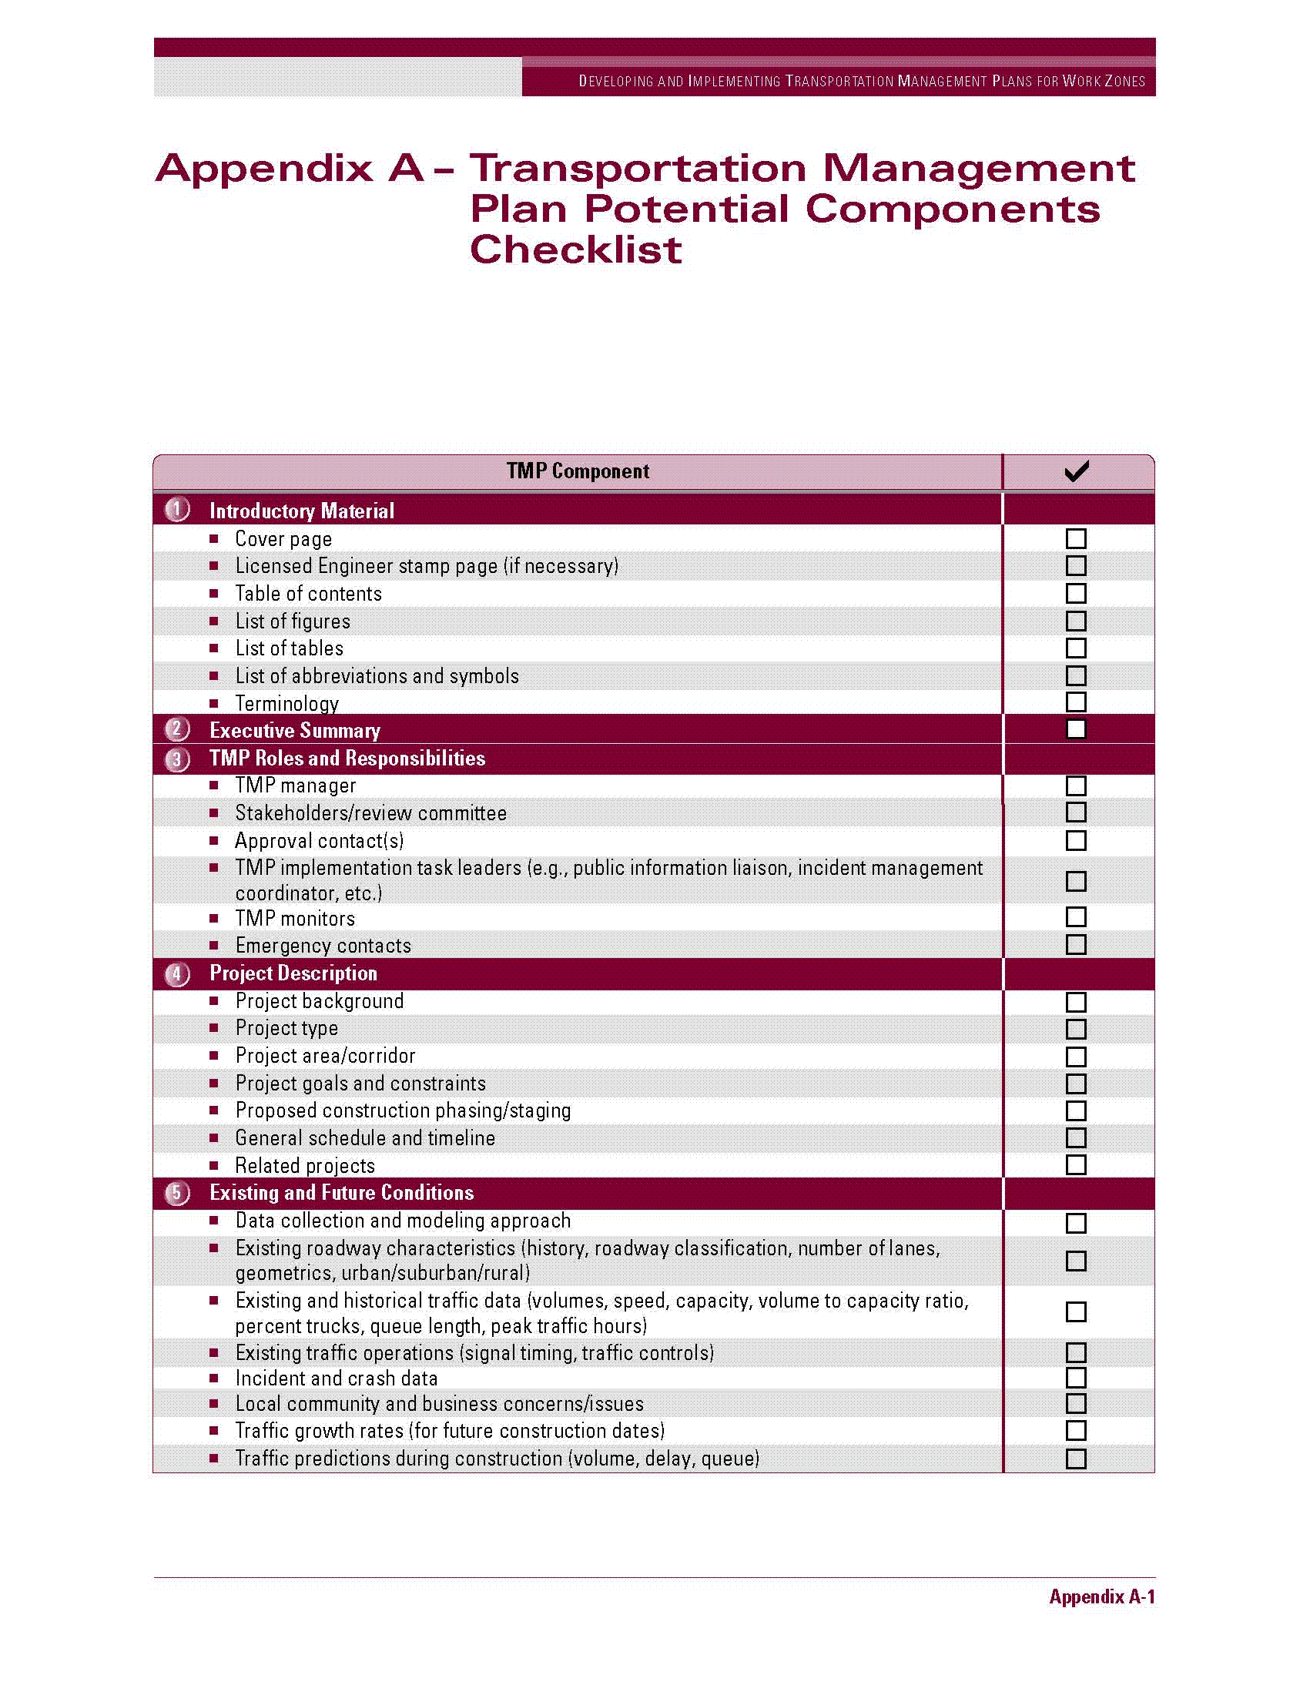

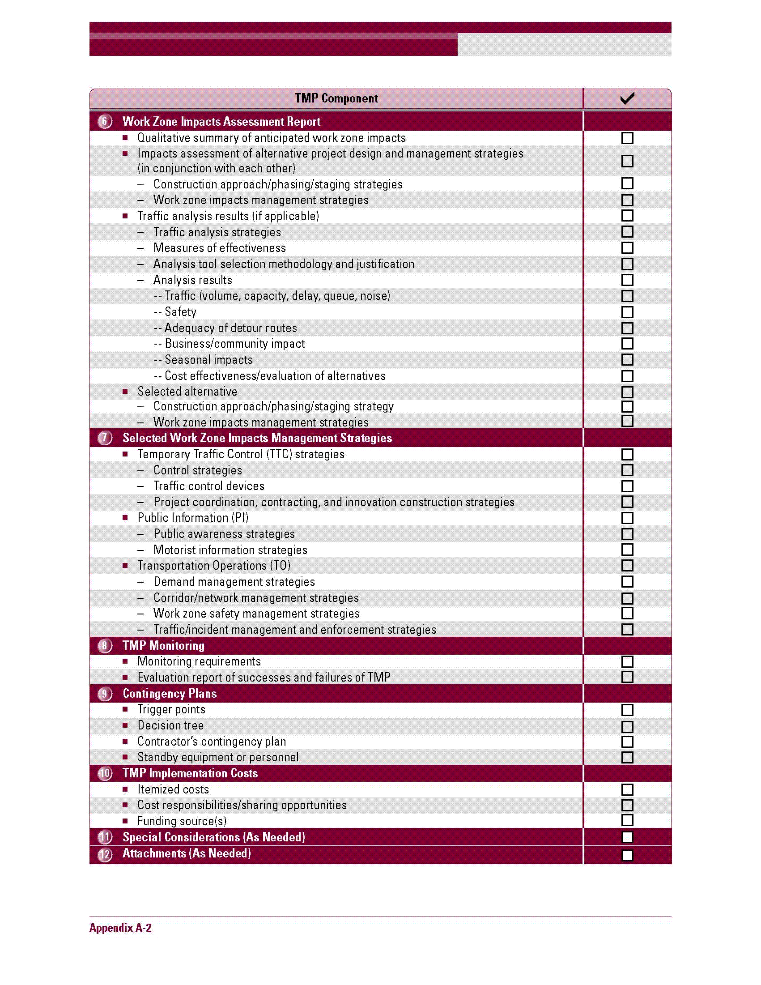

Appendix B – Example Work Zone Management Strategies Matrix
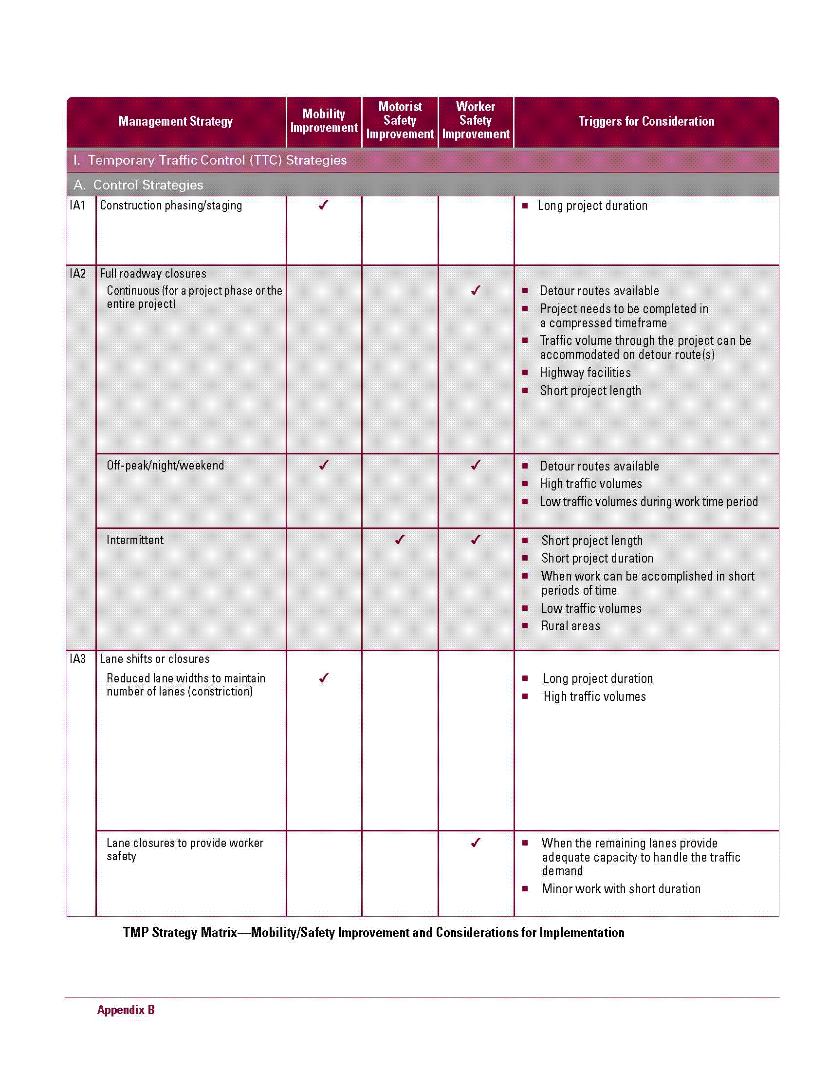

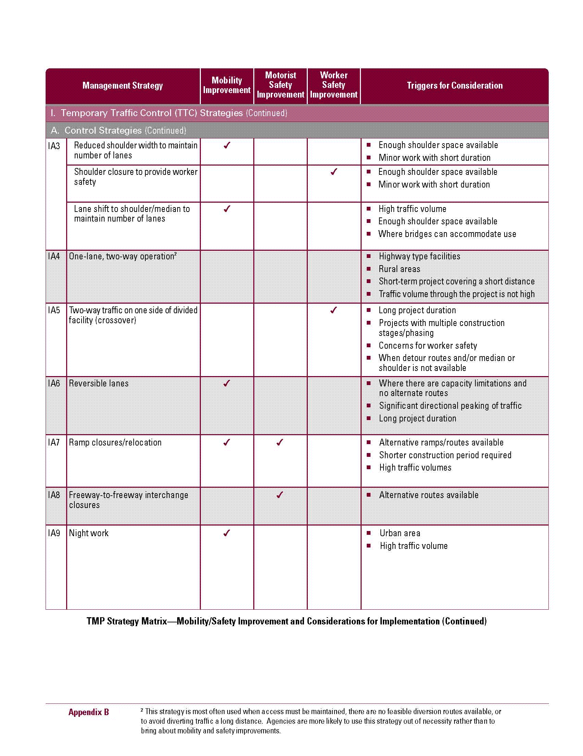

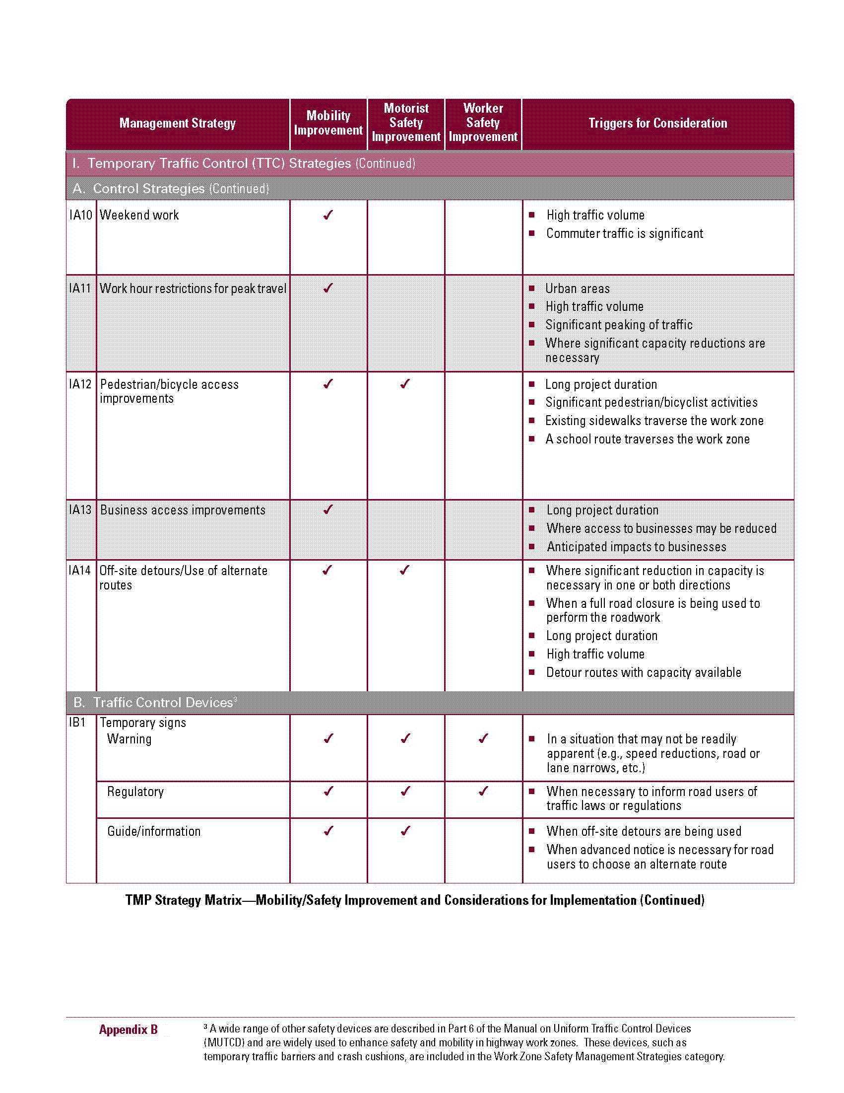

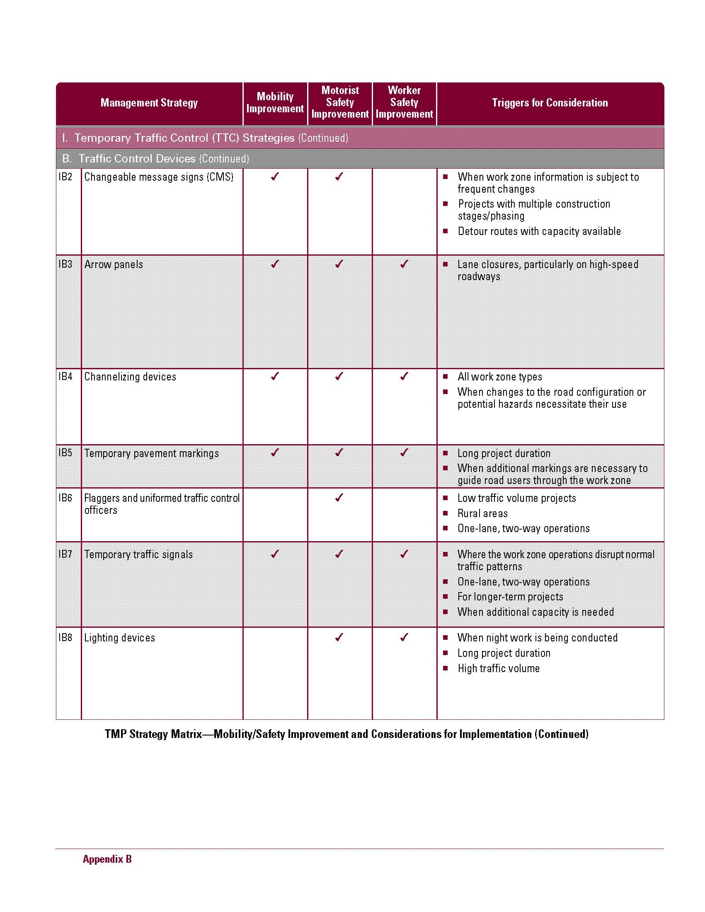

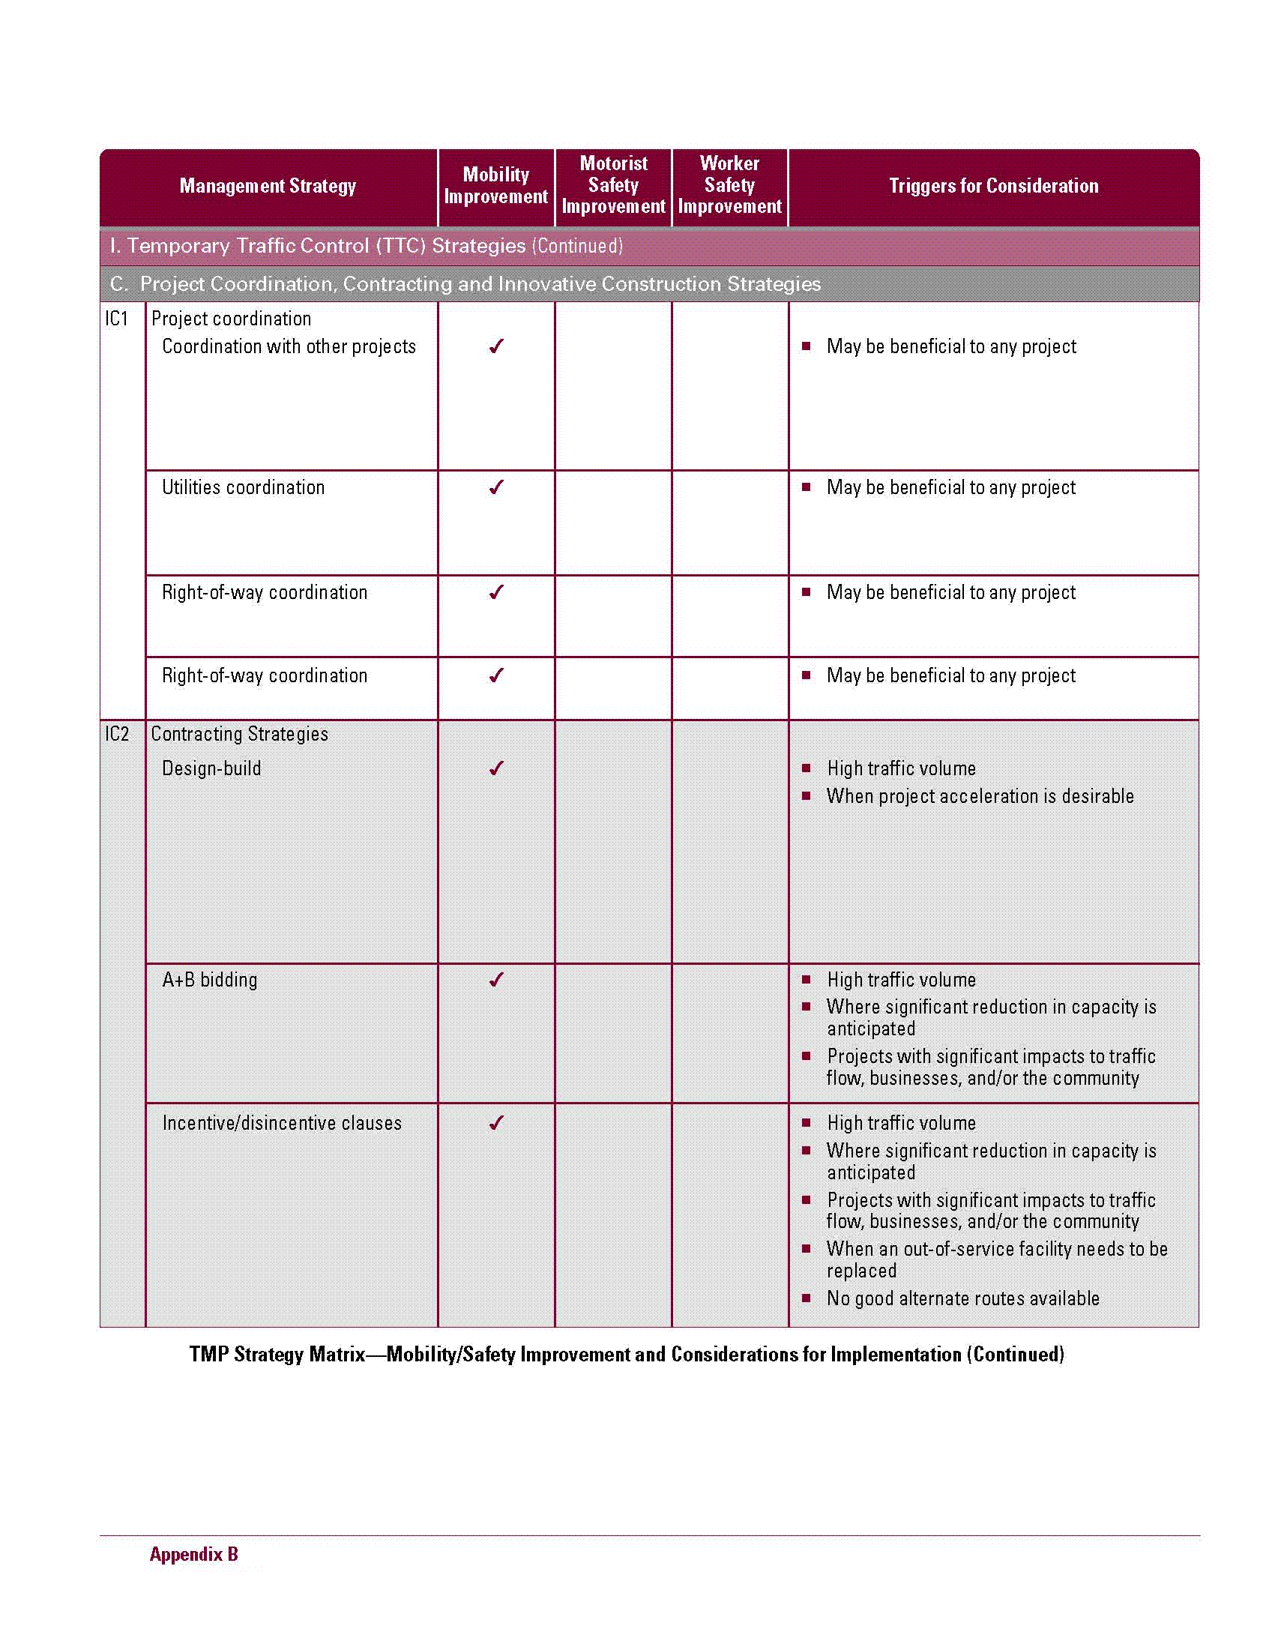

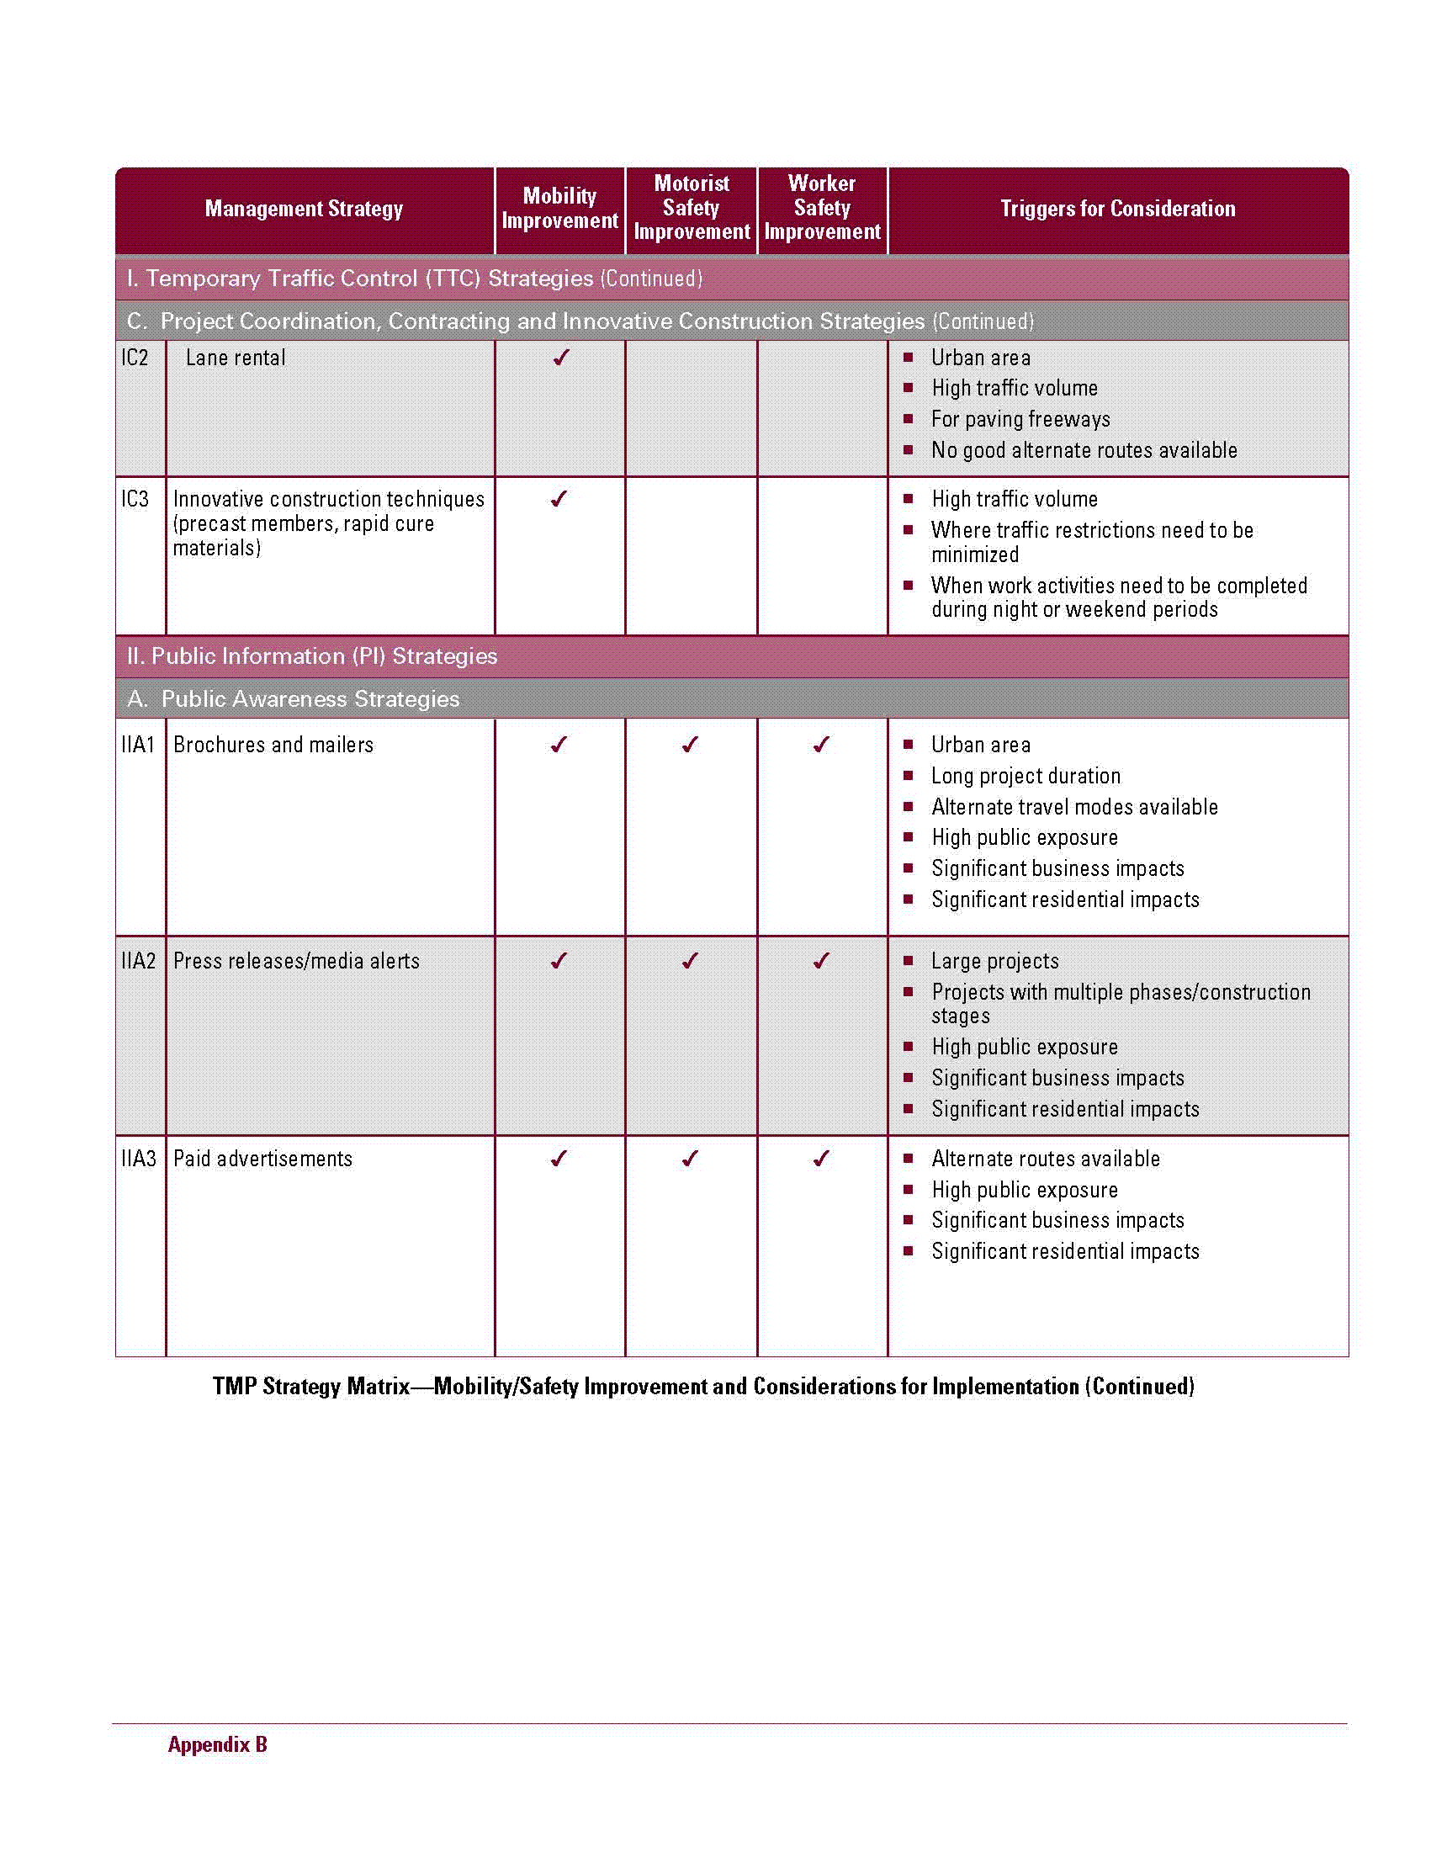

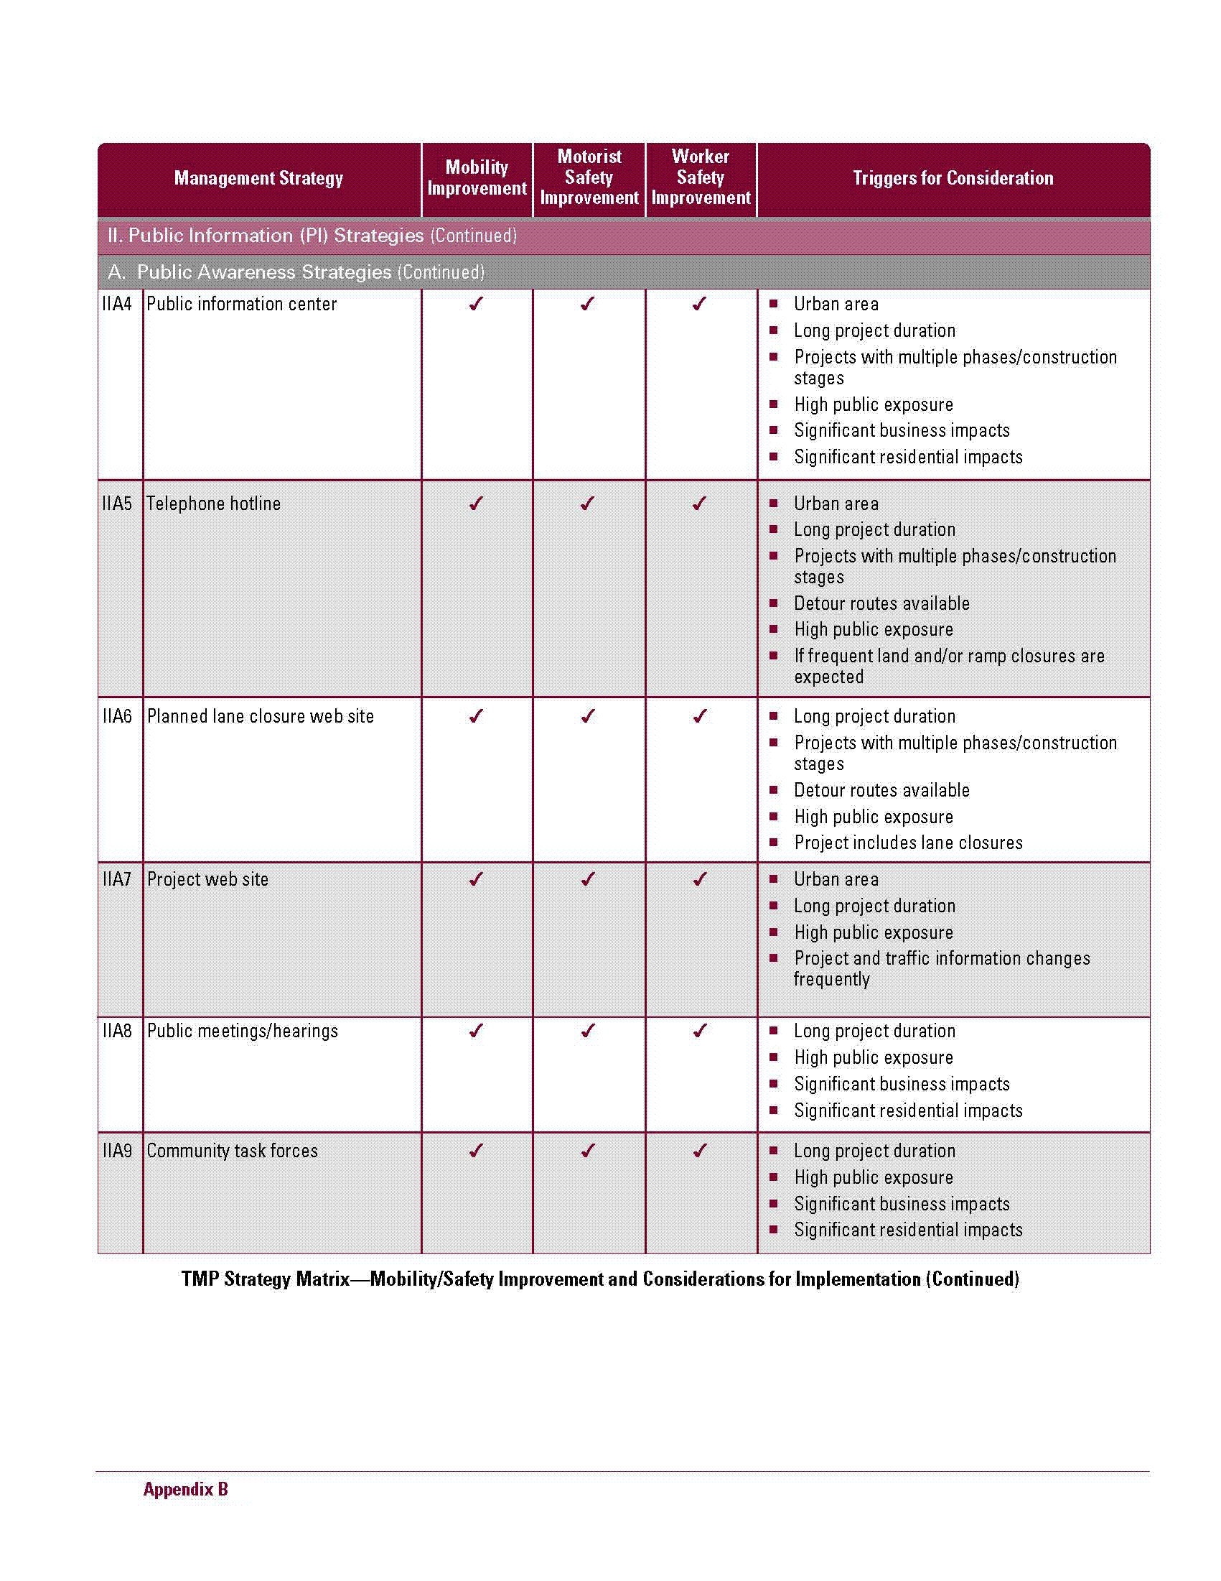

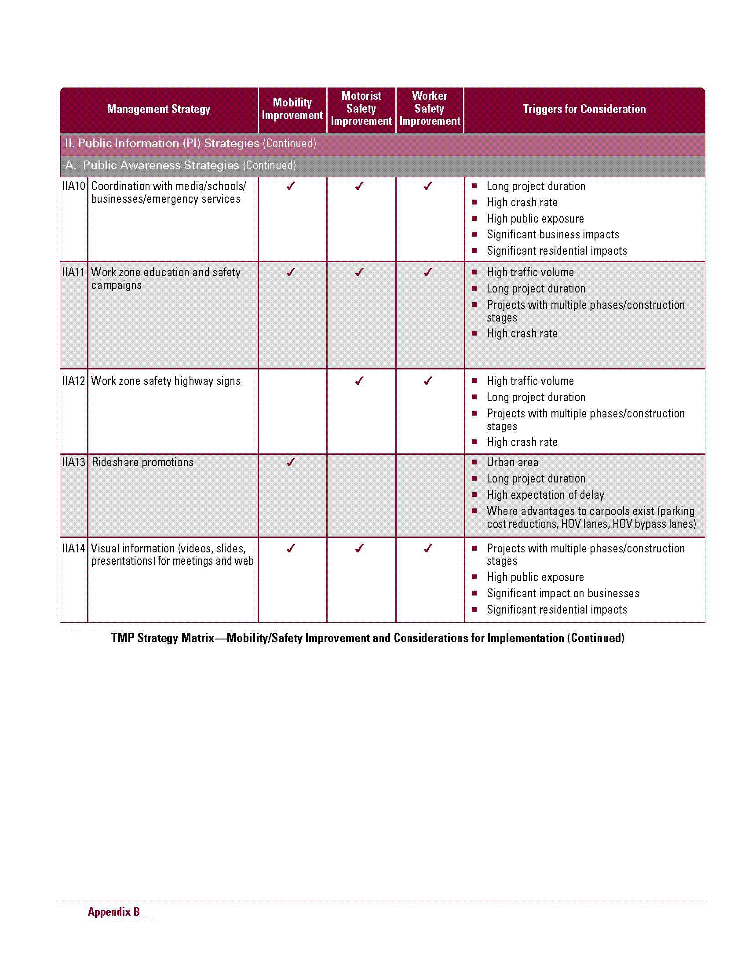

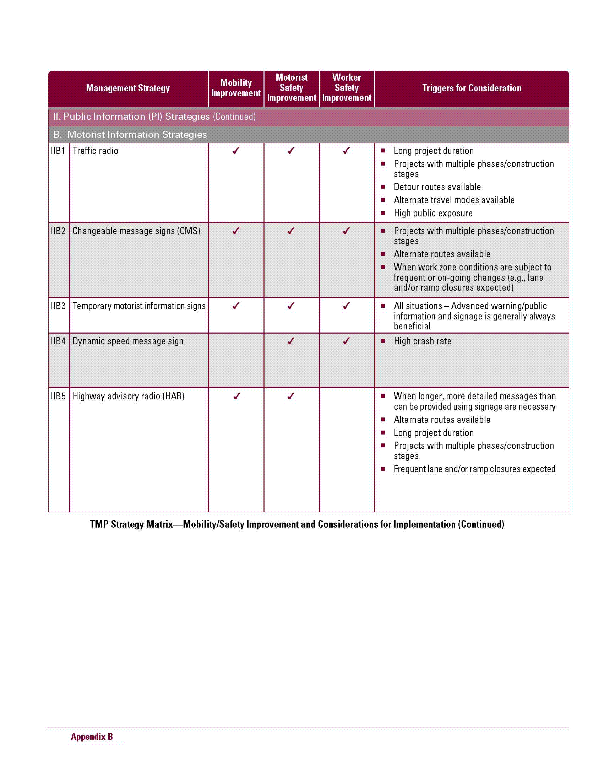

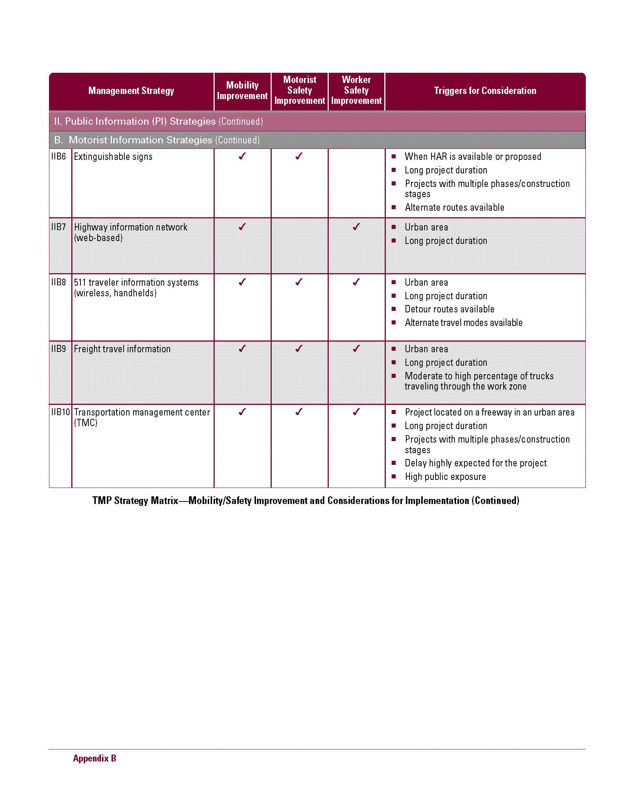

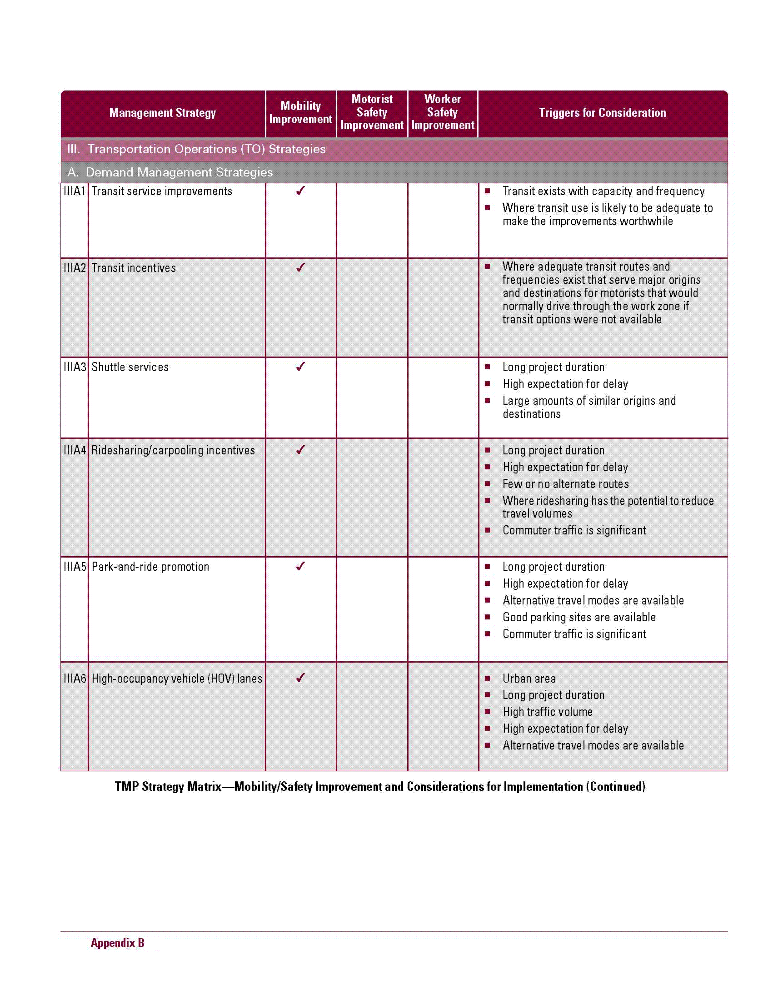

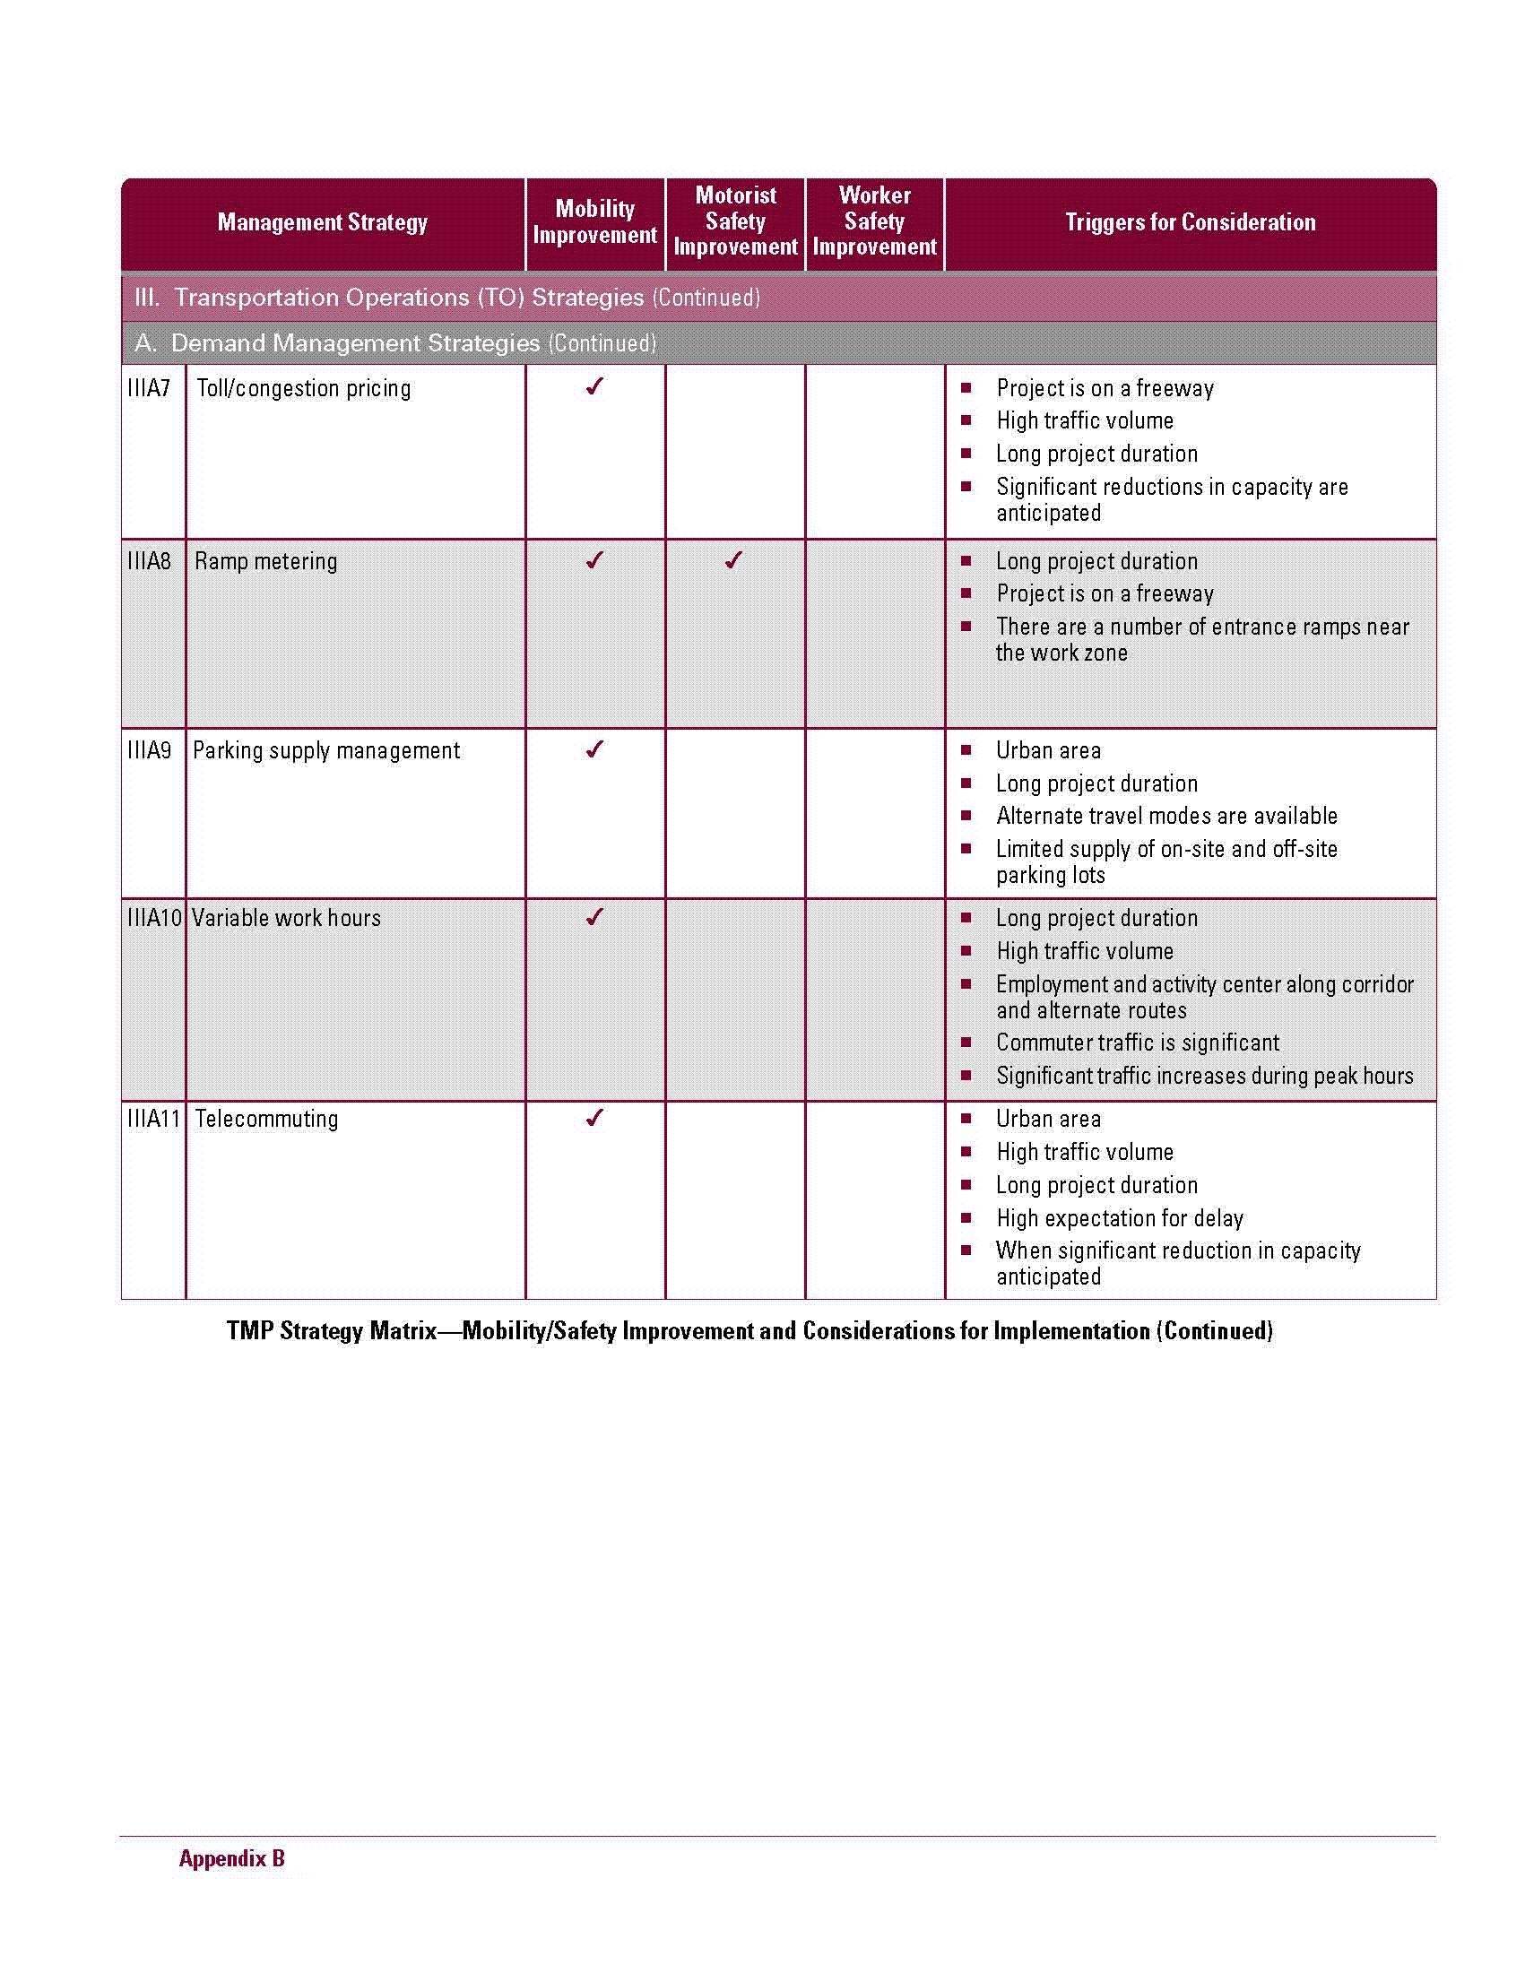

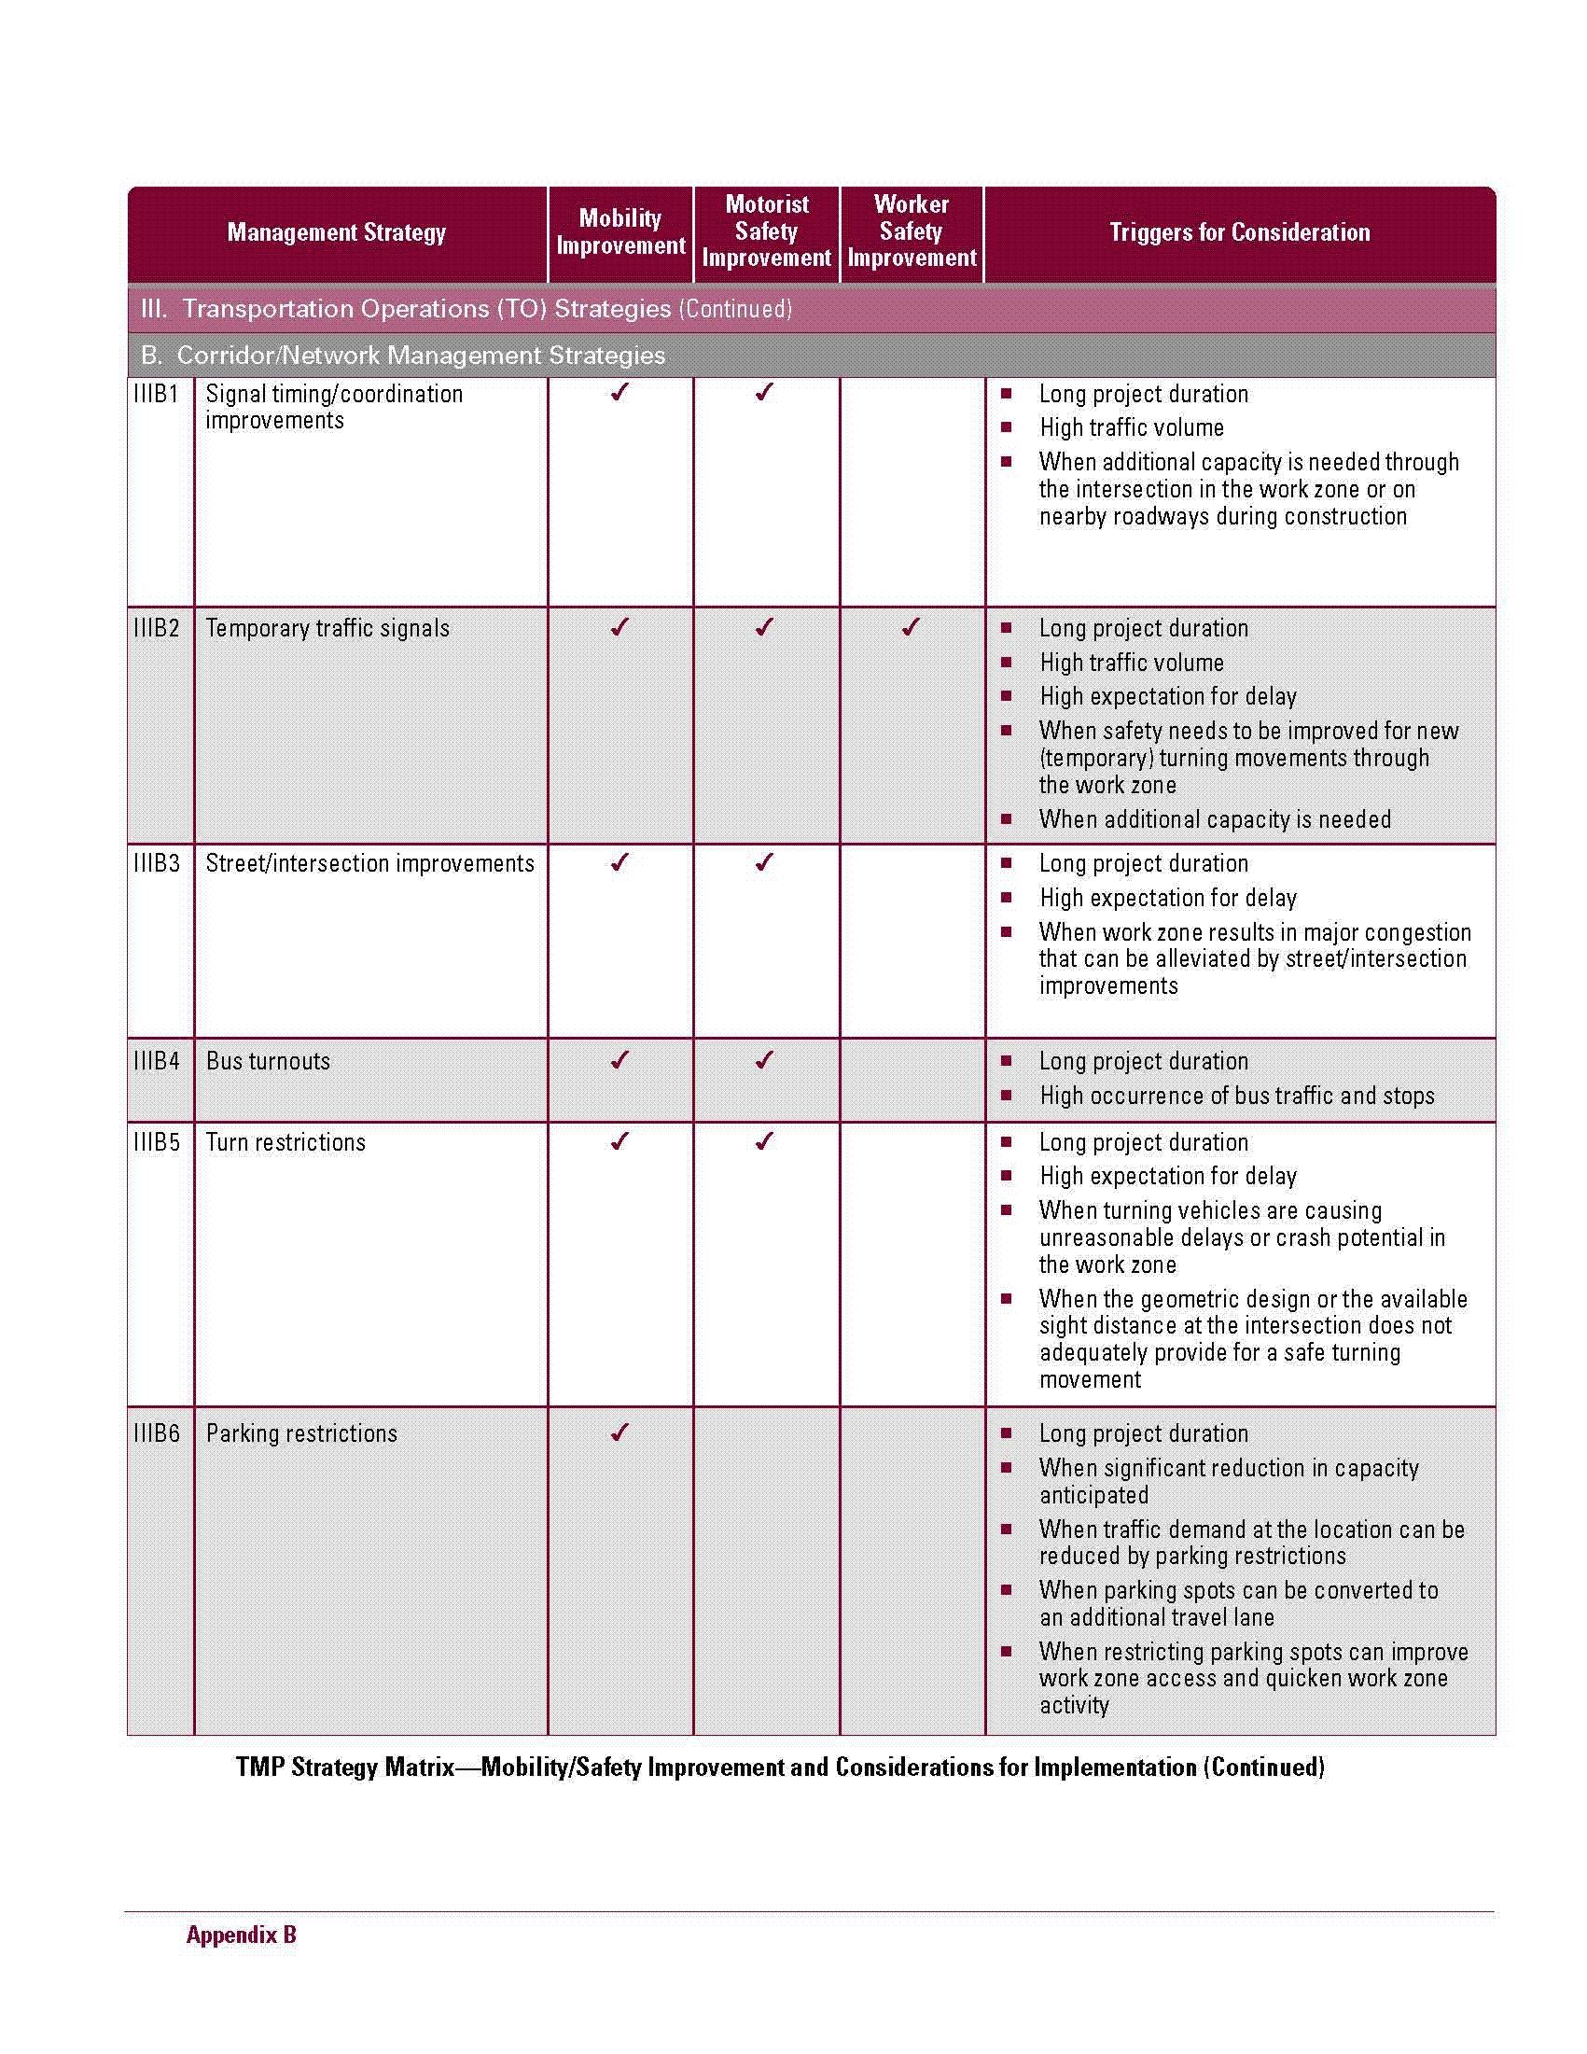

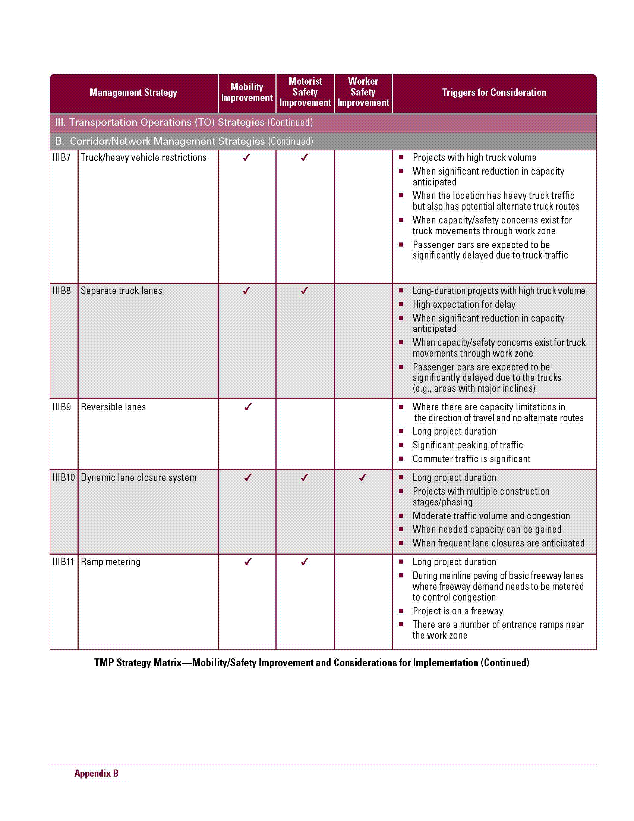

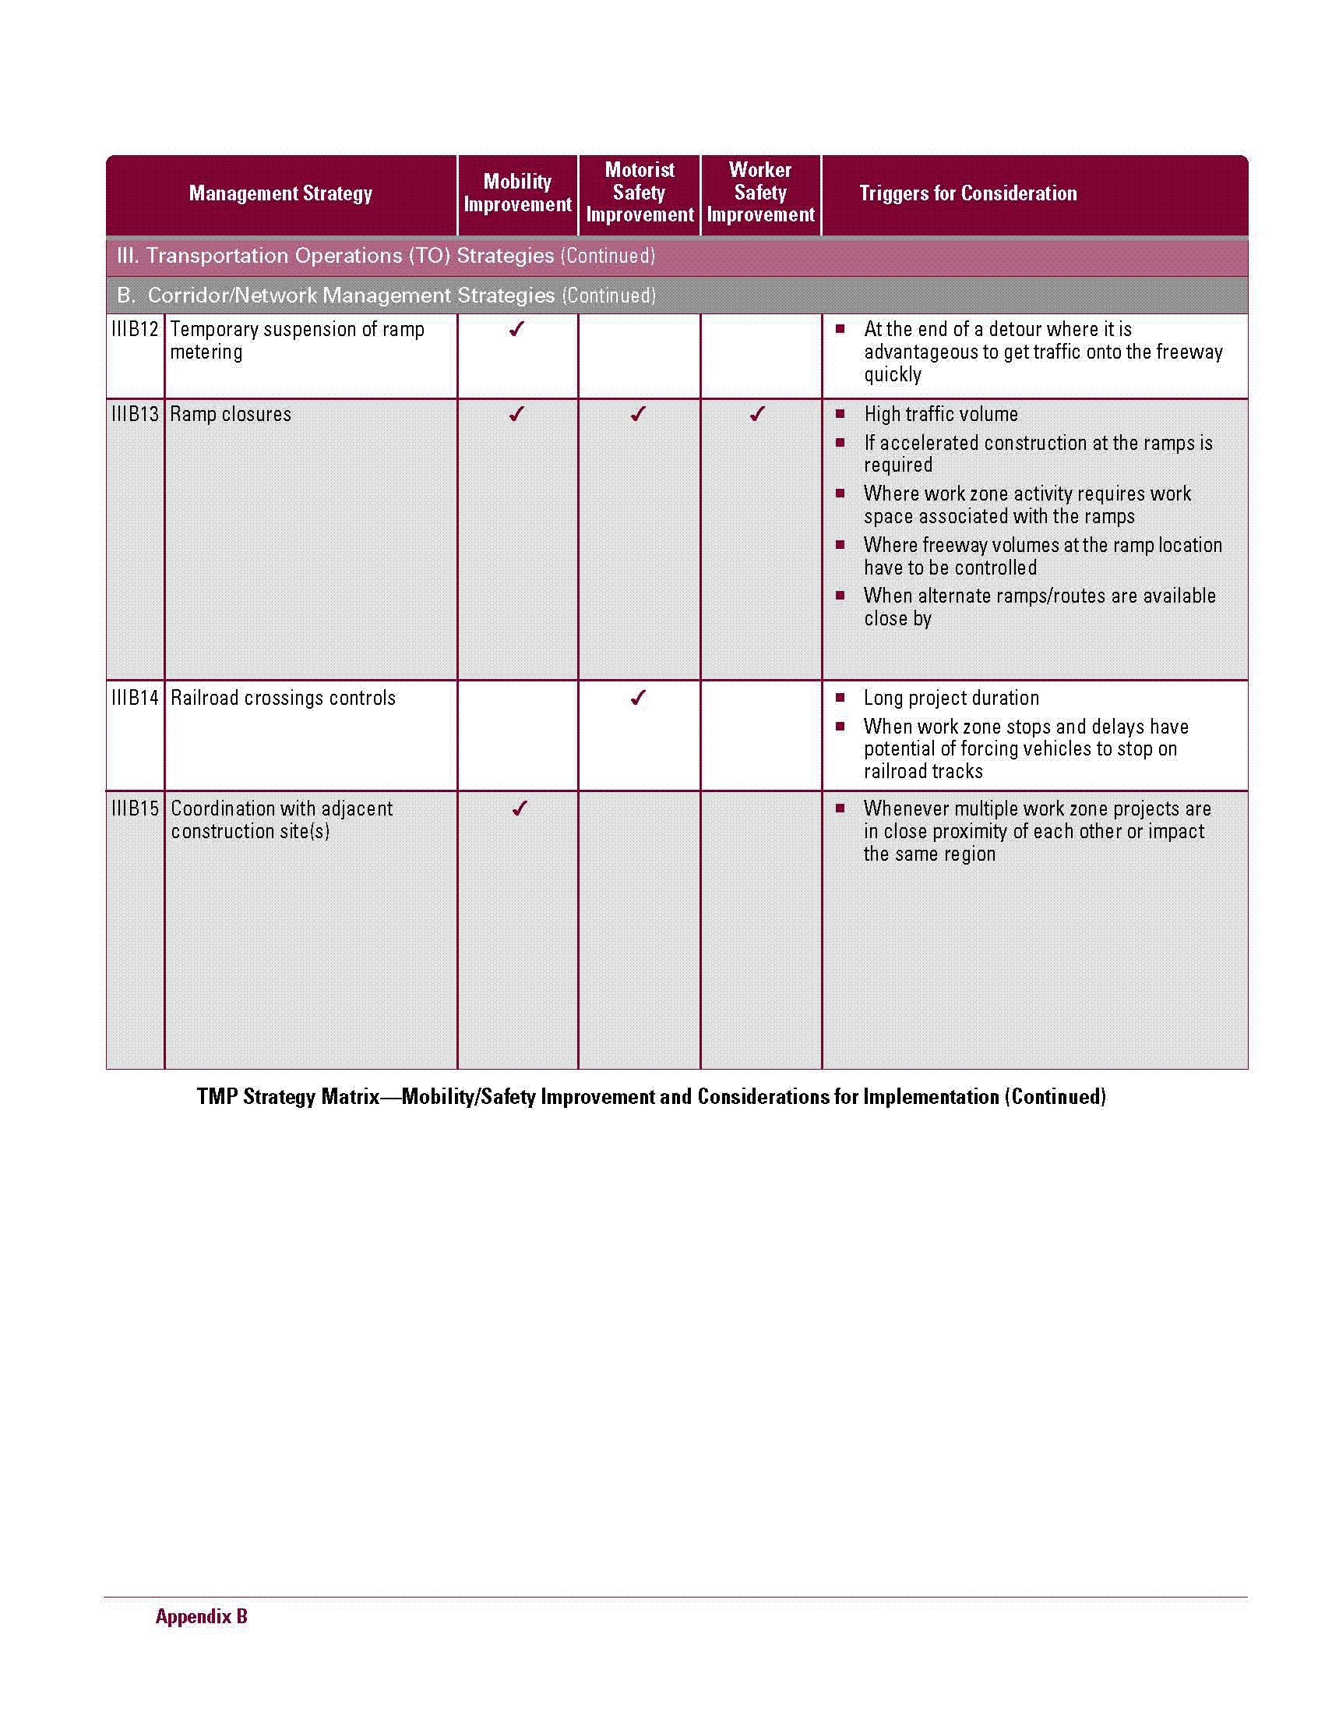

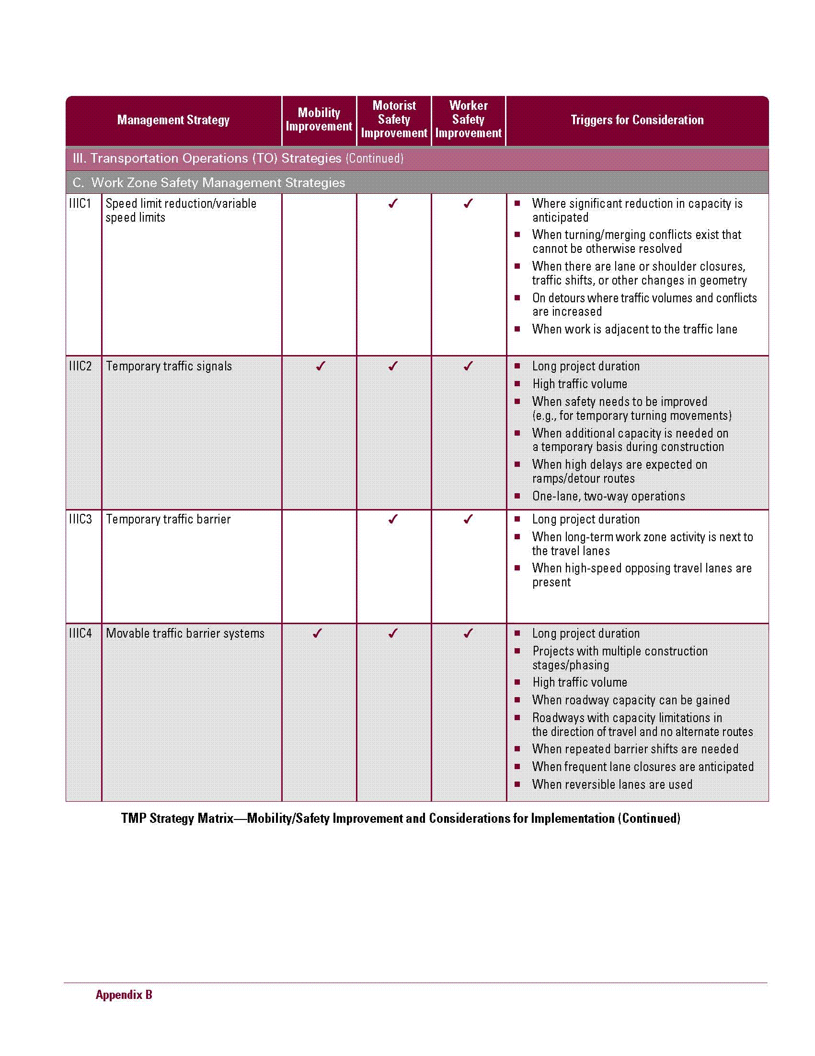

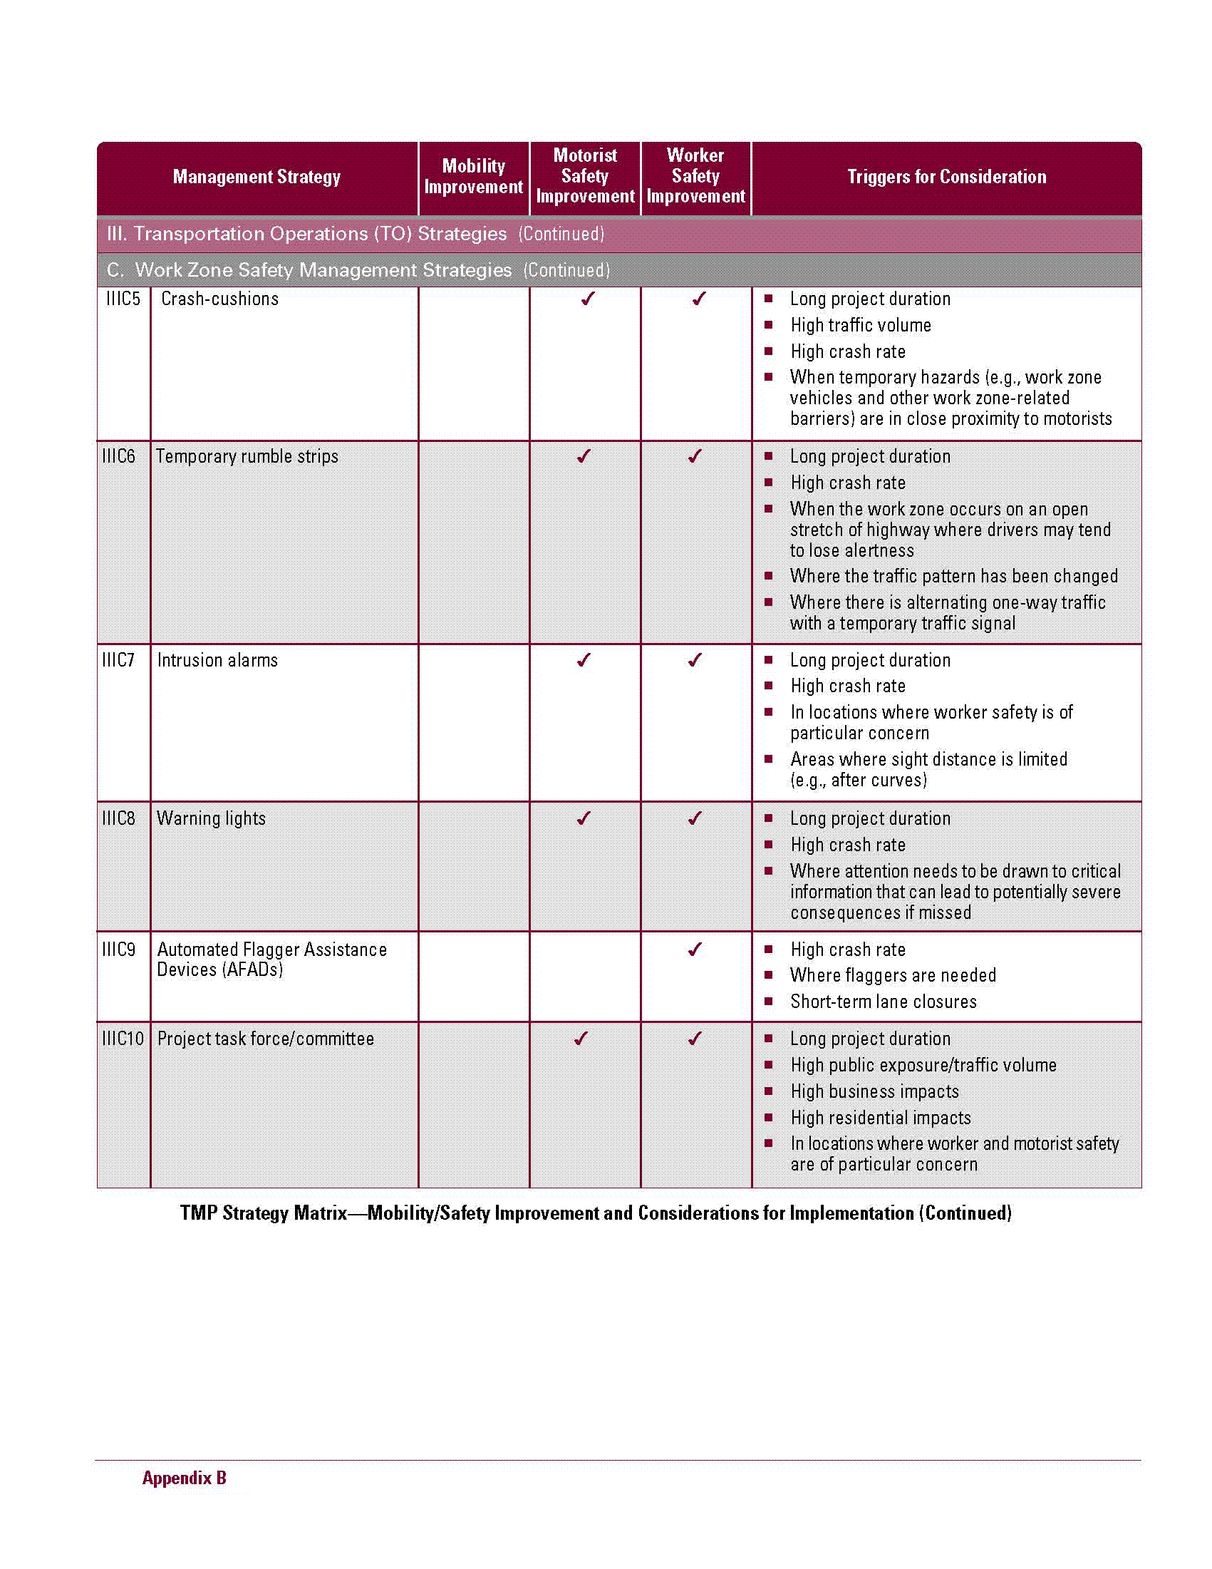

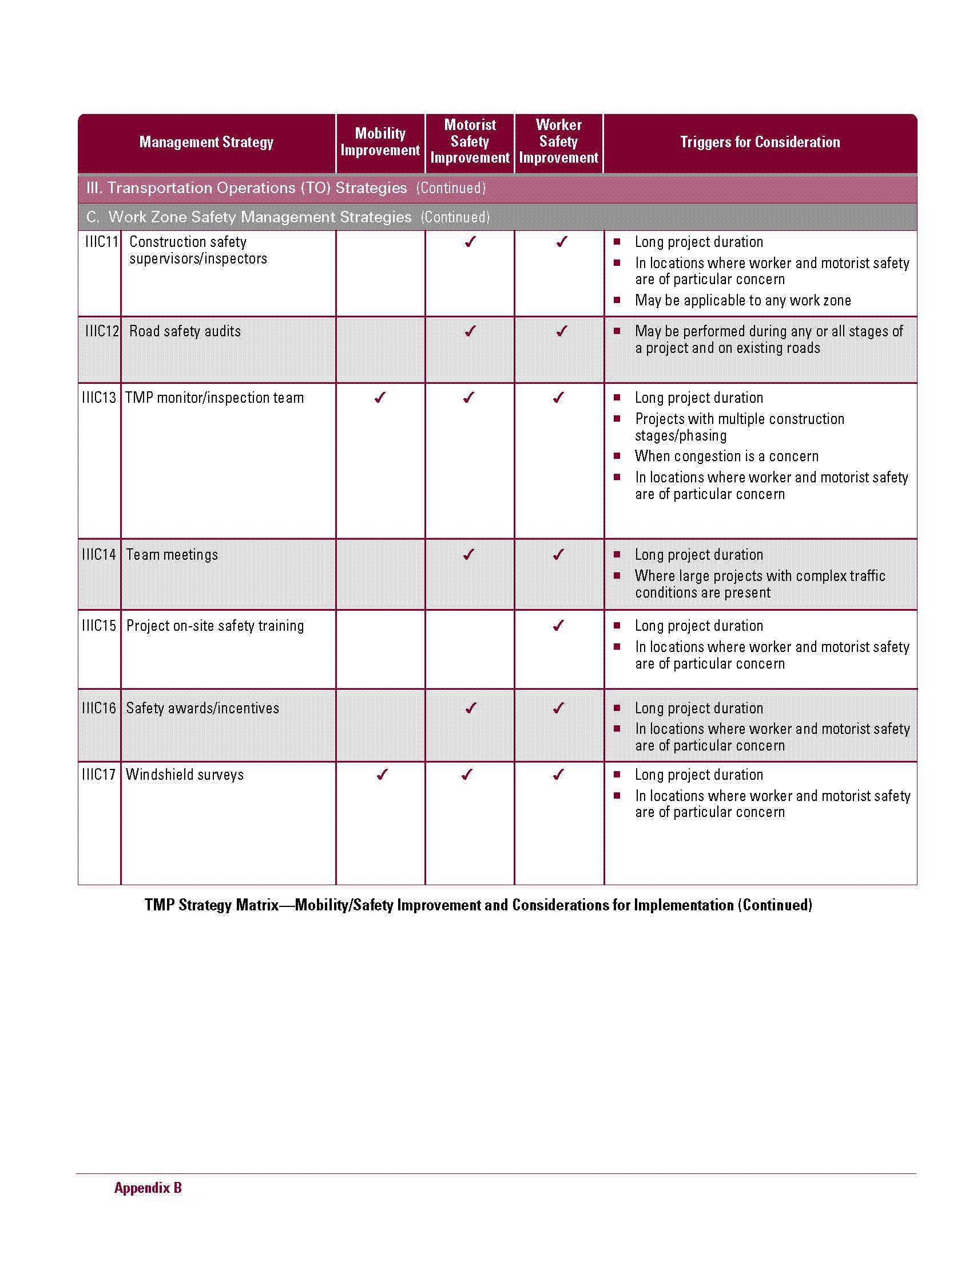

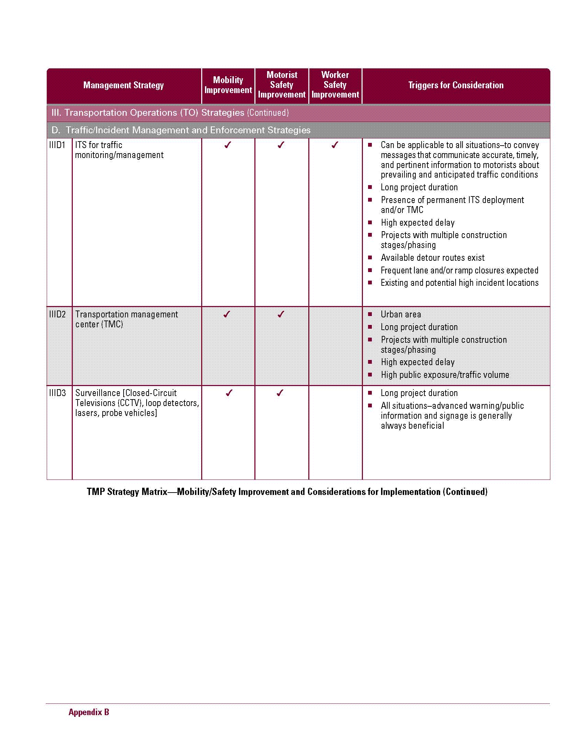

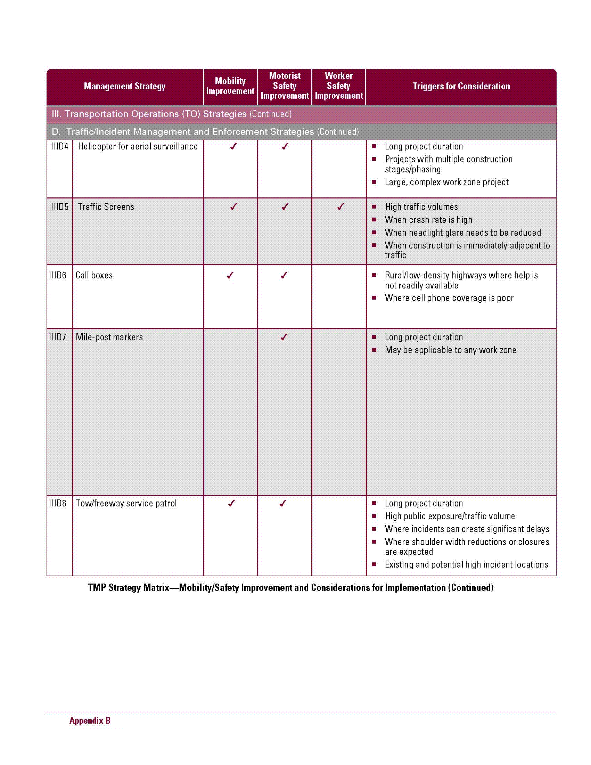

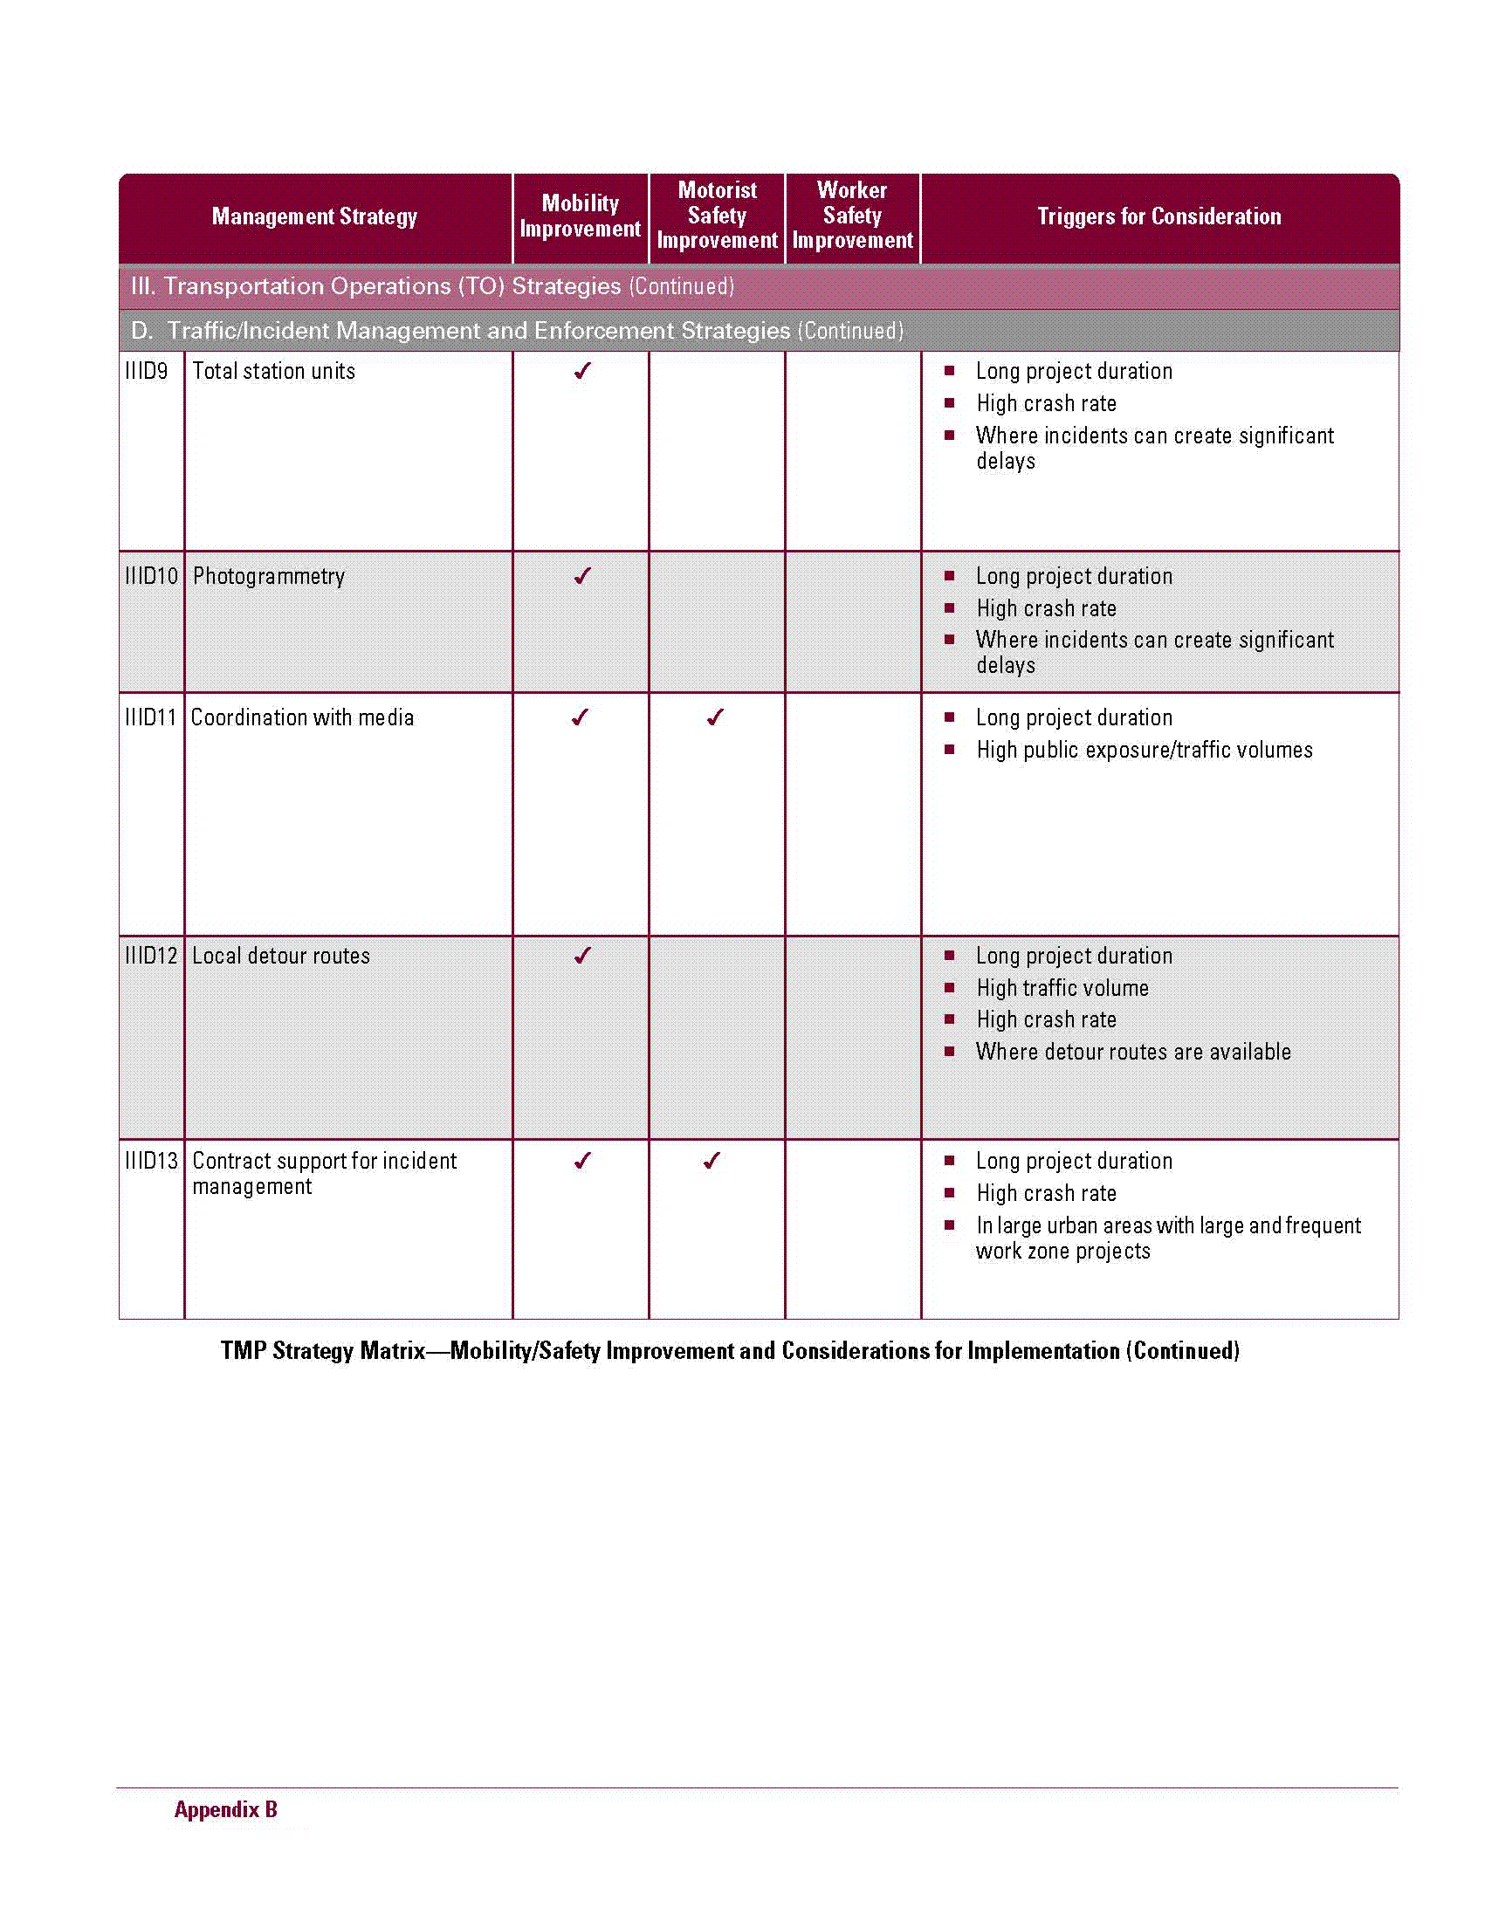

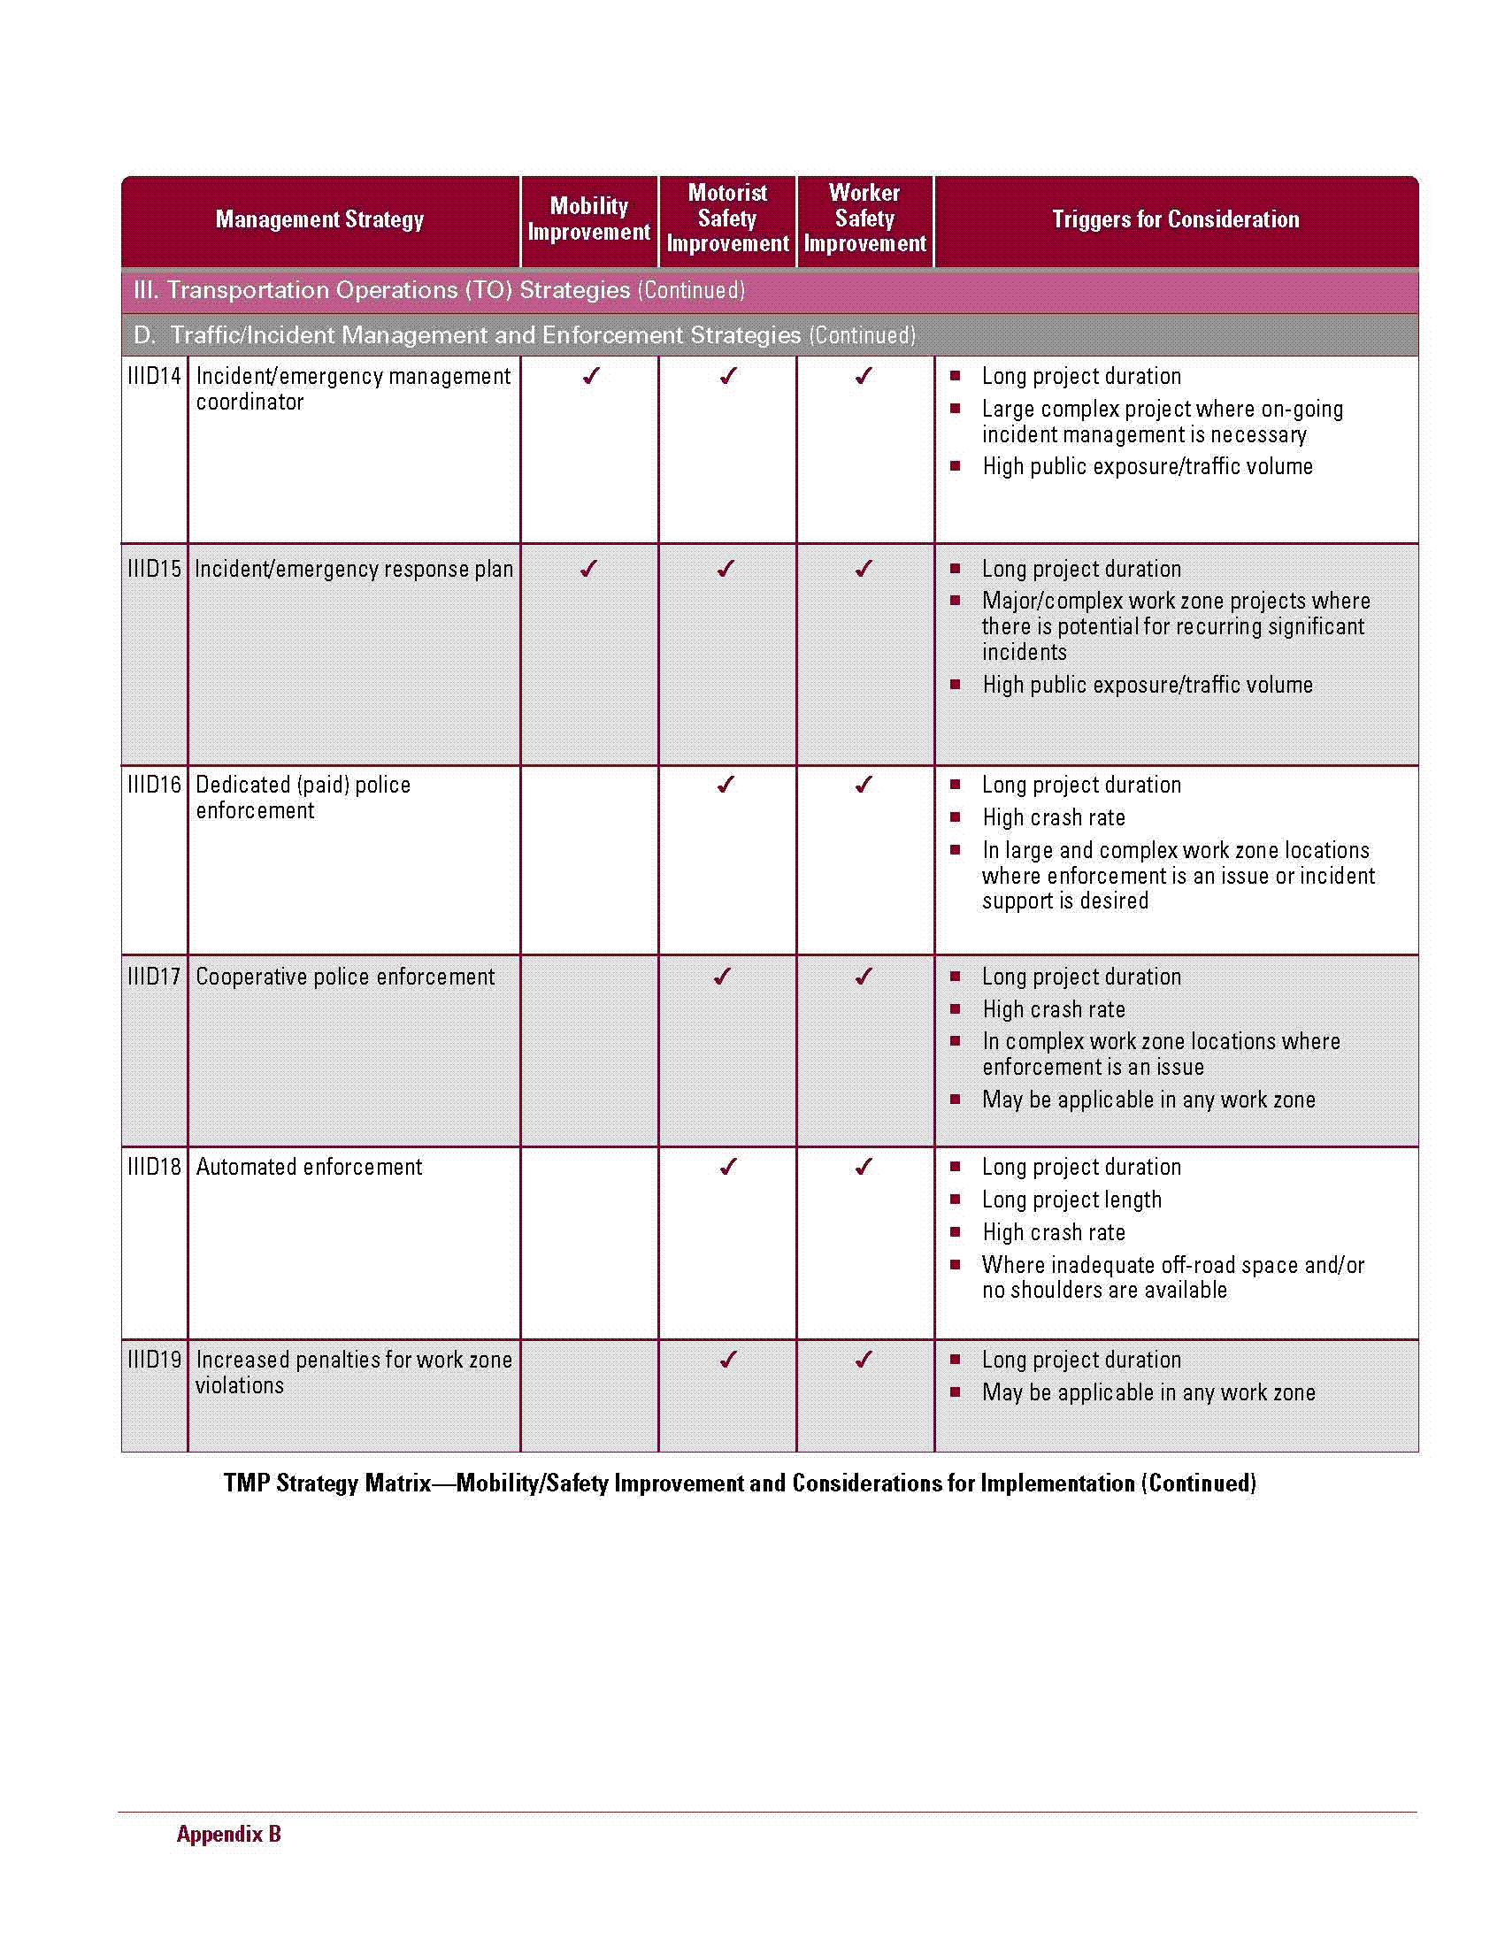

Appendix C – Significant Project Flowchart

Appendix D – Roles & Responsibilities Chart

Work Zone Safety and Mobility Responsibilities
TMP=Transportation Management Plan, PI=Public Involvement, TTC=Temporary Traffic Control
Phase | Office | Responsibility for  Non-Significant Project | Responsibility for  Significant Project
Planning | Planning | Work with District Office and Office of Construction to determine the project classification, and make certain all of the offices involved are aware of the classification (i.e. significant or non-significant) | Same as non-significant. In addition, work with the Office of Construction to complete the check list shown in Appendix A-1, “Developing and Implementing Transportation Management Plans for Work Zones”.
 | Environmental | Project will be assigned to a NEPA specialist in this phase. | Same as a non-significant project.
 | Communications | The Communication Office will be notified by the Office of Planning regarding the significance of the project. | Same as a non-significant project.
 | Design | Project will be assigned to a Project Manager (PM) in this phase. | Same as a non-significant project.
 | Construction | Provide input to the Office of Planning regarding project classification. | Same as a non-significant project.
 | Traffic Operations | For projects programmed by Traffic Operations, work with District Office and Office of Construction to determine the project classification and ensure all involved offices involved are aware of the classification (i.e. significant or non-significant) | Same as a non-significant project. In addition, work with the Office of Construction to complete the check list shown in Appendix A-1, “Developing and Implementing Transportation Management Plans for Work Zones”.
 | Maintenance | For projects programmed by the Office of Maintenance, work with the District Office and Office of Construction to determine project classification and ensure all involved offices are aware of the classification (i.e. significant or non-significant) | Same as a non-significant project. In addition, work with the Office of Construction to complete the check list shown in Appendix A-1, “Developing and Implementing Transportation Management Plans for Work Zones”.
Concept | Planning | The Office of Planning will include information in the Project’s Statement of Purpose and Need concerning the preliminary TMP. | Same as a non-significant project.
 | Environmental | Participate during concept development. | The Environmental NEPA coordinator will work with the Office of Communications to develop the appropriate PI plan and submit the PI plan to the PM to include in the TMP.
 | Communications | Participate during concept development as required by NEPA. | The Office of Communications will work with the NEPA coordinator to ensure the public is aware of project impacts.
 | Design | Include information in the concept report regarding the TMP. For a non-significant project, TMP requirements may be satisfied by the Special Provision Section 150 – Traffic Control document. Coordination between the PM and the Office of Construction is required to develop appropriate time restrictions for work. (See Appendix F for additional guidance) | The PM will work with other offices and use the TMP checklist completed by the Office of Planning (or Maintenance/Traffic Operations depending on programming) to develop a TMP. Key information for the TMP will be included in the Project Concept Reports (i.e. a statements regarding PI, TTC, lane closures, detours, etc.). (See Appendix F for additional guidance)
 | Construction | Participate during concept development. Review the TMP and provide comments to the PM. Coordination between the PM and the Office of Construction is required to develop appropriate time restrictions for work. (See Appendix F for additional guidance) | Same as a non-significant project. (See Appendix F for additional guidance)
 | Maintenance | Participate during concept development. Review TMP and provide comments to PM. | Same as a non-significant project.
 | Traffic Operations | Participate during concept development. Review the TMP and provide comments to the PM. | Same as a non-significant project.
Preliminary Plans | Environmental | Participate during preliminary plan development as required by the PDP. Implement PI (if used). | Participate during preliminary plan development as required by the PDP. Implement PI.
 | Communications | Participate during preliminary plan development as required by the PDP. Implement PI (if used). | Participate in PI and coordinate with the NEPA coordinator.
 | Design | TMP requirements may be satisfied by the Special Provision Section 150 – Traffic Control document. Coordination between the PM and the Office of Construction is required to develop appropriate time restrictions for work. (See Appendix F for additional guidance) | The PM will submit the TMP to the Office of Engineering Services along with the PFPR request package. Staging, detours, lane closures and other construction activities that effect RW will be reviewed in this phase. (See Appendix F for additional guidance)
 | Construction | Participate during preliminary plan development as required by the PDP. Review the TMP and provide comments to the PM. Coordination between the PM and the Office of Construction is required to develop appropriate time restrictions for work. (See Appendix F for additional guidance) | Same as a non-significant project. (See Appendix F for additional guidance)
 | Traffic Operations | Participate during preliminary plan development as required by the PDP. | Same as a non-significant project.
 | Maintenance | Participate during preliminary plan development as required by the PDP. | Same as a non-significant project.
 | Engineering Services | Engineering Services is responsible for scheduling and conducting the PFPR Inspection and reviewing the TMP. Provide comments to the PM via the PFPR Inspection Report. (See Appendix F for additional guidance) | Same as a non-significant project. For FOS projects, the TMP will be sent to FHWA for review and comment. (See Appendix F for additional guidance)
Final Plans | Environmental | Participate during final plan development as required by the PDP. Implement PI (if used). | Participate during final plan development as required by the PDP. Implement PI.
 | Communications | Participate during final plan development as required by the PDP. Implement PI (if used). | Participate in PI and coordinate with the NEPA coordinator.
 | Design | TMP requirements may be satisfied by the Special Provision Section 150 – Traffic Control document. Coordination between the PM and the Office of Construction is required to develop appropriate time restrictions for work. (See Appendix F for additional guidance) | The PM will submit the TMP to the Office of Engineering Services along with the FFPR request package. Issues regarding staging, detours, lane closures and other construction activities, identified during the PFPR, will be reviewed to verify they have been adequately addressed. (See Appendix F for additional guidance)
 | Construction | Participate during final plan development as required by the PDP. Review the TMP and provide comments to the PM. Coordination between the PM and the Office of Construction is required to develop appropriate time restrictions for work. (See Appendix F for additional guidance) | Same as a non-significant project. (See Appendix F for additional guidance)
 | Traffic Operations | Participate during final plan development as required by the PDP. | Same as a non-significant project.
 | Maintenance | Participate during the final plan development as required by the PDP. | Same as a non-significant project.
 | Engineering Services | Engineering Services is responsible for scheduling and conducting the FFPR Inspection and reviewing the TMP. Provide comments to the PM via the FFPR Inspection Report. (See Appendix F for additional guidance) | Same as a non-significant project. For FOS projects, the TMP will be sent to FHWA for review and comment. (See Appendix F for additional guidance)
Construction | Communications | Make contact to the public as necessary throughout the construction phase of the project. | Same as a non-significant project.
 | Construction | The Contractor’s WTCS will implement the TMP. As the project progresses through the construction phase, revisions to the TMP may be required. Any proposed revisions to the TMP will be approved by the Department prior to implementation. The Project Engineer should work with local law enforcement to obtain copies of crash reports for incidents that occur in the work zone. (See Appendix F for additional guidance) | Same as a non-significant project. (See Appendix F for additional guidance)
 | Traffic Operations | Provide an annual report of work zone crashes on all Federal-aid highway projects, where TIR’s are submitted, to the Construction Office. | Provide an annual report of work zone crashes on all Federal-aid highway projects, where TIR’s are submitted, to the Construction Office.
Open to Traffic | Construction | Review the TMP along with incident data and make recommendations concerning enhancements on future TMPs. | Same as non-significant project. In addition, the Office of Construction will coordinate with FHWA to select a minimum of one project to conduct an operational review of the TMP.
 | Traffic Operations | Not applicable. | Provide a record of all incidents occurring within the construction work zone on all Federal-aid highway projects while the project was under construction to the Office of Construction within 8 months of the final construction completion date. Work with the Construction Office to identify trends in work zone crashes and assist with recommendations for enhancements on future TMPs.

Note: At any point in the process a project can change from significant to non-significant or from non-significant to significant.

Appendix E – Links to Documents Available Online

Name | Web Address
FHWA Final Rule Guidance Documents | http://ops.fhwa.dot.gov/wz/resources/final_rule.htm
GDOT Construction Specification – Section 150 | http://tomcat2.dot.state.ga.us/thesource/contract/index.html
GDOT Construction Manual | http://tomcat2.dot.state.ga.us/thesource/construction/index.html
GDOT TOPPS Website | http://www.dot.state.ga.us/topps/index.shtml

Appendix F

Final Rule on Temporary Traffic Control Devices
Title 23 CFR 630 Subpart K

- Introduction
In an effort to develop an agency culture committed to providing reasonably safe work zones for all workers and road users while considering mobility and access, the Georgia Department of Transportation (GDOT) has developed this addendum to the Work Zone Safety and Mobility Policy (Title 23 CFR 630, subpart J). The 2007 Federal Highway Administration’s Work Zone Safety and Mobility Rule found in Title 23 CFR 630 Subpart K initiated the development of this policy. Requirements of this supplement rule include conditions for the appropriate use of, and expenditure of funds for, uniformed law enforcement officers, positive protection measures between workers and motorized traffic, and installation and maintenance of temporary traffic control devices during construction, utility, and maintenance operations. These regulations are intended to decrease the likelihood of fatalities and injuries to road users, and to workers who are exposed to motorized traffic (vehicles using the highway for purposes of travel) while working on Federal-aid highway projects.

- Georgia Policy on Temporary Traffic Control Devices

The Georgia Department of Transportation’s mission is to provide a safe, efficient and sustainable transportation system through dedicated teamwork and responsible leadership supporting economic development, environmental sensitivity and improved quality of life and to consider and manage work zone impacts.
The intent of this policy is to decrease the likelihood of highway work zone fatalities and injuries to workers and road users by establishing minimum requirements and providing guidance for the use of positive protection devices between the work space and motorized traffic, installation and maintenance of temporary traffic control devices, and use of uniformed law enforcement officers during construction, utility, and maintenance operations, and by requiring contract pay items to ensure the availability of funds for these provisions. These procedures will:

- Address the use of Positive Protection Devices to prevent the intrusion of motorized traffic into the work space and other potentially hazardous areas in the work zone
- Address Exposure Control Measures to avoid or minimize worker exposure to motorized traffic and road user exposure to work activities
- Address other Traffic Control Measures including uniformed law enforcement officers to minimize work zone crashes
- Address the safe entry/exit of work vehicles onto/from the travel lanes
- Use strategies to the extent that they are possible, practical, and adequate to manage work zone exposure and reduce the risk of crashes resulting in fatalities or injuries to workers and road users
- Be based on considerations and standards and/or guidance contained in the Manual on Uniform Traffic Control Devices (MUTCD) and the AASHTO Roadside Design Guide, as well as project characteristics and factors
- Use strategies and devices determined by a project-specific engineering study.
- Provide a Uniformed Law Enforcement Policy
Specific components of this policy include a Policy Statement, Goals and Objectives, and Policy Provisions for application during planning, design and construction. The policies provisions are used to evaluate and categorize projects as a systematic process to accomplish the Goals and Objectives for each project. Appropriate work zone strategies may be applied to projects to create more efficient and effective work zones based on the impacts each project will have on the workers, road users, businesses and local communities during construction.

This policy applies to all Federal-aid highway projects. Local agencies implementing Federal-aid highway projects must follow these policies and procedures. This policy does not apply to projects that are authorized and constructed through the Department’s State Aid Office. Any state funded project which may be eligible for Federal funding at a future date should be considered applicable under the provisions of this policy.
Information to support this policy, such as state level and project level procedures to achieve the Goals and Objectives, criteria for evaluating a project and roles and responsibilities for GDOT staff are included. Committee member and stakeholder information is included in Section II (B) (5). Links to related documents are included throughout this document and are summarized in Appendix E of the Work Zone Safety and Mobility Policy, Subpart J (TOPPS 5240-1).

  - Goals and Objectives
The goals and objectives of the GDOT Policy on Temporary Traffic Control Devices are as follows.

- Goal – Implement requirements of the Final Rule on Temporary Traffic Control Devices (Title 23 CFR 630 Subpart K)

Objective – Develop work zone policies and procedures in collaboration with other GDOT offices and FHWA.

- Goal – Develop an agency culture committed to the policy on Temporary Traffic Control Devices.

Objective-Provide training and informational sessions to all offices involved.

- Goal – Provide reasonably safe work zones for all workers and road users.

Objective –Monitor and maintain work zone devices, consider use of law enforcement and positive protection measures.

B. Specific Policy Provisions for Application During Project Delivery
    - Parameters that may affect the types of measures and strategies to be used
      - Roadway functional classification – e.g., Interstate, expressway, principal arterial, major arterial, minor arterial, collector.
      - Area type – e.g., urban, suburban, rural.
      - Project scope and duration
      - Type of work (as related to worker exposure and crash risks) – e.g., new construction, reconstruction, rehabilitation, maintenance, bridge work, equipment installation/repair.
      - Complexity of work – e.g., duration, length, intensity.
      - Level of traffic interference with construction activity.
      - Anticipated traffic speeds through the work zone
      - Anticipated traffic volume
      - Vehicle mix
      - Distance between traffic and workers, and extent of worker exposure
      - Escape paths available for workers to avoid a vehicle intrusion into the work space
      - Time of day (e.g. night work)
      - Work area restrictions (including impact on worker exposure)
      - Consequences from/to road users resulting from roadway departure
      - Potential hazard to workers and road users presented by device itself and during device placement and removal
      - Geometrics that may increase crash risks (e.g. , poor sight distance, sharp curves)
      - Access to/from work space
      - Impacts on project cost and duration
      - Potential economic disruptions
      - Roadside hazards
      - Queue length/travel time data/capacity
      - Lack of positive guidance
      - Conflicts (construction, pedestrian, access)
      - Shoulder widths
      - Utility locations
      - Visual barriers
      - Impacts of sequential and successive work zones
      - Clearance restrictions
      - Railroad crossings and train schedule
      - ROW limitations
      - Existing road conditions
      - Signal timing and signal detection
      - Accident data
      - Pedestrian and bicycle volume
      - Equipment and material storage
      - Disabled vehicle provisions
      - Minimum lane widths
      - Roadside design/ barrier placement
      - Noise ordinances that conflict with work time
      - Lighting issues
      - Citizen feedback
      - Existing roadside safety hardware
      - Availability of alternate routes
      - Project phasing and staging
      - Other parameters as determined by project conditions

    - Uniformed Law Enforcement Requirements should address
      - Interaction between GDOT and law-enforcement agency during project planning, development and implementation.
      - Conditions where law enforcement involvement in work zone traffic control may be needed or beneficial , and criteria to determine the project-specific need for law enforcement
      - General nature of law enforcement services to be provided, and procedures to determine project-specific services
      - Appropriate work zone safety and mobility training for the officers, consistent with the training requirements found in Section III.C of the Work Zone Safety and Mobility Policy.

    - Policy Guidance and Agency Processes and Procedures
      - Overall policy issues (list is not all inclusive)
The following policies and guidance’s that are already in place should be considered as resources to aid in the implementation of this policy:
- Plan Development Process (TOPPS 4050-1)
- Public Involvement Guidelines (TOPPS 4055-1)
- Construction Manual
- MUTCD
- GDOT Design Manuals
- GDOT Standards and Construction Details
- GDOT Specifications
- AASHTO Roadside Design Guide
- AASHTO Green Book
- Utility Accommodation, Policy and Standard Manual
- NCHRP 20-7 (Section 174)-Positive Protection Practices in Highway Work Zones
- NCHRP Report 581 –Design of Construction Work Zones on High-Speed Highways
- NCHRP Report 475 – A Procedure for Assessing and Planning Nighttime Highway Construction and Maintenance
- NCHRP Report 476-Guidelines for Design and Operation of Nighttime Traffic Control for Highway Maintenance and Construction

    - Definitions
      - Agency. A State or local highway agency or authority that receives Federal-aid highway funding.
      - Engineering Study. The comprehensive analysis and evaluation of available pertinent information and the application of appropriate principles, Standards, Guidance, and practices as contained in the MUTCD and other sources, for the purpose of deciding upon the applicability, design, operation, or installation of a traffic control device. An engineering study shall be performed by an engineer, or by an individual working under the supervision of an engineer, through the application of procedures and criteria established by the engineer. An engineering study shall be documented. Example of things that support an engineering study:
- Road user cost
- Road safety audit
- Public information meetings
- Public surveys
- VE studies
- Environmental document
- Constructability reviews
- Field reviews and reports
- Concept meetings
- Life cycle cost analysis
- Previously developed TMP’s and TTC’s
- Other things as determined by project conditions
      - Exposure Control Measures. Traffic management strategies to avoid work zone crashes involving workers and motorized traffic by eliminating or reducing traffic through the work zone, or diverting traffic away from the work space.
      - Federal-aid Highway Project. Highway construction, maintenance, and utility projects funded in whole or in part with Federal-aid funds.
      - Motorized Traffic. The motorized traveling public. This term does not include motorized construction or maintenance vehicles and equipment within the work space.
      - Other Traffic Control Measures. All strategies and temporary traffic controls other than Positive Protection Devices and Exposure Control Measures, but including uniformed law enforcement officers, used to reduce the risk of work zone crashes involving motorized traffic.
      - Positive Protection Devices. Devices that contain and/or redirect vehicles and meet the crashworthiness evaluation criteria contained in National Cooperative Highway Research Program (NCHRP) Report 350, Recommended Procedures for the Safety Performance Evaluation of Highway Features, 1993, Transportation Research Board, National Research Council.
      - Visual barriers. Are barriers longitudinal to the roadway used to block the driver’s view (e.g. the public’s view) of work-zone activities that may distract from driving tasks or be a nuisance to the surrounding community. Installation of visual barriers depends on many factors such as accident experience, nighttime work requiring high-intensity lighting, or complaints from the public. Desirable characteristics of a work-zone visual barrier include: will not penetrate the passenger compartment or present undue risk to workers and other traffic when hit; performs in a predictable manner when hit; effectively blocks the driver’s/public’s view of work-zone activities; is resistant to vandalism and vehicle damage; and is easy to repair.

      - Work Zone Safety Management. The entire range of traffic management and control and highway safety strategies and devices used to avoid crashes in work zones that can lead to worker and road user injuries and fatalities, including Positive Protection Devices, Exposure Control Measures, and Other Traffic Control Measures.

    - Stakeholder and Team and Information
      - GDOT Management
      - FHWA Management
      - Committee Members include representatives from Preconstruction, Construction, Communications, Urban Design, Road Design, Traffic Safety & Design, Planning, Maintenance, Traffic Operations, Utilities, Engineering Services, Training, District Design and FHWA.

    - Roles and Responsibilities are shown in Appendix D.

    - Contact Persons
      - GDOT State Construction Engineer

- State Level Process and Procedures

  - Positive Protection Devices – Procedures and/or Criteria…
    - Engineering Study

The need for longitudinal traffic barrier and other positive protection devices shall be based on an engineering study.
    - Determine the measures to be applied on an individual project

The engineering study for individual projects should be based on considerations of the factors and characteristics described in II.B.1 above. At a minimum, positive protection devices shall be considered in work zone situations that place workers at increased risk from motorized traffic, and where positive protection devices offer the highest potential for increased safety for workers and road users.

    - That Trigger Consideration for use of Positive Barrier Protection

- Work zones that provide workers no means of escape from motorized traffic (e.g., tunnels, bridges, culverts, pits, etc.);
- Long duration work zones (e.g., stationary work of two weeks or more) resulting in substantial worker exposure to motorized traffic;
- Projects with high anticipated operating speeds (e.g. 45 mph or greater), especially when combined with high traffic volumes;
- Work operations that place workers close to travel lanes open to traffic;
- Roadside hazards, such as drop offs or unfinished bridge decks, that will remain in place overnight or longer.
- If staging won’t allow for the “continuous” placement of material as noted in Section 150.06.
- Bridge widening
- Culvert extensions
- Other circumstances as determined by project conditions

  - Exposure Control Measures- Procedures and/or Criteria…

    - Should be considered where appropriate to avoid or minimize worker exposure to motorized traffic and exposure of road users to work activities, while also providing adequate considerations to the potential impacts on mobility.

    - Determine the measures to be applied on an individual project
      - Full road closures;
      - Ramp closures;
      - Median crossovers;
      - Full or partial detours or diversions;
      - Performing work at night or during off-peak periods when traffic volumes are lower;
      - Accelerated construction techniques;
      - Traffic Pacing;
      - Reversible lanes;
      - Use of shoulders or medians;
      - Temporary bypass;
      - Lane constriction;
      - Incentives/disincentives; and
      - Other measures as determined by project conditions

  - Other Traffic Control Measures
    - Should be given appropriate considerations for use in work zones traffic intrusion into the work space.

    - Determine the measures to be applied on an individual project
      - Effective, credible signing;
      - Portable Changeable message signs (PCMS);
      - Arrow panels;
      - Warning flags and lights on signs;
      - Longitudinal and lateral buffer space;
      - Certified flaggers
      - Enhanced flaggers station setups;
      - Rumble strips;
      - Pace or pilot vehicle;
      - High quality work zone pavement markings and removal of misleading markings;
      - Channelization device spacing reduction;
      - Longitudinal channelizing barricades;
      - Work Zone speed management (including changes to the regulatory speed and/or variable speed limits);
      - Law Enforcement;
      - Worker and work vehicle/equipment visibility;
      - Worker training;
      - Truck mounted attenuators;
      - Stationary crash cushions;
      - Movable concrete barriers;
      - Smart Work zone;
      - Public information and traveler information;
      - Temporary traffic signals; and
      - Other measures as determined by project conditions.

  - Uniformed Law Enforcement Officers
    - The need for law enforcement is greatest on projects with high traffic speeds and volumes, and where the work zone is expected to result in substantial disruptions to or changes in normal traffic flow patterns.

    - Specific project conditions that should be examined to determine the need for or potential benefit of law enforcement
      - Frequent worker presence adjacent to high-speed traffic without positive protection devices;
      - Traffic control setup or removal that presents significant risks for workers and road users;
      - Complex or very short term changes in traffic patterns with significant potential for road user confusion or worker risk from traffic exposure;
      - Night work operations that create substantial traffic safety risks for workers and road users;
      - Existing traffic conditions and crash histories that indicate a potential for substantial safety and congestion impacts related to the work zone activity, and that may be mitigated by improved driver behavior and awareness of the work zone;
      - Work zone operations that require brief stoppage of all traffic in one or both directions;
      - High –speed roadways where unexpected or sudden traffic queuing is anticipated, especially if the queue forms a considerable distance in advance of the work zone or immediately adjacent to the work space; and
      - Other work site conditions where traffic presents a high risk for workers and road users, such that the risk may be reduced by improving road user’s behavior and awareness.

    - Costs associated with the provisions of uniformed law enforcement to help protect workers and road users, and to maintain safe and efficient travel through highway work zones, are eligible for Federal-aid participation (Federal-aid projects). This does not include law enforcement activities that would normally be expected in and around highway problem areas requiring routine or ongoing law enforcement control and enforcement. The Department may include a section 150.11 Special Provision in the contract and include the pay item 150-9011 Traffic Control-Workzone Law Enforcement.

  - Work Vehicle and Equipment
- Safe means for work vehicles and equipment to enter and exit traffic lanes for delivery of construction materials to the work space is addressed in current Standard Specification 107 and current Special Provision 150. In addition to this, construction exits shall be identified on the Erosion, Sedimentation and Pollution Control plan for each project. Section 150 also requires the use of Certified Flaggers. A channelized termination taper (150 feet max.) is required on all lane closures to return road users to their normal path and force construction vehicles that may be exiting the work zone to the shoulder prior to merging with traffic.

  - Payment for Traffic Control
    - Payment for work zone traffic control features and operations shall not be incidental to the contract, or included in payment for other items of work not related to traffic control and safety.
    - As a minimum, separate pay items shall be provided for major categories of traffic control devices, safety features, and work zone safety activities, including but not limited to positive protection devices, work zone law enforcement, portable changeable message signs, radar speed display unit, and temporary traffic control signal.
    - For method based specifications, the specifications and other PS&E documents should provide sufficient details such that the quantity and types of devices and the overall effort required to implement and maintain the TMP can be determined.
    - For method-based specifications, unit price pay items, lump sum pay items, or a combination thereof may be used.
    - Specifications should clearly indicate how placement, movement/relocation, and maintenance of traffic control devices and safety features will be compensated.
    - The specifications should include provisions to require and enforce contractor compliance with the contract provisions relative to implementation and maintenance of the project TMP and related traffic control items. Enforcement provisions may include remedies such as liquidated damages, work suspensions, or withholding payment for noncompliance (non refundable deductions).

  - Maintenance of Temporary Traffic Control Devices
    - Special Provision 150 and the Construction Manual (see Appendix E) currently address the maintenance of temporary traffic control devices and the appropriate level of inspection necessary to provide ongoing compliance with the quality guidelines.

- Policy for the use of Uniformed Law Enforcement

  - Conditions and criteria for determining need for law enforcement involvement in work zone traffic control shall be determined in the Plan Development Process (see conditions noted in Section III (D) above). The minimum number of hours needed shall also be determined.

  - Service to be provided shall be addressed in a Special Provision Section 150.11 and included in the contract.

  - The pay item 150-9011 Traffic Control-Workzone Law Enforcement shall be included in the contract with the number of hours needed for a specific project.

  - The contractor will be responsible for securing the Workzone Law Enforcement required by contract Special Provision Section 150.11. The contractor will be responsible for negotiating and entering into agreements for required Workzone Law Enforcement with the appropriate Law Enforcement Agency.

  - The contractor will recover the cost for providing the required Workzone Law Enforcement through the contract pay item noted above.

